

Owner’s Manual

Modbus converter
Model AC-422

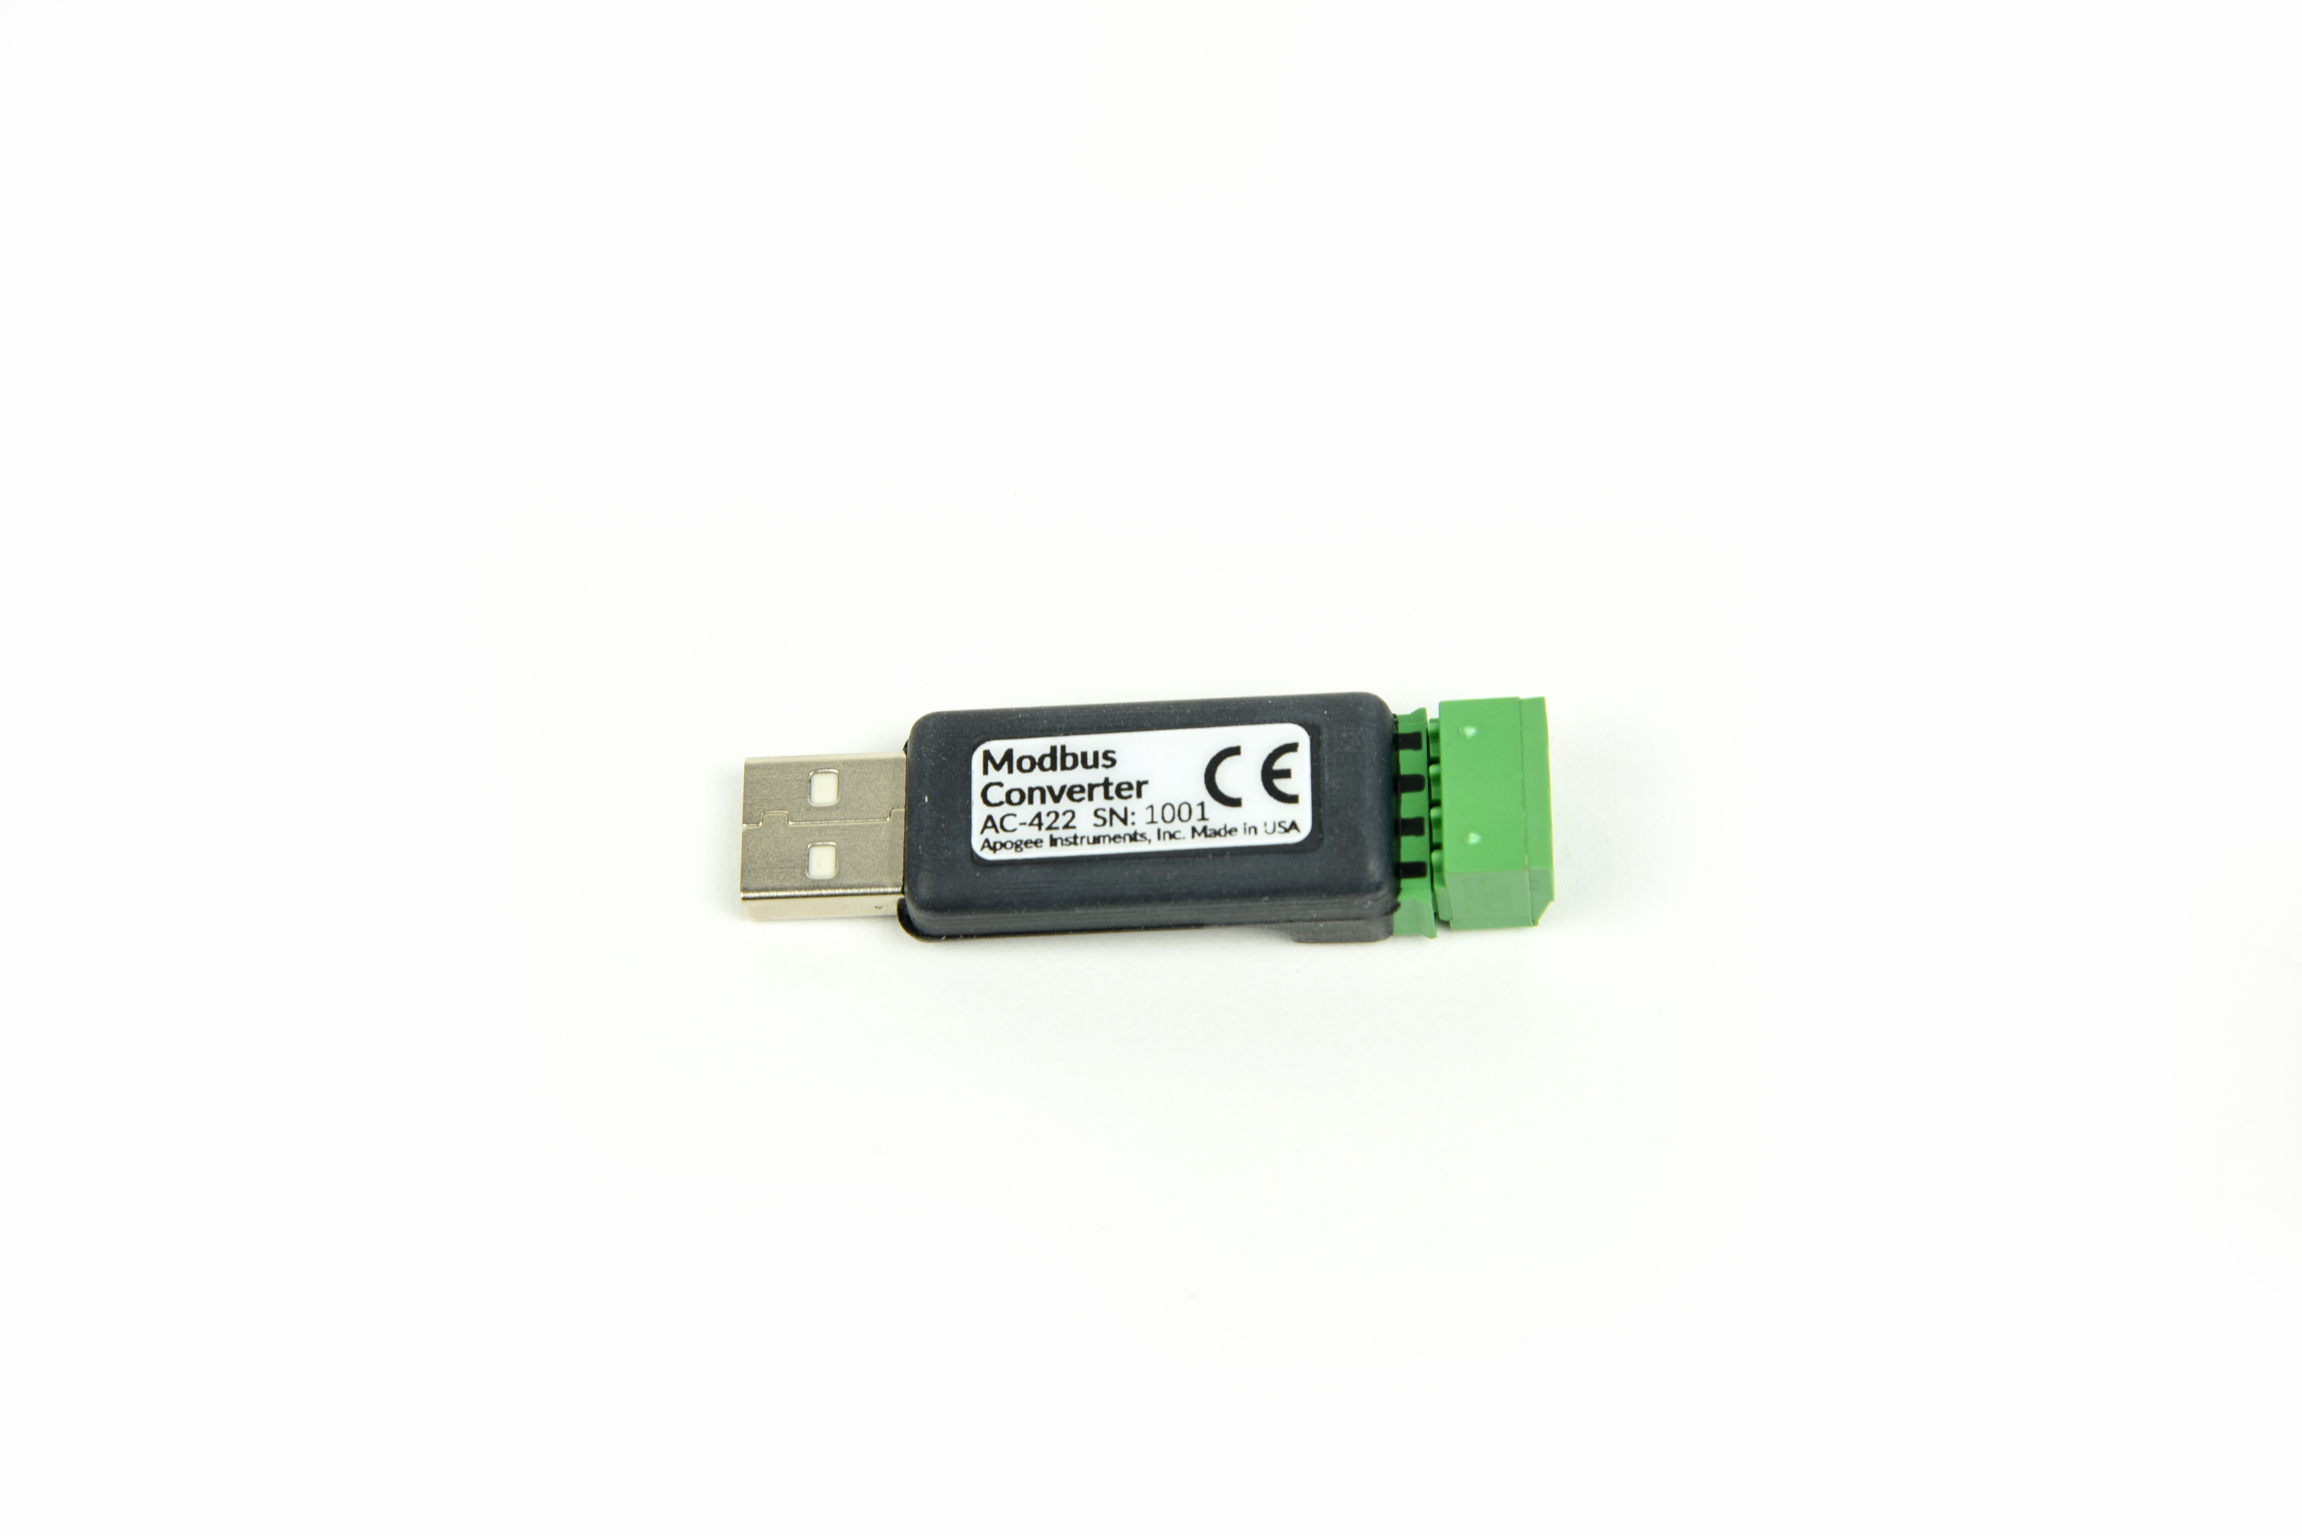
Table of Contents
Owner’s Manual 1
Declaration of Conformity 3
Introduction 4
Sensor Models 4
Specifications 4
Deployment and Installation 5
Operation and Measurement 6
Spreadsheet Table of Majority of SDI-12 Commands 7
Maintenance and Recalibration 8
Troubleshooting and Customer Support 9
Return and Warranty Policy 15

Declaration of Conformity

EU Declaration of Conformity
This declaration of conformity is issued under the sole responsibility of the manufacturer:
Apogee Instruments, Inc.
721 W 1800 N
Logan, Utah 84321
USA
for the following product(s):

Models: AC-422
Type: Modbus Converter

The object of the declaration described above is in conformity with the relevant Union harmonization legislation:

2014/30/EU Electromagnetic Compatibility (EMC) Directive
2011/65/EU Restriction of Hazardous Substances (RoHS 2) Directive

Standards referenced during compliance assessment:

EN 61326-1:2013 Electrical equipment for measurement, control and laboratory use – EMC requirements
EN 50581:2012 Technical documentation for the assessment of electrical and electronic products with respect to the restriction of hazardous substances

Please be advised that based on the information available to Apogee Instruments from the raw material suppliers, the products manufactured by Apogee Instruments do not contain, as intentional additives, any of the restricted materials including cadmium, hexavalent chromium, lead, mercury, polybrominated biphenyls (PBB), polybrominated diphenyls (PBDE).

Further note that Apogee Instruments does not specifically analyze raw materials or end products for the presence of these substances, but relies on the information provided by the material suppliers.

Signed for and on behalf of:
Apogee Instruments, June 2020

Bruce Bugbee
President
Apogee Instruments, Inc.

Introduction
This device is used for testing and addressing Modbus sensors. It also allows customer utilize the serial USB port to connect a Modbus sensor and communicate with it through its own software. This tool can be used to familiarize oneself with Modbus commands as well as troubleshooting induvial sensors performance.

Sensor Models
Model | Output
Modbus converter | USB

Sensor model number and serial number are located on the top of the USB device. If you need the manufacturing date of your sensor, please contact Apogee Instruments with the serial number of your sensor.

Specifications
 | AC-422
Input Voltage Requirement | 5 V USB
Current Draw | 13 mA
Operating Environment | -45 to 80 C; 0 to 100 % relative humidity (non-condensing)
Dimensions | 60.80 mm x 17.40 mm x 12.45 mm
Mass | 11 g

Deployment and Installation
Plug into USB port and open up DSI software.
NOTE: The sensor should be wired to the AC-422 first before plugging it into a USB port. The AC-422 should also be unplugged from the USB port before performing any changes to the wiring.
Apogee DSI software can be downloaded from: https://www.apogeeinstruments.com/downloads/
Apogee Digital Sensor Opening Screen
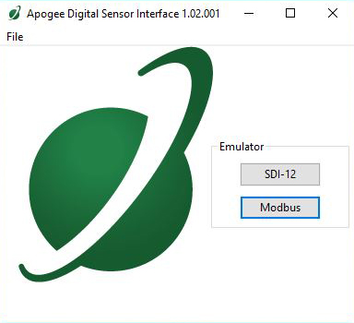

Operation and Measurement
Wire up to green block (AC-422) and plug in.
Wiring Configurations

Below is an example wiring configuration of Apogee Modbus sensors. Please see your respective sensor’s product manual to find the correct wiring configuration for your sensor as wiring configurations come in two variations depending on the protocol.

Wiring
White: RS-232 RX / RS-485 Positive
Blue: RS-232 TX / RS-485 Negative
Green: Select (Switch between RS-232 and RS-485)
Black: Ground
Red: Power +12 V
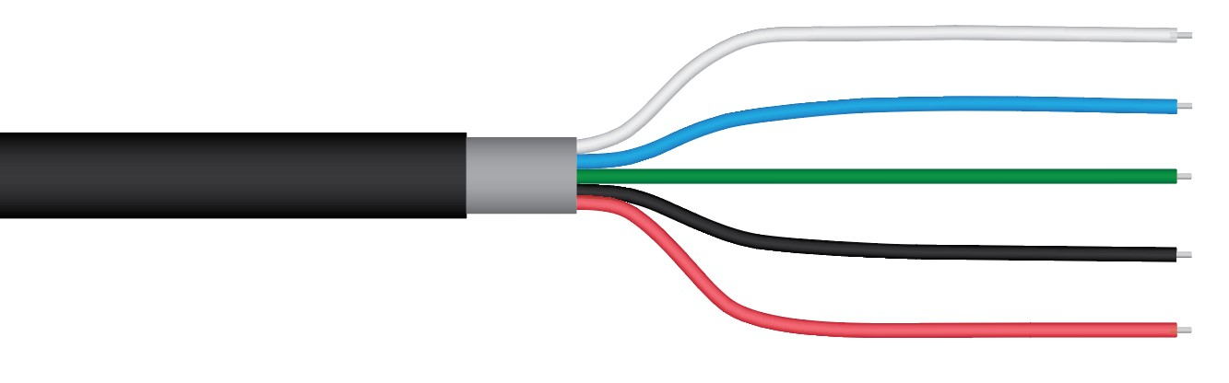

The Green wire should be connected to Ground to enable RS-485 communication, or it should be connected to 12 V power for RS-232 communication. Text for the White and Blue wires above refers to the port that the wires should be connected to.

Modbus intro

Overview

The primary idea of the Modbus interface is that each sensor exists at an address and appears as a table of values. These values are called Registers. Each value in the table has an associated index, and that index is used to identify which value in the table is being accessed.
Register Index

Each register in a sensor represents a value in the sensor, such as a measurement or a configuration parameter. Some registers can only be read, some registers can only be written, and some can be both read and written. Each register exists at a specified index in the table for the sensor. Often this index is called an address, which is a separate address than the sensor address, but can be easily confused with the sensor address.

However, there are two different indexing schemes used for Modbus sensors, though translating between them is simple. One indexing scheme is called one-based numbering, where the first register is given the index of 1, and is thereby accessed by requesting access to register 1. The other indexing scheme is called zero-based numbering, where the first register is given the index 0, and is thereby accessed by requesting access to register 0. Apogee Sensors use zero-based numbering. However, if using the sensor in a system that uses one-based numbering, such as using a CR1000X logger, adding 1 to the zero-based address will produce the one-based address for the register.

Register Format:

According to the Modbus protocol specification, Holding Registers (the type registers Apogee sensors contain) are defined to be 16 bits wide. However, when making scientific measurements, it is desirable to obtain a more precise value than 16 bits allows. Thus, several Modbus implementations will use two 16-bit registers to act as one 32-bit register. Apogee Modbus sensors use this 32-bit implementation to provide measurement values as 32-bit IEEE 754 floating point numbers.

Apogee Modbus sensors also contain a redundant, duplicate set of registers that use 16-bit signed integers to represent values as decimal-shifted numbers. It is recommended to use the 32-bit values, if possible, as they contain more precise values.
Communication Parameters:

Apogee Sensors communicate using the Modbus RTU variant of the Modbus protocol. The default communication parameters are as follows:

Slave address: 1
Baudrate: 19200
Data bits: 8
Stop bits: 1
Parity: Even
Byte Order: Big-Endian (most significant byte sent first)
The baudrate and slave address are user configurable. Valid slave addresses are 1 to 247. Setting the slave address to 255 will trigger a reset event, and all settings will revert back to the original default, which is slave address 1 (i.e. if a sensor with a slave address of 5 is changed to 0, it will revert to slave address 1). (This will also reset factory-calibrated values and should NOT be done by the user unless otherwise instructed.)

Maintenance and Recalibration

Keep dry and free of dust. There is no need to send back for calibration as it only converts digital signals and doesn’t actually measure anything.

Troubleshooting and Customer Support

Startup Options
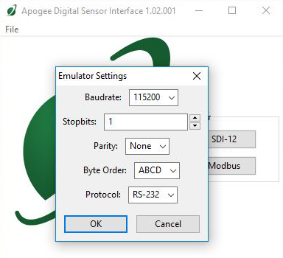
Startup Drop-down Menu
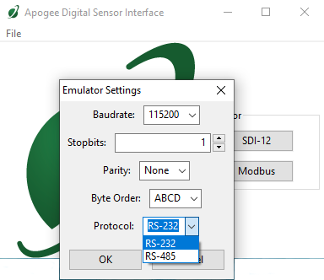

Modbus Screen
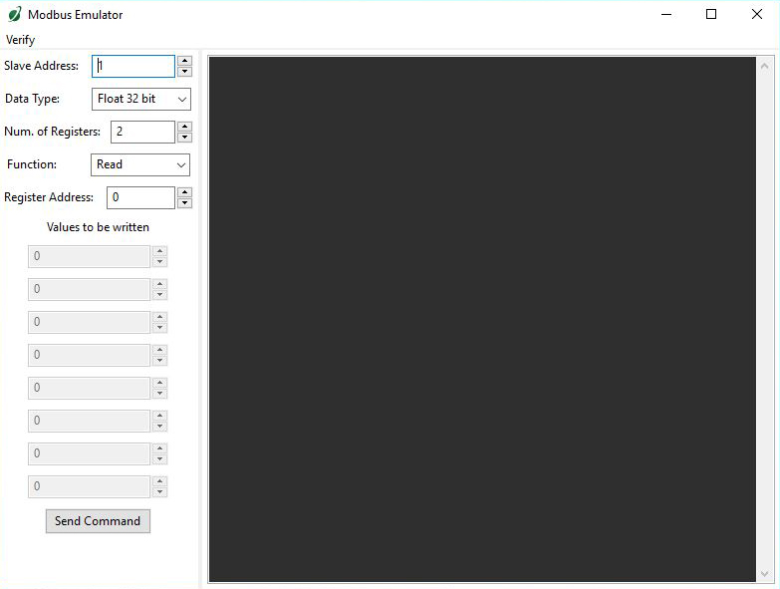

Bit Drop-down Menu – Select Between Float 32 Bit or Integer 16 Bit
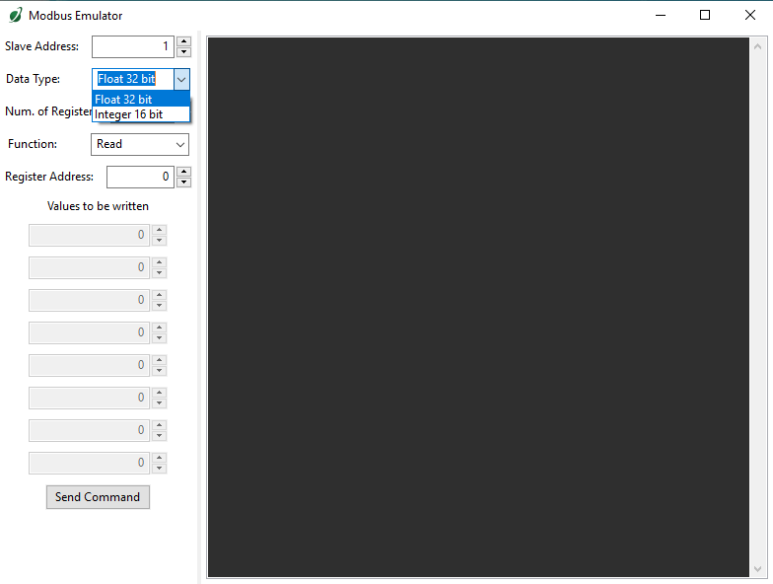
Read/Write Drop-down Menu – Toggle Between Read and Write Functions
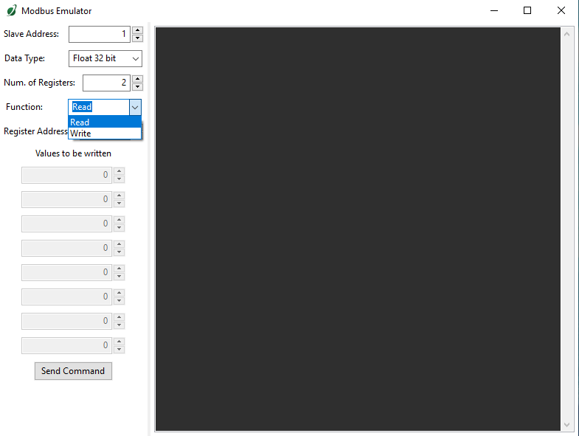

Slave Address
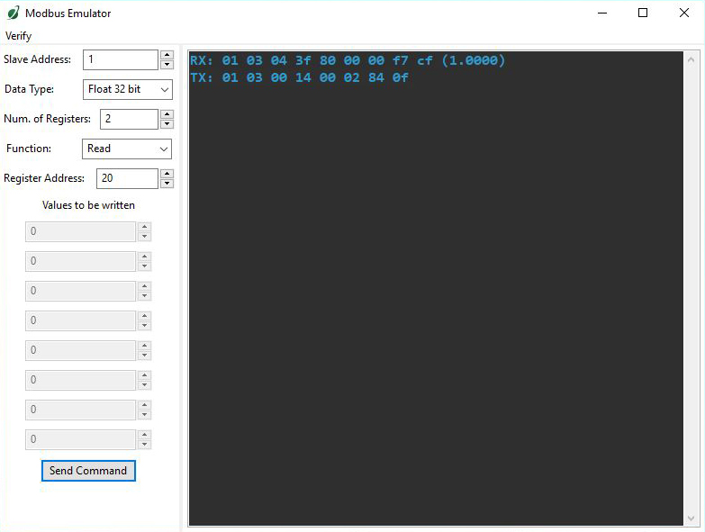
Modbus No Communication Error
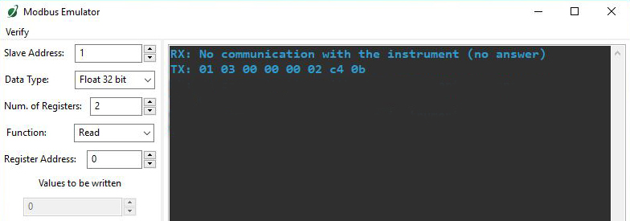
Solutions: [1] Check wiring and protocol [2] Unplug and then plug AC-422 back in.

Not Enough Bytes Error
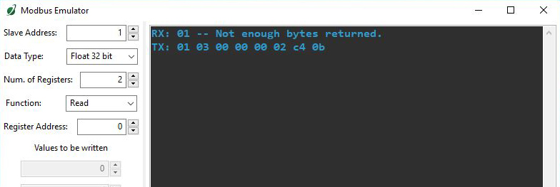
Solutions: [1] Check wiring and protocol [2] Unplug and then plug AC-422 back in.

Successful 16-bit Measurement
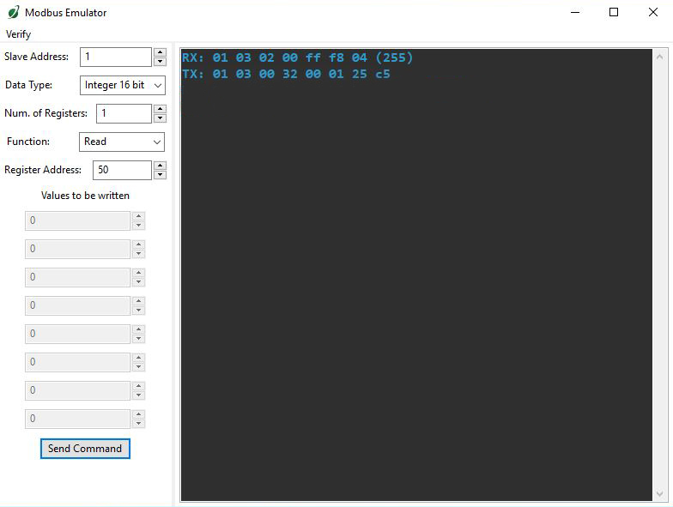

Successful 16-bit Write
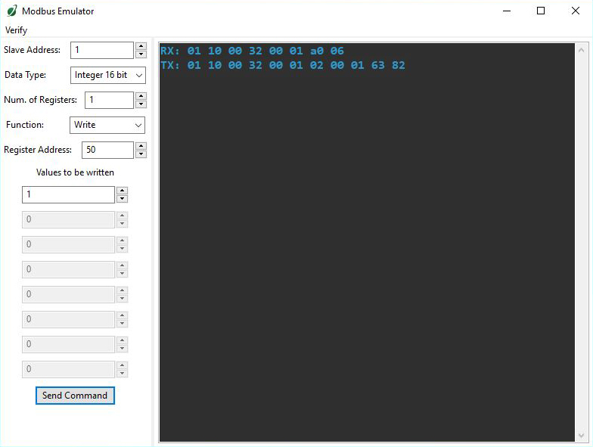
Successful 32-bit Measurement
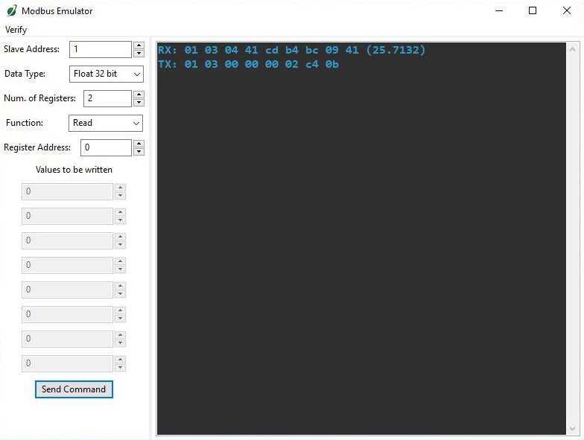

Successful 32-bit Write
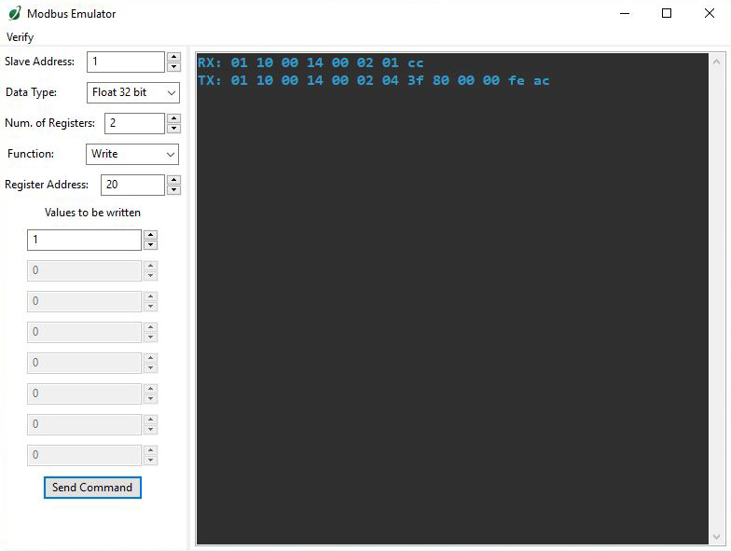

Return and Warranty Policy

RETURN POLICY
Apogee Instruments will accept returns within 30 days of purchase as long as the product is in new condition (to be determined by Apogee). Returns are subject to a 10 % restocking fee.

WARRANTY POLICY
What is Covered
All products manufactured by Apogee Instruments are warranted to be free from defects in materials and craftsmanship for a period of four (4) years from the date of shipment from our factory. To be considered for warranty coverage an item must be evaluated either at our factory or by an authorized distributor.
Products not manufactured by Apogee (spectroradiometers, chlorophyll content meters, EE08-SS probes) are covered for a period of one (1) year.
What is Not Covered
The customer is responsible for all costs associated with the removal, reinstallation, and shipping of suspected warranty items to our factory.
The warranty does not cover equipment that has been damaged due to the following conditions:
1. Improper installation or abuse.
2. Operation of the instrument outside of its specified operating range.
3. Natural occurrences such as lightning, fire, etc.
4. Unauthorized modification.
5. Improper or unauthorized repair.
Please note that nominal accuracy drift is normal over time. Routine recalibration of sensors/meters is considered part of proper maintenance and is not covered under warranty.
Who is Covered
This warranty covers the original purchaser of the product or other party who may own it during the warranty period.
What Apogee Will Do
At no charge Apogee will:
1. Either repair or replace (at our discretion) the item under warranty.
2. Ship the item back to the customer by the carrier of our choice.
Different or expedited shipping methods will be at the customer’s expense.
How To Return An Item
1. Please do not send any products back to Apogee Instruments until you have received a Return Merchandise Authorization (RMA) number from our technical support department by calling (435) 245-8012 or by submitting an online RMA form at www.apogeeinstruments.com/tech-support-recalibration-repairs/. We will use your RMA number for tracking of the service item.
2. Send all RMA sensors and meters back in the following condition: Clean the sensor’s exterior and cord. Do not modify the sensors or wires, including splicing, cutting wire leads, etc. If a connector has been attached to the cable end, please include the mating connector – otherwise the sensor connector will be removed in order to complete the repair/recalibration.
3. Please write the RMA number on the outside of the shipping container.
4. Return the item with freight pre-paid and fully insured to our factory address shown below. We are not responsible for any costs associated with the transportation of products across international borders.
5. Upon receipt, Apogee Instruments will determine the cause of failure. If the product is found to be defective in terms of operation to the published specifications due to a failure of product materials or craftsmanship, Apogee Instruments will repair or replace the items free of charge. If it is determined that your product is not covered under warranty, you will be informed and given an estimated repair/replacement cost.
Apogee Instruments, Inc.
721 West 1800 North Logan, UT
84321, USA

Products Beyond the Warranty Period
For issues with sensors beyond the warranty period, please contact Apogee at techsupport@apogeeinstruments.com to discuss repair or replacement options.

Other Terms
The available remedy of defects under this warranty is for the repair or replacement of the original product, and Apogee Instruments is not responsible for any direct, indirect, incidental, or consequential damages, including but not limited to loss of income, loss of revenue, loss of profit, loss of wages, loss of time, loss of sales, accruement of debts or expenses, injury to personal property, or injury to any person or any other type of damage or loss.
This limited warranty and any disputes arising out of or in connection with this limited warranty ("Disputes") shall be governed by the laws of the State of Utah, USA, excluding conflicts of law principles and excluding the Convention for the International Sale of Goods. The courts located in the State of Utah, USA, shall have exclusive jurisdiction over any Disputes.
This limited warranty gives you specific legal rights, and you may also have other rights, which vary from state to state and jurisdiction to jurisdiction, and which shall not be affected by this limited warranty. This warranty extends only to you and cannot by transferred or assigned. If any provision of this limited warranty is unlawful, void or unenforceable, that provision shall be deemed severable and shall not affect any remaining provisions. In case of any inconsistency between the English and other versions of this limited warranty, the English version shall prevail.
This warranty cannot be changed, assumed, or amended by any other person or agreement.
APOGEE INSTRUMENTS, INC. | 721 WEST 1800 NORTH, LOGAN, UTAH 84321, USA
TEL: (435) 792-4700 | FAX: (435) 787-8268 | WEB: APOGEEINSTRUMENTS.COM
Copyright © 2020 Apogee Instruments, Inc.

