

Owner’s Manual

EE08-SS Probe
Rev: 21-Sept-2021
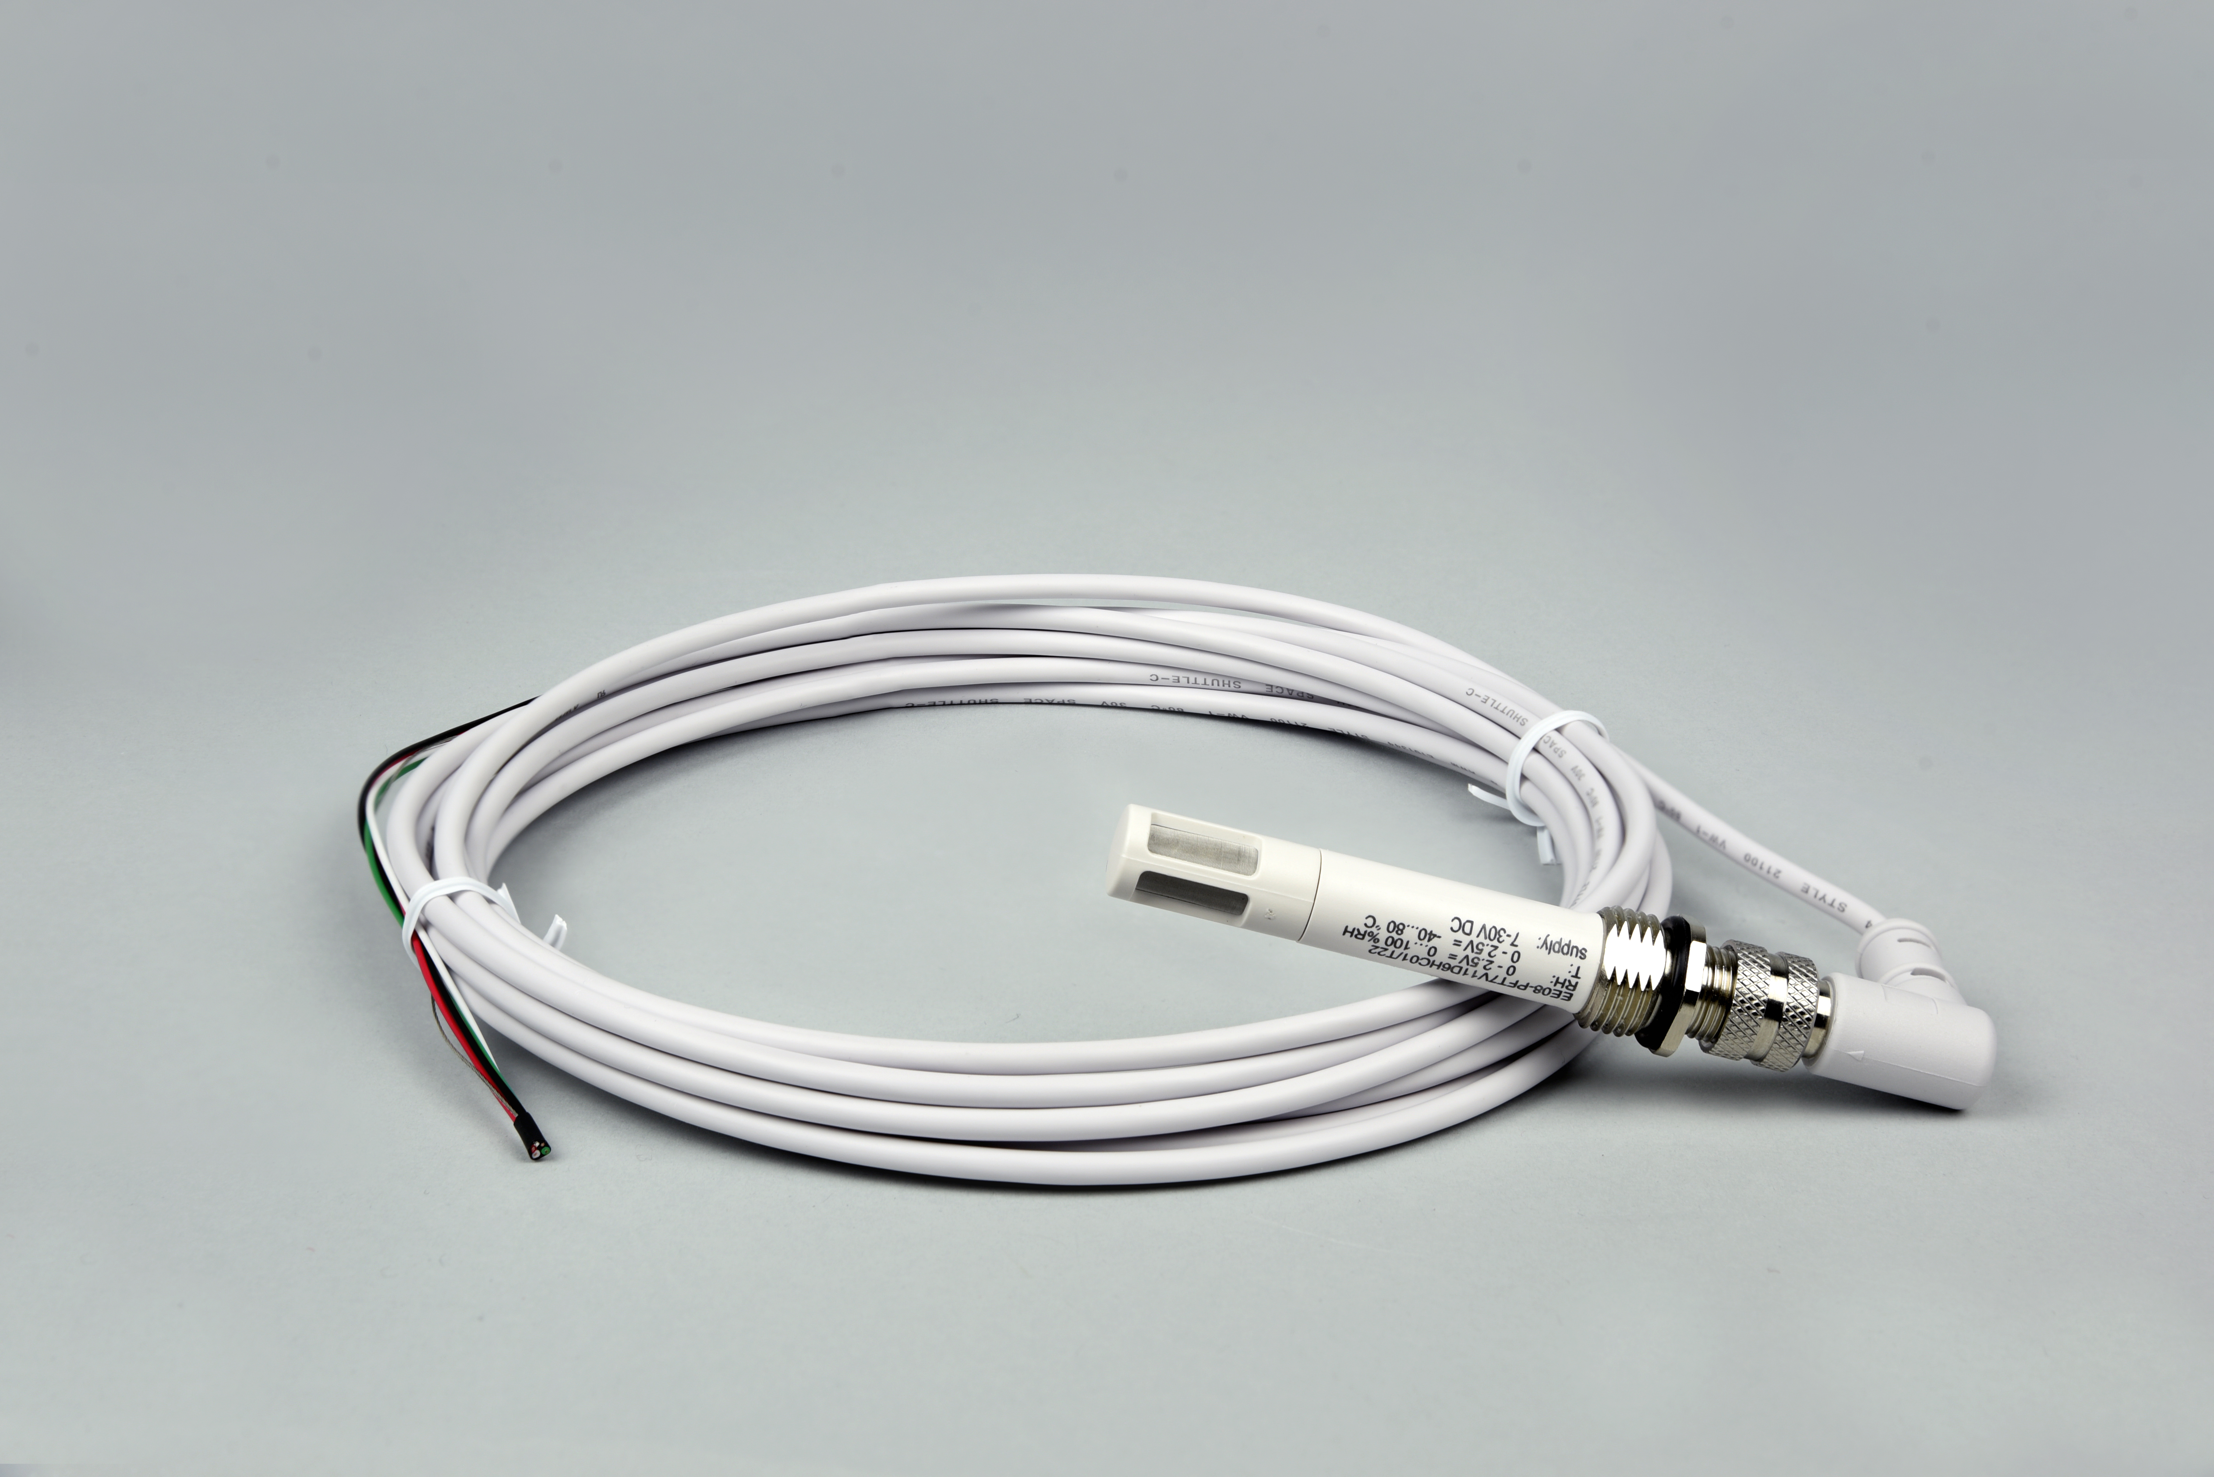
Table of Contents
Owner’s Manual 1
Certificate of Compliance 3
Introduction 4
Sensor Models 5
Specifications 6
Deployment and Installation 8
Operation and Measurement 9
Maintenance and Recalibration 11
Troubleshooting and Customer Support 12
Return and Warranty Policy 13

Certificate of Compliance

EU Declaration of Conformity
This declaration of conformity is issued under the sole responsibility of the manufacturer:
Apogee Instruments, Inc.
721 W 1800 N
Logan, Utah 84321
USA
for the following product(s):

Models: EE08-SS
Type: Temperature and Relative Humidity Probe

The object of the declaration described above is in conformity with the relevant Union harmonization legislation:

2014/30/EU Electromagnetic Compatibility (EMC) Directive
2011/65/EU Restriction of Hazardous Substances (RoHS 2) Directive
2015/863/EU Amending Annex II to Directive 2011/65/EU (RoHS 3)

Standards referenced during compliance assessment:

EN 61326-1:2013 Electrical equipment for measurement, control and laboratory use – EMC requirements
EN 50581:2012 Technical documentation for the assessment of electrical and electronic products with respect to the restriction of hazardous substances

Please be advised that based on the information available to us from our raw material suppliers, the products manufactured by us do not contain, as intentional additives, any of the restricted materials including lead (see note below), mercury, cadmium, hexavalent chromium, polybrominated biphenyls (PBB), polybrominated diphenyls (PBDE), bis (2-ethylhexyl) phthalate (DEHP), butyl benzyl phthalate (BBP), dibutyl phthalate (DBP), and diisobutyl phthalate (DIBP). However, please note that articles containing greater than 0.1% lead concentration are RoHS 3 compliant using exemption 6c.

Further note that Apogee Instruments does not specifically run any analysis on our raw materials or end products for the presence of these substances, but we rely on the information provided to us by our material suppliers.

Signed for and on behalf of:
Apogee Instruments, September 2021

Bruce Bugbee
President
Apogee Instruments, Inc.

Introduction
Air temperature and relative humidity (RH) are fundamental weather variables that characterize and quantify the state of the atmosphere. Properties of materials, and nearly all biological, chemical, and physical processes, are temperature dependent, and many are humidity dependent. Thus, temperature and relative humidity are two of the most widely measured environmental variables.
Electronic temperature sensors and humidity sensors are often combined into a single device, and are called temperature/RH probes. Typical applications of temperature/RH probes include measurements in weather networks, often for weather forecasting or as input variables required for calculation of evapotranspiration, and greenhouse monitoring and control.
The E + E Elektronik model EE08 temperature/RH probe consists of a PT1000 (1000 ohm) Class A platinum resistance thermometer (PRT), capacitive relative humidity element, and signal processing circuitry mounted in a rugged polycarbonate housing. The Apogee Instruments version of the EE08 (Apogee model number EE08-SS) includes a stainless steel cable connector. EE08 probes are designed for continuous air temperature and relative humidity measurements in indoor or outdoor environments. The EE08 outputs two analog voltage signals, one directly proportional to air temperature and the other directly proportional to RH.

Sensor Models
The EE08 air temperature/RH probe is manufactured by E + E Elektronik in Austria. The version sold by Apogee Instruments (Apogee model number EE08-SS) includes an M12 stainless steel connector and custom cable with a ninety degree connector that optimizes the fit of the probe inside the Apogee TS-100 fan-aspirated radiation shield. The EE08-SS offered by Apogee includes the proprietary coating from E + E Elektronik for the relative humidity sensing element that provides maximum long-term stability. Additionally, the temperature and RH sensing elements are protected by a stainless steel filter for maximum long-term stability.

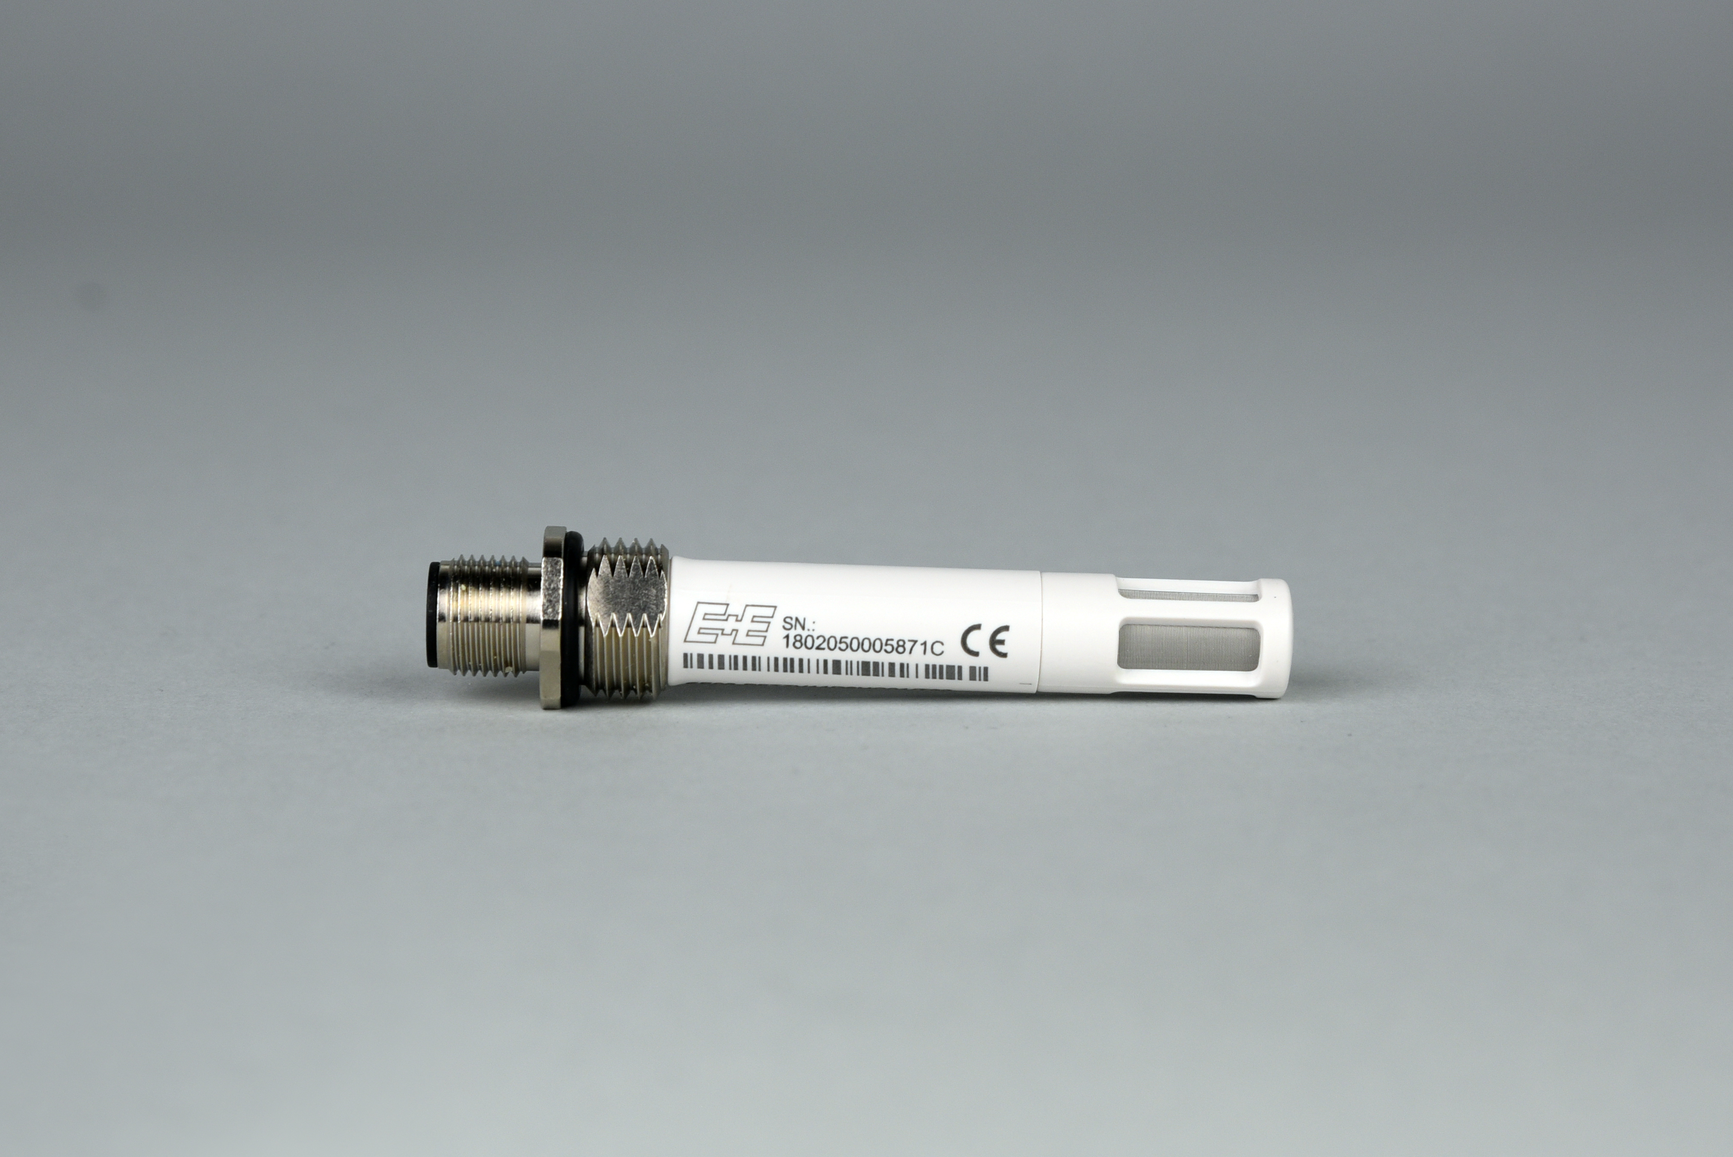
A sensor’s model number and serial number are located on the probe body between the connector and filter cap.

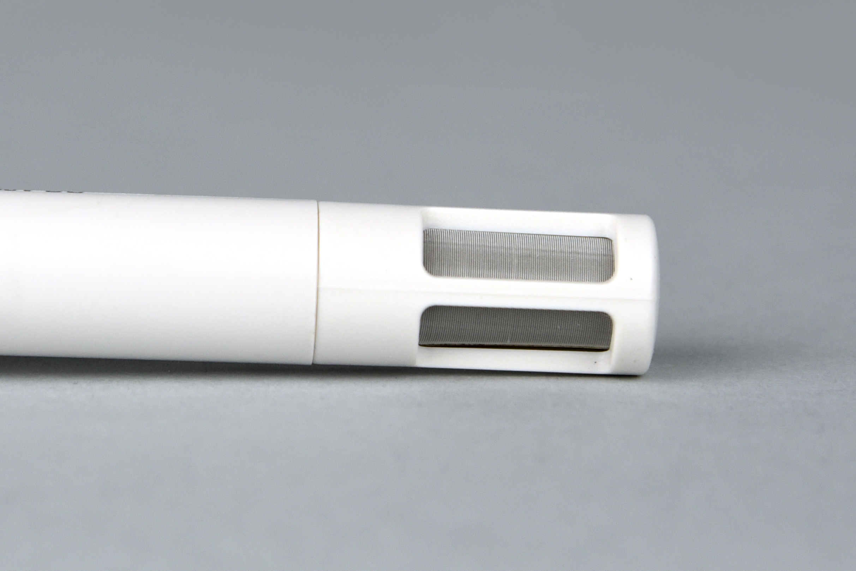
Sensor includes a stainless-steel filter for maximum long-term stability.

.

Specifications
 | EE08 Probe
Input Voltage | 7 to 30 V DC
Current Draw | Less than 1.3 mA
Start-up Time | 2 s
Housing | Polycarbonate, IP65
Filter | Stainless steel wire mesh, 30 micron pore size
Connector | M12, IP67
Dimensions | 83 mm length, 12 mm diameter
Mass with 5 m Cable | 270 g
Operating Environment | -40 to 80 C; 0 to 100 % relative humidity
Cable | M12 connector (IP67 rating) to interface to sensor housing, 5 m of four conductor, shielded, twisted-pair wire (10 m and 20 m cables also available), white TPR jacket (high water resistance, high UV stability, flexibility in cold conditions), pigtail lead wires
Warranty | 1 year against defects in materials and workmanship

Temperature Measurement |  | Relative Humidity Measurement
Sensor | PT1000 (Class A) | Sensor | Capacitance Chip
Measurement Range | -40 to 60 C | Measurement Range | 0 to 100 %
Output Signal Range | 0 to 2.5 V DC | Output Signal Range | 0 to 2.5 V DC
Slope | 0.04 C per mV | Slope | 0.04 % per mV
Intercept | -40 C | Intercept | 0.00 %
Accuracy at 20 C | ± 0.2 C | Accuracy at 20 C | ± 2 % RH from 0 to 90 %; ± 3 % RH from 90 to 100 %
Long-term Stability | Less than 0.1 C per year | Temperature Response | Less than -0.05 % per C
Time Constant | Less than 30 s | Long-term Stability | Less than 1 % per year
Accuracy Over Measurement Range | (see graph below) | Time Constant | Less than 30 s

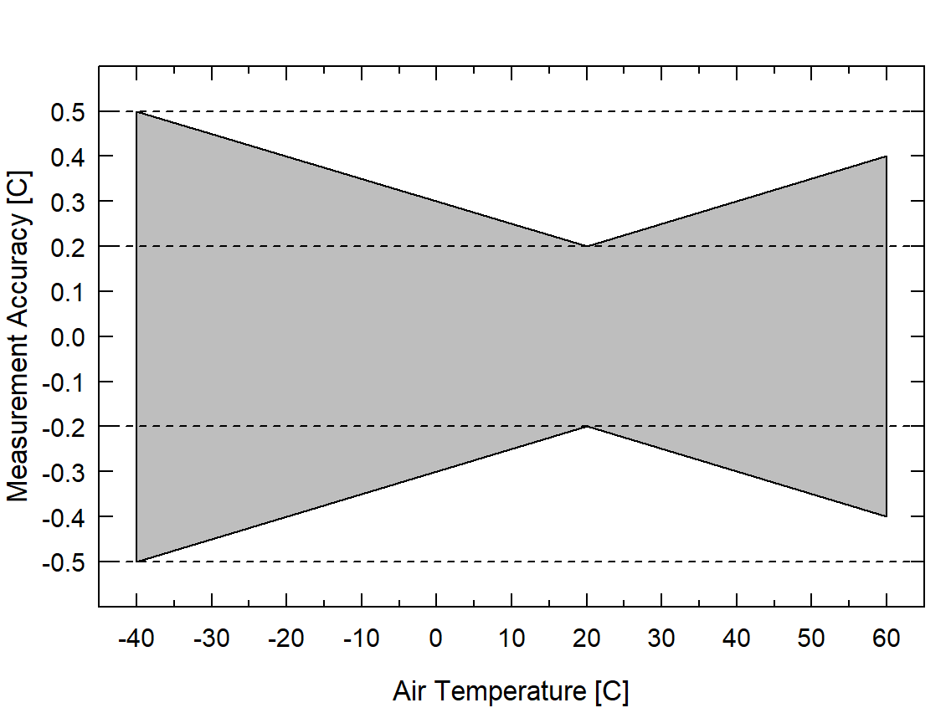Accuracy Over Measurement Range

Calibration Traceability
EE08 temperature/relative humidity probes are calibrated at the factory (E + E Elektronik in Austria) against standards traceable to international standard units administered by national metrology institutes (e.g., NIST, NPL, PTB, BEV). The calibration certificate for each probe is included in the box with the probe. An example is shown below.
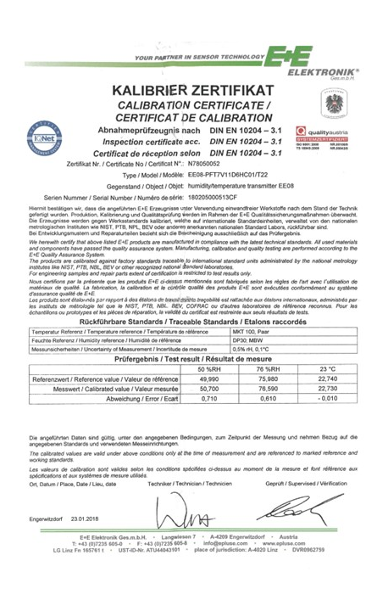

Deployment and Installation
The measurement returned by a temperature sensor is the temperature for the sensor itself and not that of the environment the sensor is in, unless the sensor is in thermal equilibrium with the environment. In order to get representative air temperature measurements, EE08 probes must be in thermal equilibrium with air. Accurate air temperature measurement requires a radiation shield to minimize the effects of shortwave radiation absorption (causes warming; occurs during the day) and longwave radiation emission (causes cooling; occurs on clear nights) by the sensor. Proper ventilation is also required to ensure coupling and thermal equilibrium with air.
Condensation on air temperature sensors can pose a problem because it is a source of latent heat that can warm the sensor. When the condensed water evaporates, it cools the sensor via removal of latent heat (evaporational cooling). Similar to air temperature measurements, accurate relative humidity measurements are dependent on the equilibration of the sensor with the air.
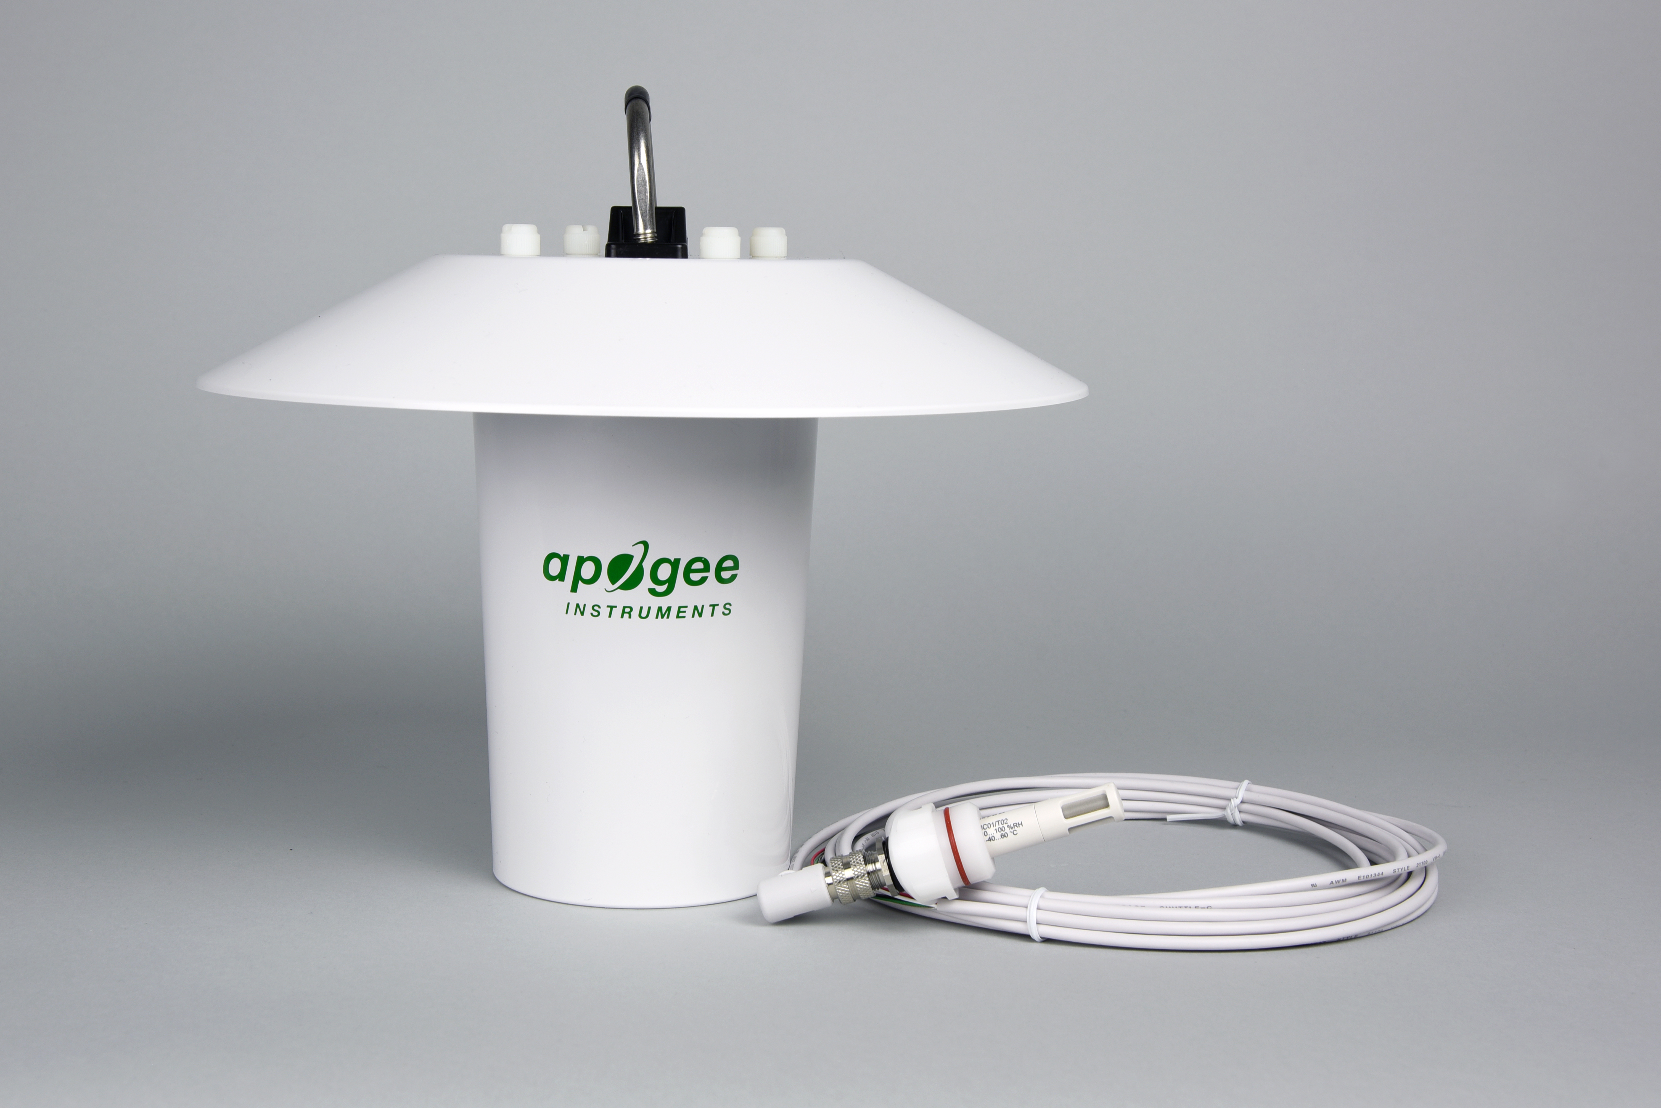The EE08 probe should be mounted inside a radiation shield. The Apogee version of the EE08 probe is optimized to fit inside the Apogee TS-100 fan-aspirated radiation shield using the ninety degree cable connector and custom port adapter (see photos below).

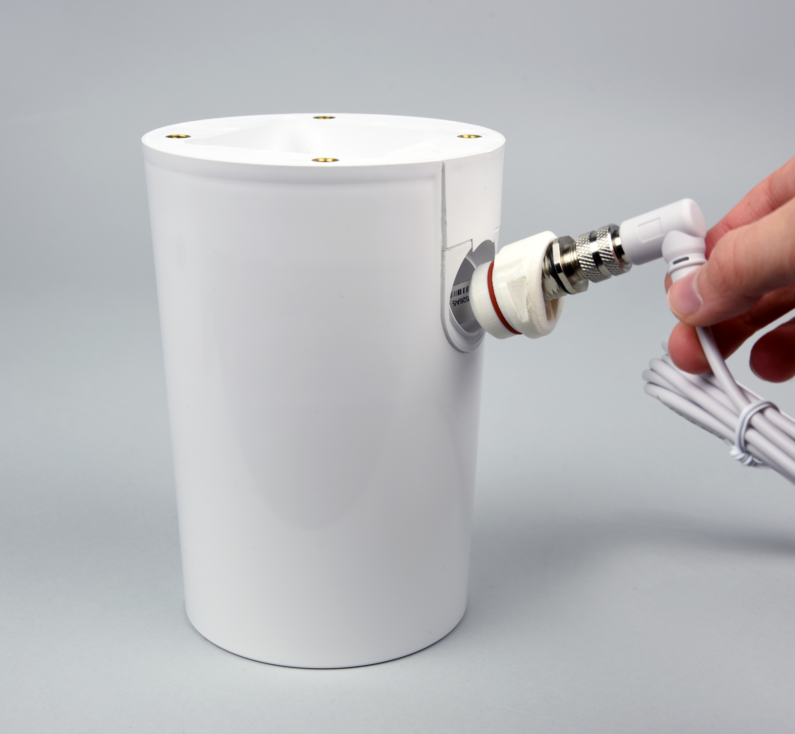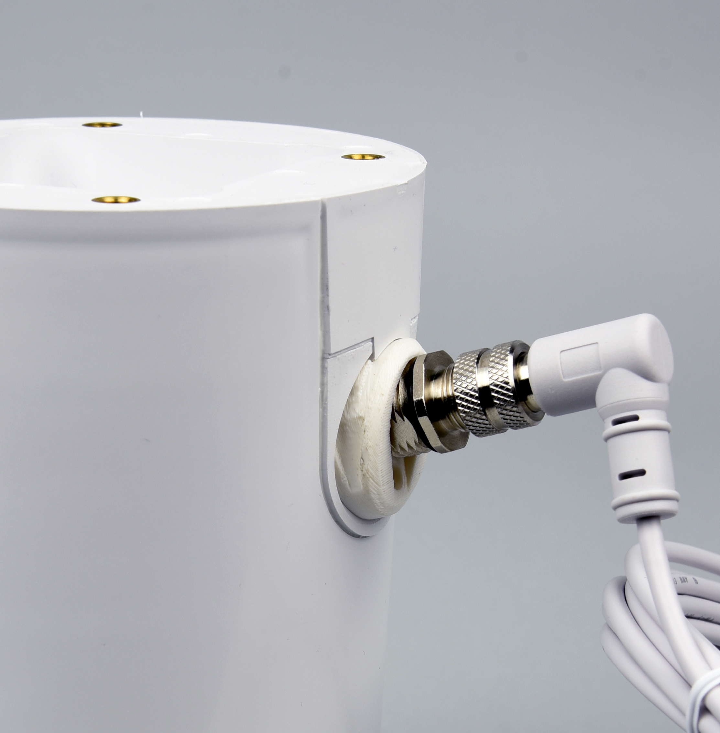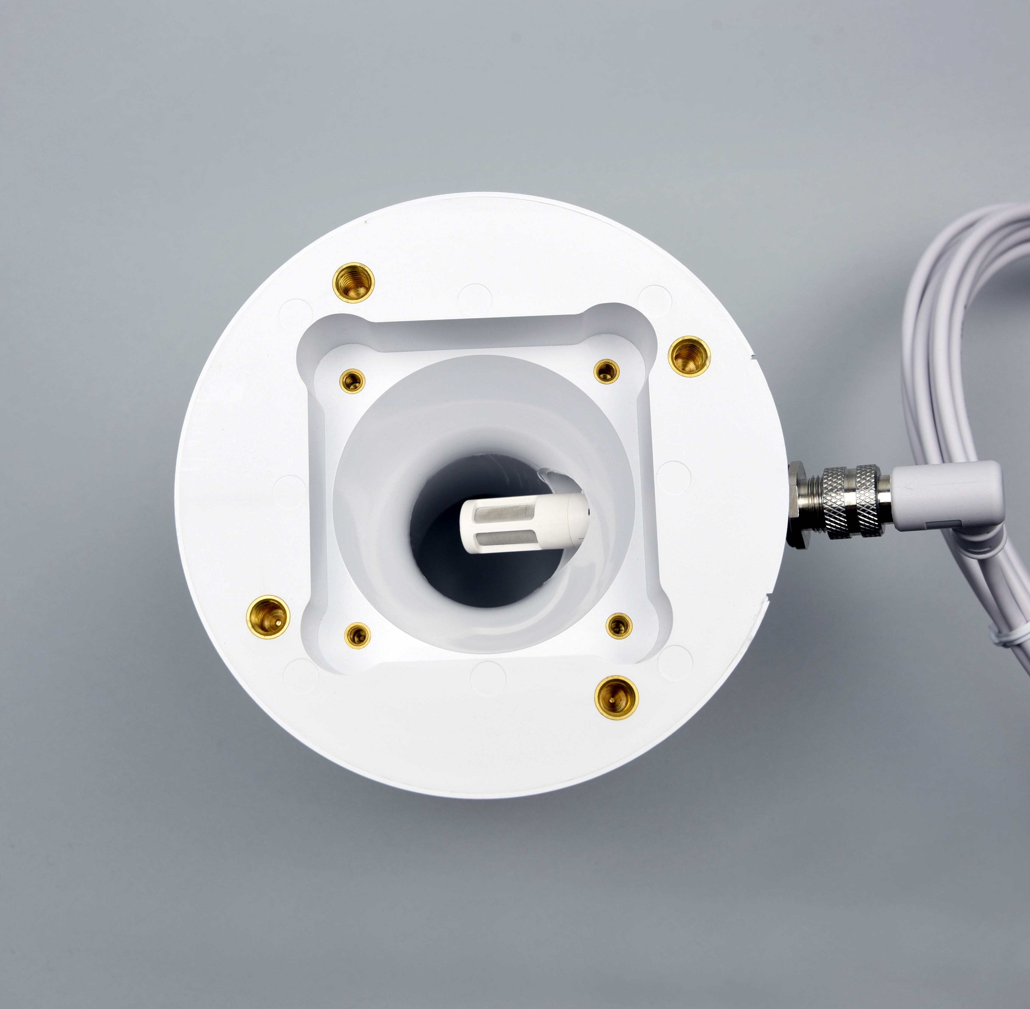
EE08 custom port adapter inside TS-100 fan-aspirated radiation shield.

Push the EE08 into adapter port.

EE08 mounted inside TS-100 fan-aspirated radiation shield.

Operation and Measurement

Connect the EE08 probe to a measurement device (meter, datalogger, controller) capable of inputting 7 to 30 V DC, and measuring and displaying or recording a millivolt (mV) signal. An input measurement range of 0 to 2500 mV is required to cover the entire air temperature and relative humidity range of the probe. In order to maximize measurement resolution and signal-to-noise ratio, the input range of the measurement device should closely match the output range of the probe. To increase measurement accuracy, the black wire (ground) should be connected to a signal ground rather than a power ground.

White: Single-ended channel (signal output by relative humidity sensor)
Green: Single-ended channel (signal output by air temperature sensor)
Red: Input voltage (7 to 30 V DC)
Black: Signal Ground
Clear: Signal Ground (shield)

Wiring for EE08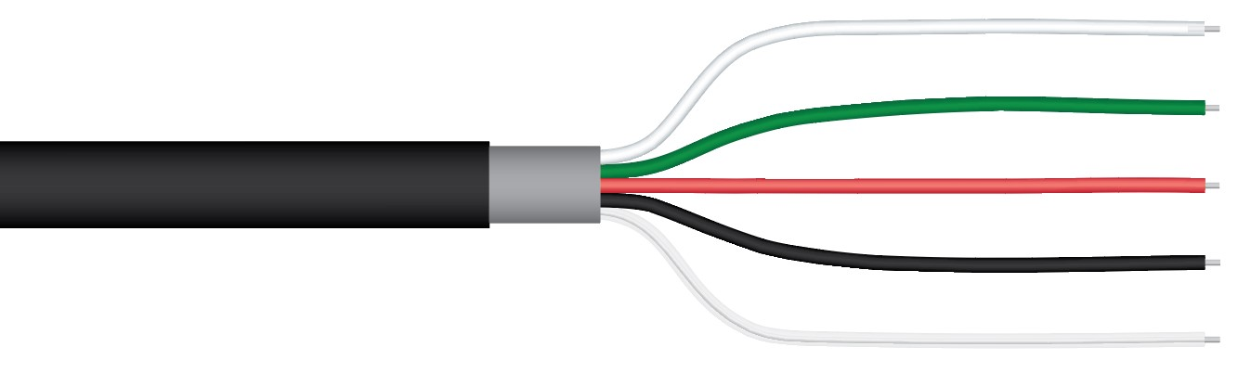

Sensor Calibration
All versions of EE08 probes sold by Apogee Instruments have generic calibration factors for air temperature and relative humidity.
Air temperature:
Slope = 0.04 C per mV
Intercept = -40 C
Relative Humidity:
Slope = 0.04 % per mV
Intercept = 0.00 %
Multiply the measured voltage signals from the sensors by the slopes and add the intercepts to convert output voltages to air temperature and relative humidity:

Air temperature example:
Slope (0.04 C per mV) X Sensor output signal (mV) + Intercept (C) = Air temperature (C)
0.04 X 1500 + -40 = 20
Relative humidity example:
Slope (0.04 % per mV) X Sensor output signal (mV) + Intercept (%) = Relative humidity (%)
0.04 X 1250 + 0 = 50
Air temperatures in Celsius can be converted to Fahrenheit or Kelvin with the following equations:
Fahrenheit = 1.8* Celsuis + 32
Kelvin = Celsius + 273.15

Relative Humidity and Amount of Water Vapor in the Air
The EE08 probe measures relative humidity, which is the amount of water vapor currently in the air expressed as a fraction or percentage of the amount of water vapor the air can hold. Oftentimes, absolute humidity (mass of water vapor in a given mass of air or given volume of air) or the partial pressure of water vapor in air is the required variable (e.g., in biophysical applications, like calculation of evapotranspiration). Mathematically, relative humidity is the ratio of the partial pressure of water vapor in the air (ea, often expressed in kPa) to the partial pressure of water vapor in the air if the air were saturated, called the saturation vapor pressure (es, often expressed in kPa):
RH = 100 (ea / es)
The factor 100 in the equation expresses RH as a percentage. A measurement of RH can be converted to ea by rearranging the equation above and inputting es. Saturation vapor pressure (es) is dependent on air temperature, increasing as temperature increases. Multiple equations are available for calculating es from air temperature. A commonly used equation valid for a wide temperature range (-20 to 50 C) comes from Buck (1981):
es = 0.61121exp[17.502Ta / (Ta + 240.97)]
where Ta is air temperature in units of C and es is in units of kPa (units of mb are obtained by multiplying by 10).
Dewpoint temperature, the temperature to which air must cool to be saturated with water vapor or the temperature to which the air must cool to reach 100 % RH, is also a useful variable. Dewpoint temperature (Tdew) can be calculated from ea:
Tdew = [240.97ln(ea / 0.61121)] / [17.502 – ln(ea / 0.61121)]
where ea is in units of kPa and Tdew is in units of C.
Buck, A.L., 1981. New equations for computing vapor pressure and enhancement factor. Journal of Applied Meteorology 20:1527-1532.

Maintenance and Recalibration
EE08 probes are rugged and weatherproof and designed for air temperature and relative humidity measurements inside radiation shields. When probes are not in use, it is recommended they be removed from the measurement environment, cleaned, and stored. EE08 probes, especially the filter cap, should be periodically cleaned to remove all dust and debris. Additional filter caps are available from Apogee to replace clogged filter caps. For more information about filter cap replacement, call or email Apogee technical support: 435.245.8012, techsupport@apogeeinstruments.com.
EE08 probes are factory calibrated and preprogrammed and come with a generic calibration factor (see Sensor Calibration in OPERATION AND MEASUREMENT section). A custom calibration can be derived by comparing the air temperature or relative humidity measurements from the probe to reference air temperature or relative humidity measurements. Probes can also be recalibrated at the factory. Recalibration is recommended every two years. Recalibration information is found on the Apogee webpage: https://www.apogeeinstruments.com/recalibration-and-repairs/. Questions about recalibration can be emailed to: calibration@apogeeinstruments.com.
Cleaning instructions:
The metal grid filter on the EE08 probe is designed to keep the temperature and relative humidity detectors free of dust and particles. However, dust can accumulate on this filter and hinder air flow to the detectors, which slows down the response time. To clean the EE08 probe, use one of the following methods:
- Remove the filter from the probe and rinse it off in running water. If the dust on the filter is stubborn, use a cotton swab to remove the stubborn dust particles from the filter. Allow the filter to air dry for at least 30 minutes.
Note: The detector under the filter is very fragile, handle the probe with extreme care when the filter is removed.
- Swish the entire probe in isopropyl alcohol, then rinse off with deionized water. Allow the probe to air dry for at least 30 minutes.
If the filter is still dirty after trying both of the above methods, please contact Apogee Instruments for a replacement.

Troubleshooting and Customer Support
Independent Verification of Functionality
EE08 probes output voltage signals linearly proportional to air temperature and relative humidity. A quick and easy check of probe functionality can be accomplished with a voltmeter and 9 V battery. Connect the red wire from the probe to the positive terminal on the 9 V battery, and connect the black wire from the probe to the negative terminal on the 9 V battery. Connect the positive lead wire of the voltmeter to the green wire from the probe and the negative lead wire of the voltmeter to the black wire from the probe. The voltage measurement should be 1.5 V DC at 20 C and 1.625 V DC at 25 C (20 to 25 C is the approximate room temperature range). Move the positive lead wire of the voltmeter to the white wire from the probe. The voltage measurement should be 0.5 V DC at 20 %, 1.25 V DC at 50 %, and 2.0 V DC at 80 %.

Compatible Measurement Devices (Dataloggers/Controllers/Meters)
Operation of the EE08 requires a voltage input of 7 to 30 V DC. Measurement of the output signals requires a single-ended voltage measurement over a range of 0 to 2.5 V DC. A compatible measurement device should have the capability to supply and measure these voltages.
The sensitivity of the air temperature sensor (voltage output from sensor per degree C) is 25 mV per C (reciprocal of the slope listed in the OPERATION AND MEASUREMENT section). This means a voltage measurement resolution of 2.5 mV is required to yield an air temperature measurement resolution of 0.1 C, and 0.25 mV is required to yield an air temperature measurement resolution of 0.01 C. The sensitivity of the relative humidity sensor (voltage output from sensor per % RH) is 25 mV per % (reciprocal of the slope listed in the OPERATION AND MEASUREMENT section). This means a voltage measurement resolution of 2.5 mV is required to yield a relative humidity measurement resolution of 0.1 % C, and 0.25 mV is required to yield a relative humidity measurement resolution of 0.01 %.
An example datalogger program for Campbell Scientific dataloggers can be found on the Apogee webpage at: https://www.apogeeinstruments.com/content/EplusE-EE08-Temp-RH-Probe.CR1

Modifying Cable Length
Standard Apogee cable lengths for the EE08 are 5 m, 10 m, and 20 m. If a length greater than 20 m is required, additional cable can be spliced onto a standard cable. See Apogee webpage for details on how to extend sensor cable length (https://www.apogeeinstruments.com/how-to-make-a-weatherproof-cable-splice/). For cable extensions, shielded, twisted-pair cable is recommended, in order to minimize electromagnetic interference. This is particularly important for long lead lengths in electromagnetically noisy environments. However, additional cable adds resistance and may influence the accuracy of the measurement.

Return and Warranty Policy

RETURN POLICY
Apogee Instruments will accept returns within 30 days of purchase as long as the product is in new condition (to be determined by Apogee). Returns are subject to a 10 % restocking fee.

WARRANTY POLICY
What is Covered
All products manufactured by Apogee Instruments are warranted to be free from defects in materials and craftsmanship for a period of four (4) years from the date of shipment from our factory. To be considered for warranty coverage an item must be evaluated by Apogee.
Products not manufactured by Apogee (spectroradiometers, chlorophyll content meters, EE08-SS probes) are covered for a period of one (1) year.
What is Not Covered
The customer is responsible for all costs associated with the removal, reinstallation, and shipping of suspected warranty items to our factory.
The warranty does not cover equipment that has been damaged due to the following conditions:
1. Improper installation or abuse.
2. Operation of the instrument outside of its specified operating range.
3. Natural occurrences such as lightning, fire, etc.
4. Unauthorized modification.
5. Improper or unauthorized repair.
Please note that nominal accuracy drift is normal over time. Routine recalibration of sensors/meters is considered part of proper maintenance and is not covered under warranty.
Who is Covered
This warranty covers the original purchaser of the product or other party who may own it during the warranty period.
What Apogee Will Do
At no charge Apogee will:
1. Either repair or replace (at our discretion) the item under warranty.
2. Ship the item back to the customer by the carrier of our choice.
Different or expedited shipping methods will be at the customer’s expense.

How To Return An Item
1. Please do not send any products back to Apogee Instruments until you have received a Return Merchandise Authorization (RMA) number from our technical support department by submitting an online RMA form at www.apogeeinstruments.com/tech-support-recalibration-repairs/. We will use your RMA number for tracking of the service item. Call (435) 245-8012 or email techsupport@apogeeinstruments.com with questions.
2. For warranty evaluations, send all RMA sensors and meters back in the following condition: Clean the sensor’s exterior and cord. Do not modify the sensors or wires, including splicing, cutting wire leads, etc. If a connector has been attached to the cable end, please include the mating connector – otherwise the sensor connector will be removed in order to complete the repair/recalibration. Note: When sending back sensors for routine calibration that have Apogee’s standard stainless-steel connectors, you only need to send the sensor with the 30 cm section of cable and one-half of the connector. We have mating connectors at our factory that can be used for calibrating the sensor.
3. Please write the RMA number on the outside of the shipping container.
4. Return the item with freight pre-paid and fully insured to our factory address shown below. We are not responsible for any costs associated with the transportation of products across international borders.
Apogee Instruments, Inc.
721 West 1800 North Logan, UT
84321, USA
5. Upon receipt, Apogee Instruments will determine the cause of failure. If the product is found to be defective in terms of operation to the published specifications due to a failure of product materials or craftsmanship, Apogee Instruments will repair or replace the items free of charge. If it is determined that your product is not covered under warranty, you will be informed and given an estimated repair/replacement cost.

Products Beyond the Warranty Period
For issues with sensors beyond the warranty period, please contact Apogee at techsupport@apogeeinstruments.com to discuss repair or replacement options.

Other Terms
The available remedy of defects under this warranty is for the repair or replacement of the original product, and Apogee Instruments is not responsible for any direct, indirect, incidental, or consequential damages, including but not limited to loss of income, loss of revenue, loss of profit, loss of data, loss of wages, loss of time, loss of sales, accruement of debts or expenses, injury to personal property, or injury to any person or any other type of damage or loss.
This limited warranty and any disputes arising out of or in connection with this limited warranty ("Disputes") shall be governed by the laws of the State of Utah, USA, excluding conflicts of law principles and excluding the Convention for the International Sale of Goods. The courts located in the State of Utah, USA, shall have exclusive jurisdiction over any Disputes.
This limited warranty gives you specific legal rights, and you may also have other rights, which vary from state to state and jurisdiction to jurisdiction, and which shall not be affected by this limited warranty. This warranty extends only to you and cannot by transferred or assigned. If any provision of this limited warranty is unlawful, void or unenforceable, that provision shall be deemed severable and shall not affect any remaining provisions. In case of any inconsistency between the English and other versions of this limited warranty, the English version shall prevail.
This warranty cannot be changed, assumed, or amended by any other person or agreement
APOGEE INSTRUMENTS, INC. | 721 WEST 1800 NORTH, LOGAN, UTAH 84321, USA
TEL: (435) 792-4700 | FAX: (435) 787-8268 | WEB: APOGEEINSTRUMENTS.COM
Copyright © 2021 Apogee Instruments, Inc.

