

Owner’s Manual

Quantum Meter
Models MQ-100X and MQ-200X
Rev: 30-March-2022
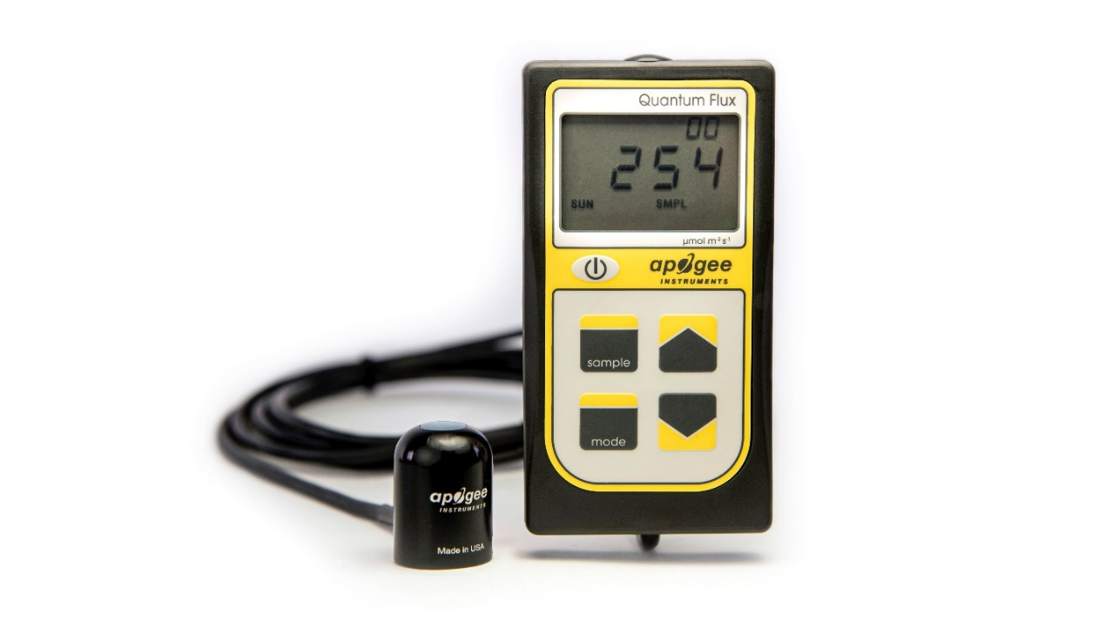
Table of Contents
Owner’s Manual 1
Certificate of Compliance 3
Introduction 4
Sensor Models 5
Specifications 6
Deployment and Installation 9
Battery Installation and Replacement 10
Operation and Measurement 11
Apogee AMS Software 15
Maintenance and Recalibration 17
Troubleshooting and Customer Support 19
Return and Warranty Policy 21

Certificate of Compliance

EU Declaration of Conformity
This declaration of conformity is issued under the sole responsibility of the manufacturer:
Apogee Instruments, Inc.
721 W 1800 N
Logan, Utah 84321
USA
for the following product(s):

Models: MQ-100X, MQ-200X
Type: Quantum Meter

The object of the declaration described above is in conformity with the relevant Union harmonization legislation:

2014/30/EU Electromagnetic Compatibility (EMC) Directive
2011/65/EU Restriction of Hazardous Substances (RoHS 2) Directive
2015/863/EU Amending Annex II to Directive 2011/65/EU (RoHS 3)

Standards referenced during compliance assessment:

EN 61326-1:2013 Electrical equipment for measurement, control, and laboratory use – EMC requirements
EN 50581:2012 Technical documentation for the assessment of electrical and electronic products with respect to the restriction of hazardous substances

Please be advised that based on the information available to us from our raw material suppliers, the products manufactured by us do not contain, as intentional additives, any of the restricted materials including lead (see note below), mercury, cadmium, hexavalent chromium, polybrominated biphenyls (PBB), polybrominated diphenyls (PBDE), bis (2-ethylhexyl) phthalate (DEHP), butyl benzyl phthalate (BBP), dibutyl phthalate (DBP), and diisobutyl phthalate (DIBP). However, please note that articles containing greater than 0.1 % lead concentration are RoHS 3 compliant using exemption 6c.

Further note that Apogee Instruments does not specifically run any analysis on our raw materials or end products for the presence of these substances, but we rely on the information provided to us by our material suppliers.

Signed for and on behalf of:
Apogee Instruments, March 2022

Bruce Bugbee
President
Apogee Instruments, Inc.

Introduction
Radiation that drives photosynthesis is called photosynthetically active radiation (PAR) and is typically defined as total radiation across a range of 400 to 700 nm. PAR is often expressed as photosynthetic photon flux density (PPFD): photon flux in units of micromoles per square meter per second (µmol m⁻² s⁻¹, equal to microEinsteins per square meter per second) summed from 400 to 700 nm (total number of photons from 400 to 700 nm). While Einsteins and micromoles are equal (one Einstein = one mole of photons), the Einstein is not an SI unit, so expressing PPFD as µmol m⁻² s⁻¹ is preferred.
The acronym PPF is also widely used and refers to the photosynthetic photon flux. The acronyms PPF and PPFD refer to the same variable. The two terms have co-evolved because there is not a universal definition of the term “flux”. Some physicists define flux as per unit area per unit time. Others define flux only as per unit time. We have used PPFD in this manual because we feel that it is better to be more complete and possibly redundant.
Sensors that measure PPFD are often called quantum sensors due to the quantized nature of radiation. A quantum refers to the minimum quantity of radiation, one photon, involved in physical interactions (e.g., absorption by photosynthetic pigments). In other words, one photon is a single quantum of radiation.
Typical applications of quantum sensors include incoming PPFD measurement over plant canopies in outdoor environments or in greenhouses and growth chambers and reflected or under-canopy (transmitted) PPFD measurement in the same environments.
Apogee Instruments MQX series quantum meters consist of a handheld meter and a dedicated quantum sensor that is integrated into the top of the meter housing (MQ-100X) or connected by cable to an anodized aluminum housing (MQ-200X). Integrated and separate sensors consist of a cast acrylic diffuser (filter), photodiode, and are potted solid with no internal air space. MQX series quantum meters provide a real-time PPFD reading on the LCD display and offer measurements that determine the radiation incident on a planar surface (does not have to be horizontal), where the radiation emanates from all angles of a hemisphere. MQX series quantum meters include manual and automatic data logging features for making spot-check measurements or calculating daily light integral (DLI).

Sensor Models
Apogee MQX series quantum meters covered in this manual are self-contained and come complete with handheld meter and sensor.
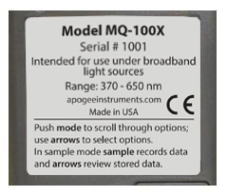
A sensor’s model number and serial number are located on a label on the backside of the handheld meter.

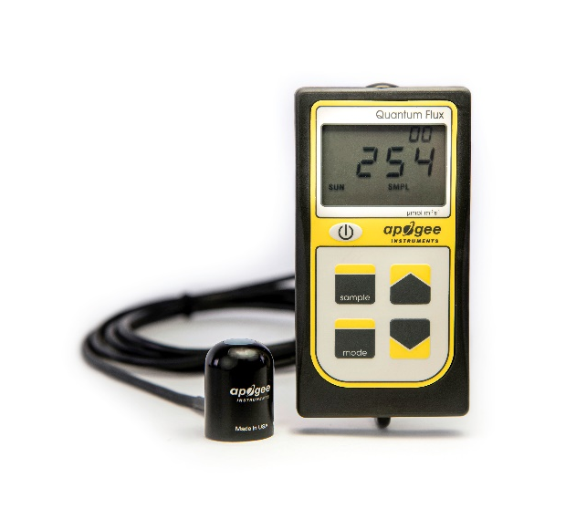
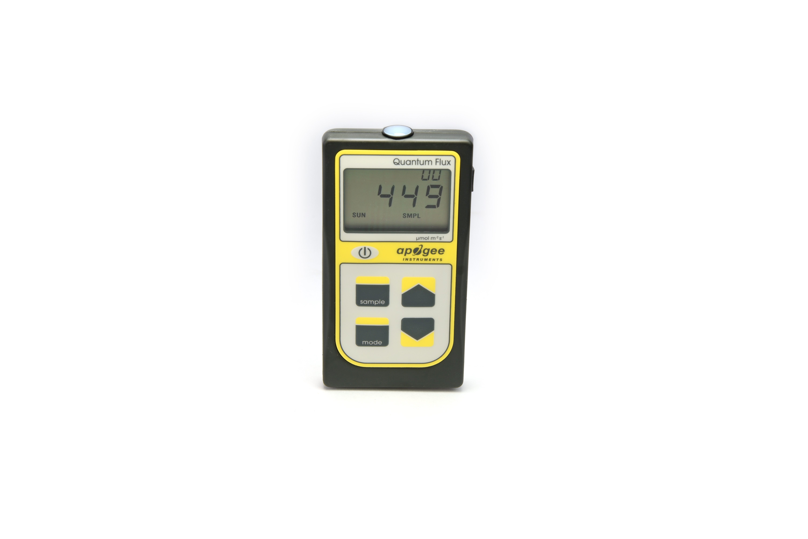

MQ-100X:
Meter w/ integral sensor
MQ-200X:
Meter w/ separate sensor

Specifications
 | MQ-100X | MQ-200X
Calibration Uncertainty | ± 5 % (see calibration Traceability below)
Measurement Repeatability | Less than 1 %
Long-term Drift  (Non-stability) | Less than 2 % per year
Non-linearity | Less than 1 % (up to 2500 µmol m⁻² s⁻¹)
Response Time | Less than 1 ms
Field of View | 180°
Spectral Range | 370 to 650 nm (wavelengths where response is greater than 50 % of maximum; see Spectral Response below)
Directional (Cosine) Response | ± 5 % at 75° zenith angle (see Cosine Response below)
Temperature Response | -0.04 % per C (see Temperature Response below)
Operating Environment | 0 to 50 C; less than 90 % non-condensing relative humidity up to 30 C; less than 70 % non-condensing relative humidity from 30 to 50 C; separate sensors can be submerged in water up to depths of 30 m
Meter Dimensions | 126 mm length; 70 mm width; 24 mm height
Sensor Dimensions | Integrated w/ Meter | 24 mm diameter; 33 mm height
Mass | 150 g | 180 g
Cable | 2 m of two conductor, shielded, twisted pair wire; TPR jacket (high water resistance, high UV stability, flexibility in cold conditions)

Calibration Traceability
Apogee MQX series quantum meters are calibrated through side-by-side comparison to the mean of four transfer standard quantum sensors under a reference lamp. The reference quantum sensors are recalibrated with a 200 W quartz halogen lamp traceable to the National Institute of Standards and Technology (NIST).

Spectral Response
Mean spectral response of four MQ-100x series quantum sensors compared to PPFD weighting function. Spectral response measurements were made at 10 nm increments across a wavelength range of 350 to 800 nm in a monochromator with an attached electric light source. Measured spectral data from each quantum sensor were normalized by the measured spectral response of the monochromator/electric light combination, which was measured with a spectroradiometer.

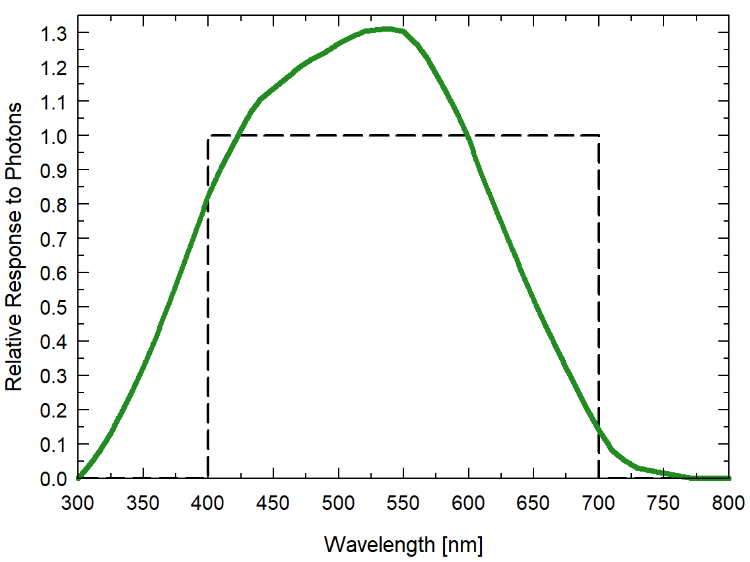

Cosine Response
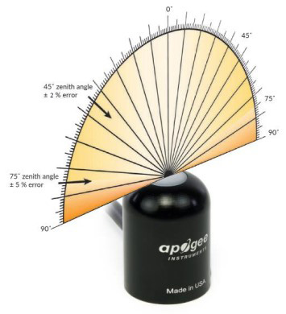
Directional, or cosine, response is defined as the measurement error at a specific angle of radiation incidence. Error for Apogee MQ-100X series quantum sensors is approximately ± 2 % and ± 5 % at solar zenith angles of 45° and 75°, respectively.

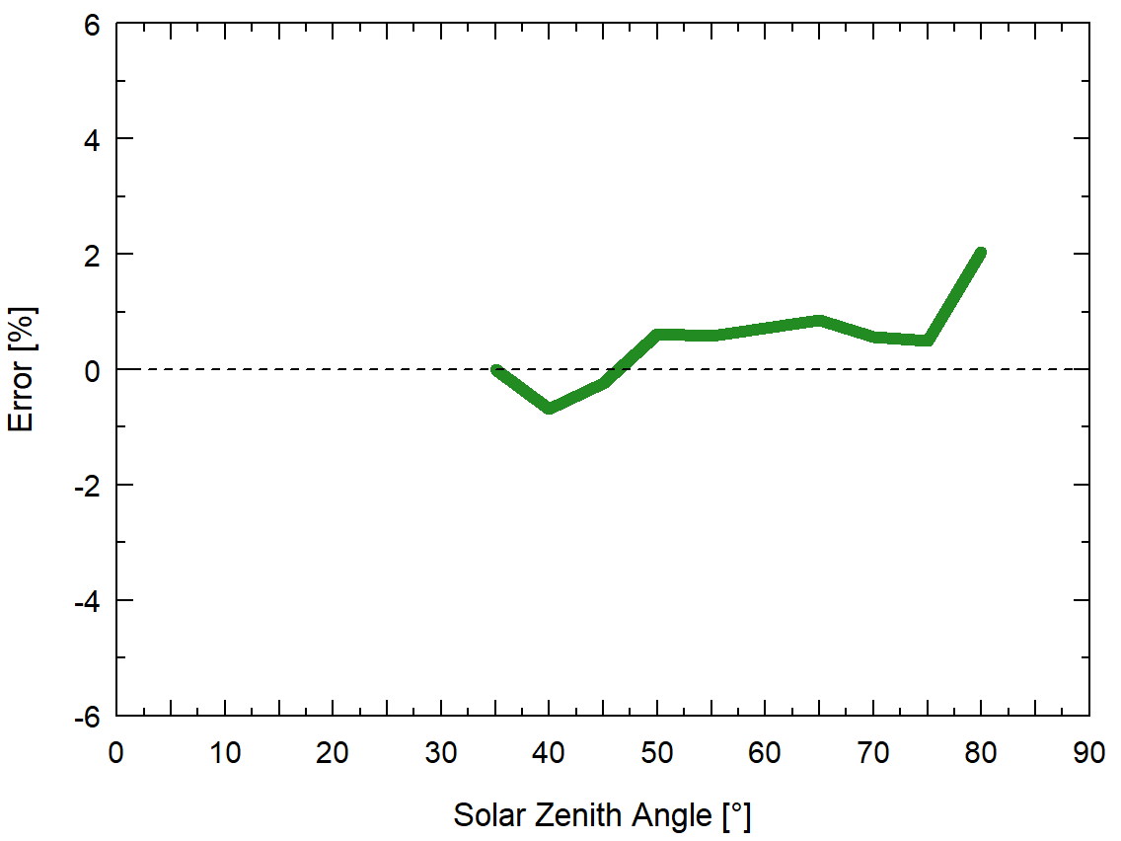
Mean cosine response of five MQ-100X series quantum sensors. Cosine response measurements were made by direct side-by-side comparison to the mean of seven reference SQ-500 quantum sensors.

Deployment and Installation
Apogee MQX series quantum meters are designed for spot-check measurements, and calculation of daily light integral (DLI; total number of photons incident on a planar surface over the course of a day) through the built-in logging feature. To accurately measure PFFD incident on a horizontal surface, the sensor must be level. For this purpose, each MQX model comes with a different option for mounting the sensor to a horizontal plane.
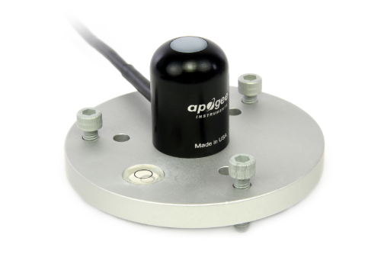
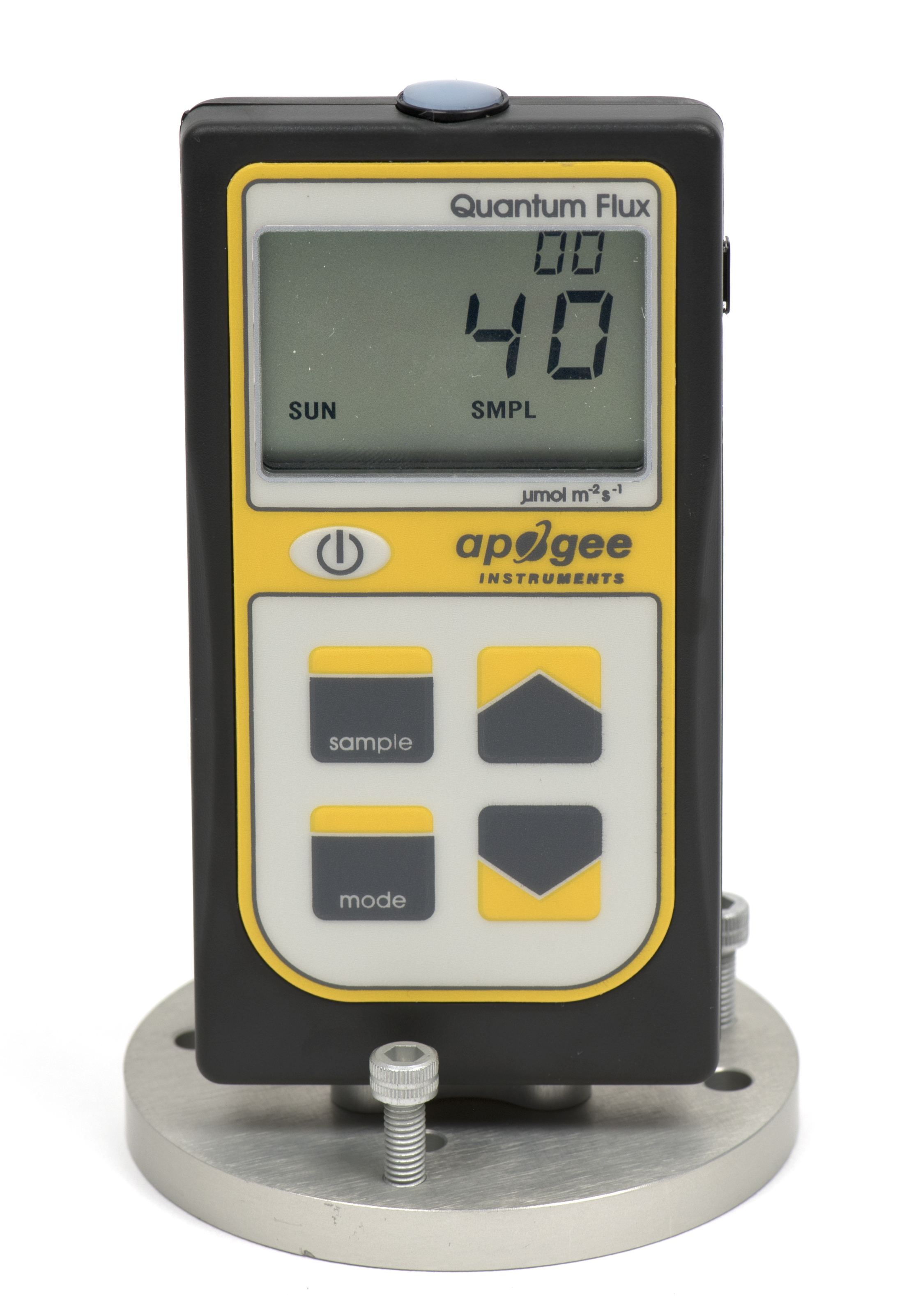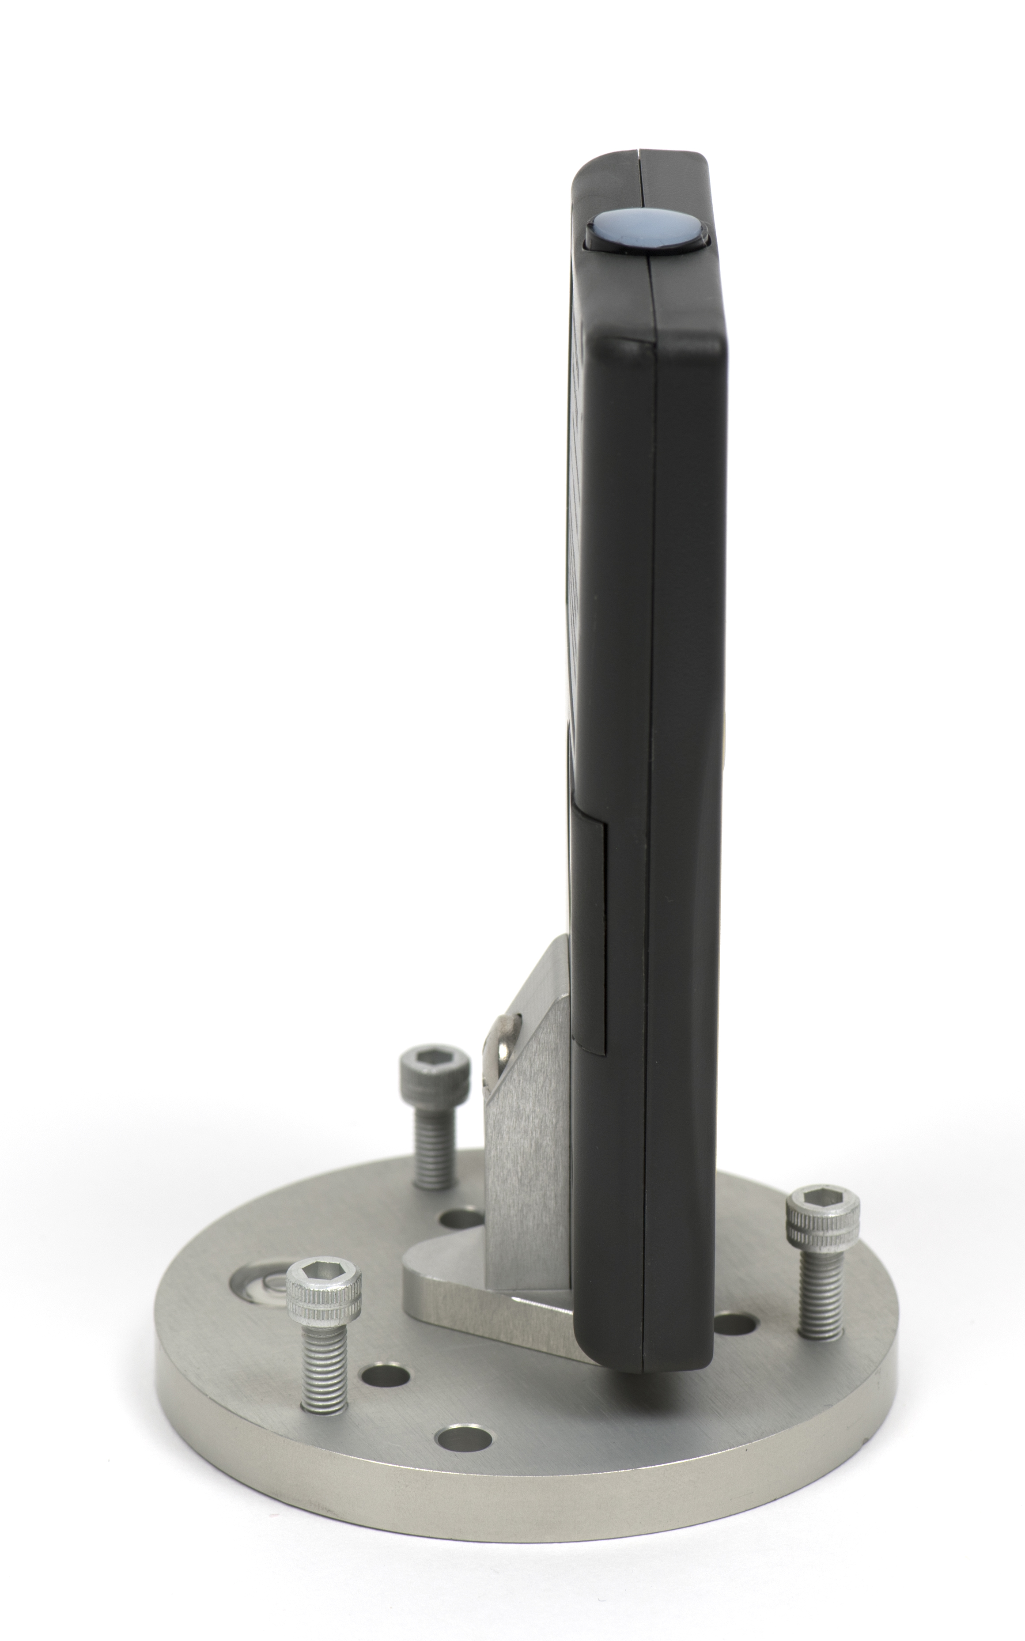
The AL-100 leveling plate is recommended for use with the MQ-200X. To facilitate mounting to a cross arm, the AL-120 mounting bracket is recommended.
The AL-210 leveling plate is recommended for use with the MQ-100X.

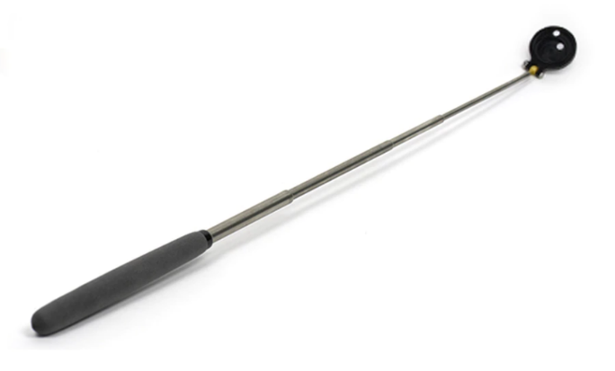
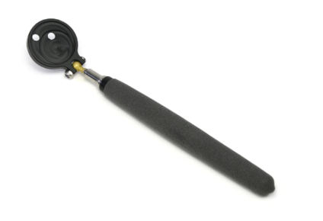
The AM-310 Sensor Wand accessory incorporates a mounting fixture at the end of an extendable telescopic wand (up to 33 inches/84 cm). The wand is not suited for wet environments; however, it is excellent for greenhouses and growth chambers. Its ability to retract to a smaller size also makes it ideal for travel use.

AM-310 Extendable Sensor Wand

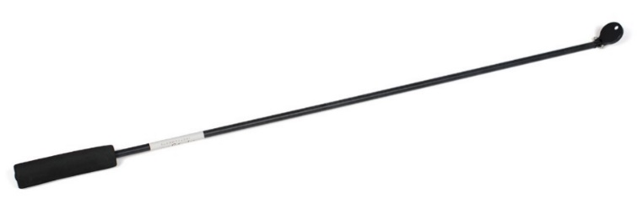
The AM-320 Saltwater Submersible Sensor Wand accessory incorporates a mounting fixture at the end of a 40-inch segmented fiberglass wand and is well-suited for saltwater use. The wand allows the user to place the sensor in hard-to-reach areas such as aquariums.
AM-320 Saltwater Submersible Sensor Wand

NOTE: The handheld meter portion of the instrument is not waterproof. Do not get the meter wet or leave the meter in high humidity environments for prolonged periods of time. Doing so can lead to corrosion that could void the warranty.

Battery Installation and Replacement
Use a Phillips head screwdriver to remove the screw from the battery cover. Remove the battery cover by slightly lifting and sliding the outer edge of the cover away from the meter.
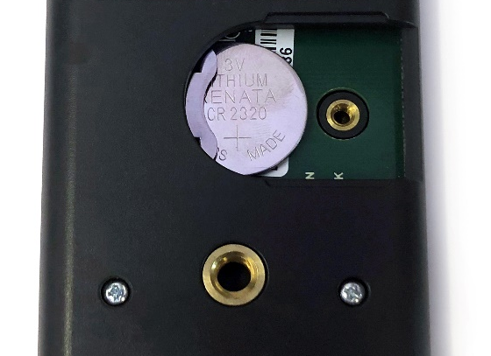
To power the meter, slide the included battery (CR2320) into the battery holder, after removing the battery door from the meter’s back panel.
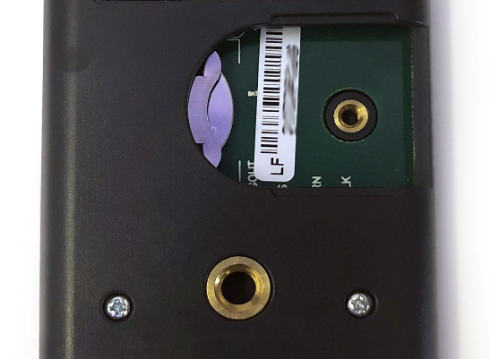
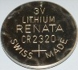

The positive side (designated by a “+” sign) should be facing out from the meter circuit board.
NOTE: The battery cradle can be damaged by using an incorrectly sized battery. If the battery cradle is damaged, the circuit board will need to be replaced and the warranty will be void. To avoid this costly problem, use only a CR2320 battery.

Battery Removal
Press down on the battery with a screwdriver or similar object. Slide battery out.
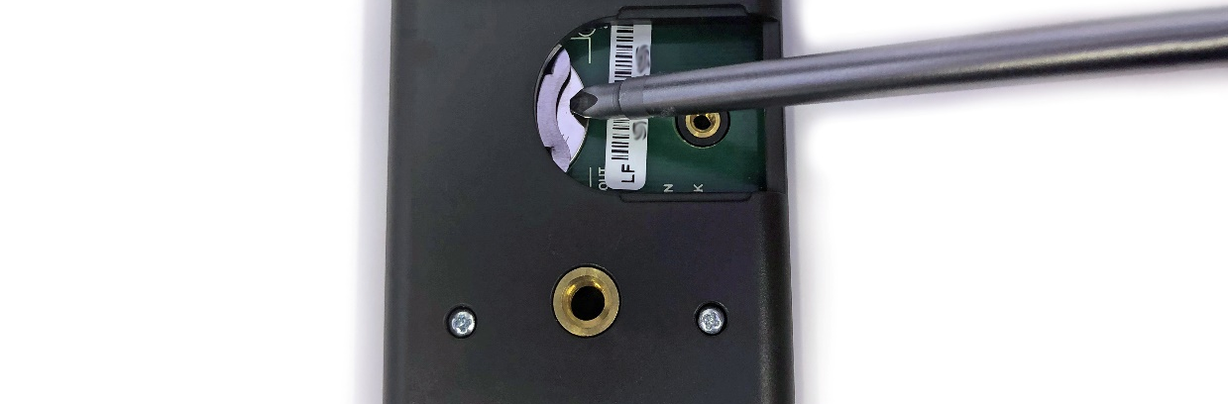
If the battery is difficult to move, turn the meter on its side so that the opening for the battery is facing downward and tap the meter downward against an open palm to dislodge the battery enough so that it can be removed with your thumb to slide the battery out of the battery holder.

Operation and Measurement
MQX series quantum meters are designed with a user-friendly interface allowing quick and easy measurements.
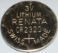 To power the meter, slide the included battery (CR2320) into the battery holder, after removing the battery door from the meter’s back panel. The positive side (designated by a “+” sign) should be facing out from the meter circuit board.
 Press the power button to activate the LCD display. After two minutes of non-activity the meter will revert to sleep mode and the display will shut off to conserve battery life.
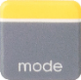 Press the mode button to access the main menu, where manual or automatic logging are selected, and where the meter can be reset.
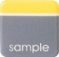 Press the sample button to log a reading while taking manual measurements.
 Press the up button to make selections in the main menu. This button is also used to view and scroll through the logged measurements on the LCD display.
 Press the down button to make selections in the main menu. This button is also used to view and scroll through the logged measurements on the LCD display.
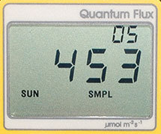
The LCD display consists of the total number of logged measurements in the upper right-hand corner, the real-time PPFD value in the center, and the selected menu options along the bottom.
Logging: To choose between manual or automatic logging, push the mode button once and use the up/down buttons to make the appropriate selection (SMPL or LOG). Once the desired mode is blinking, press the mode button two more times to exit the menu. When in SMPL mode press the sample button to record up to 99 manual measurements (a counter in the upper right-hand corner of the LCD display indicates the total number of saved measurements). When in LOG mode the meter will power on/off to make a measurement every 30 seconds. Every 30 minutes the meter will average the sixty 30 second measurements and record the averaged value to memory. The meter can store up to 99 averages and will start to overwrite the oldest measurement once there are 99 measurements. Every 48 averaged measurements (making a 24-hour period), the meter will also store an integrated daily total in moles per meter squared per day (mol m⁻² d⁻¹).
Reset: To reset the meter, in either SMPL or LOG mode, push the mode button three times (RUN should be blinking), then while pressing the down button, press the mode button once. This will erase all of the saved measurements in memory, but only for the selected mode. That is, performing a reset when in SMPL mode will only erase the manual measurements and performing a reset when in LOG mode will only erase the automatic measurements.
Review/Download Data: Each of the logged measurements in either SMPL or LOG mode can be reviewed on the LCD display by pressing the up/down buttons. To exit and return to the real-time readings, press the sample button. Note that the integrated daily total values are not accessible through the LCD and can only be viewed by downloading to a computer.
Downloading the stored measurements will require the AC-100 communication cable and software (sold separately). The meter outputs data using the UART protocol and requires the AC-100 to convert from UART to USB, so standard USB cables will not work. Set up instructions and software can be downloaded from the Apogee website (http://www.apogeeinstruments.com/ac-100-communcation-cable/).

Spectral Errors
Apogee SQ-100X series sensors can measure PPFD for sunlight and electric light with a single calibration factor. However, errors occur in various light sources due to changes in spectral output. If the light source spectrum is known, then errors can be estimated and used to adjust the measurements. The weighting function for PPFD is shown in the graph below, along with the spectral response of Apogee SQ-100X series quantum sensors. The closer the spectral response matches the defined PPFD spectral weighting functions, the smaller spectral errors will be. The table below provides spectral error estimates for PPFD measurements from light sources different than the calibration source. The method of Federer and Tanner (1966) was used to determine spectral errors based on the PPFD spectral weighting functions, measured sensor spectral response, and radiation source spectral outputs (measured with a spectroradiometer). This method calculates spectral error and does not consider calibration, cosine, and temperature errors.
Federer, C. A., and C. B. Tanner, 1966. Sensors for measuring light available for photosynthesis. Ecology 47:654-657.
McCree, K. J., 1972. The action spectrum, absorptance and quantum yield of photosynthesis in crop plants. Agricultural Meteorology 9:191-216.

Spectral Errors for PPFD Measurements with Apogee SQ-100x and SQ-500 Series Quantum Sensors
Radiation Source (Error Calculated Relative to Sun, Clear Sky) | SQ-100X Series  PPFD Error [%]
Sun (Clear Sky) | 0.0
Sun (Cloudy Sky) | 0.2
Reflected from Grass Canopy | 5.0
Transmitted below Wheat Canopy | 7.0
Cool White Fluorescent (T5) | 7.2
Metal Halide | 6.9
Ceramic Metal Halide | -8.8
High Pressure Sodium | 3.3
Blue LED (448 nm peak, 20 nm full-width half-maximum) | 14.5
Green LED (524 nm peak, 30 nm full-width half-maximum) | 29.6
Red LED (635 nm peak, 20 nm full-width half-maximum) | -30.9
Red LED (667 nm peak, 20 nm full-width half-maximum) | -56.7
Red, Blue LED Mixture (80 % Red, 20 % Blue) | -21.2
Red, Blue, White LED Mixture (60 % Red, 25 % White, 15 % Blue) | -29.7
Cool White LED | 7.3
Warm White LED | -7.8
Quantum sensors can be a very practical means of measuring PPFD and YPFD from multiple radiation sources, but spectral errors must be considered. The spectral errors in the table above can be used as correction factors for individual radiation sources.

Underwater Measurements and Immersion Effect
When a quantum sensor that was calibrated in air is used to make underwater measurements, the sensor reads low. This phenomenon is called the immersion effect and happens because the refractive index of water (1.33) is greater than air (1.00). The higher refractive index of water causes more light to be backscattered (or reflected) out of the sensor in water than in air (Smith,1969; Tyler and Smith,1970). As more light is reflected, less light is transmitted through the diffuser to the detector, which causes the sensor to read low. Without correcting for this effect, underwater measurements are only relative, which makes it difficult to compare light in different environments.
The SQ-100X series sensors have an immersion effect correction factor of 1.15. This correction factor should be multiplied to measurements made underwater.
NOTE: The handheld meter portion of the instrument is not waterproof. Do not get the meter wet or leave the meter in high humidity environments for prolonged periods of time. Doing so can lead to corrosion that could void the warranty.
Further information on underwater measurements and the immersion effect can be found at http://www.apogeeinstruments.com/underwater-par-measurements/.

Smith, R.C., 1969. An underwater spectral irradiance collector. Journal of Marine Research 27:341-351.
Tyler, J.E., and R.C. Smith, 1970. Measurements of Spectral Irradiance Underwater. Gordon and Breach, New York, New York. 103 pages

Apogee AMS Software
Downloading data to a computer requires the AC-100 communication cable and the free ApogeeAMS software. The meter outputs data using the UART protocol and requires the AC-100 to convert from UART to USB, so standard USB cables will not work.
The most recent version of ApogeeAMS software can be downloaded at http://www.apogeeinstruments.com/downloads/.
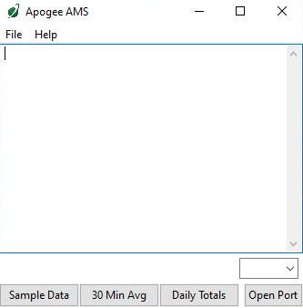

When the ApogeeAMS software is first opened, it will show a blank screen until communication with the meter is established. If you click “Open Port” it will say “connection failed.”

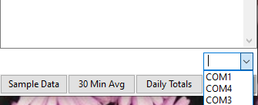
To establish communication, make sure the meter is plugged into your computer using the AC-100 communication cable. To connect click the dropdown menu button and “COM#” options will appear. For more details on how to figure out which COM is the right one, watch our video.

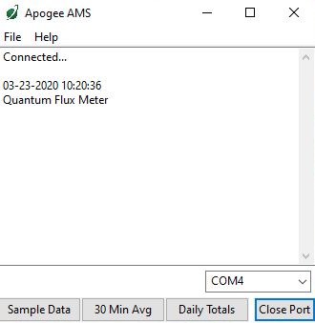

When you have connected to the correct COM#, the software will say “Connected”.
Click “Sample Data” to view saved sample readings.

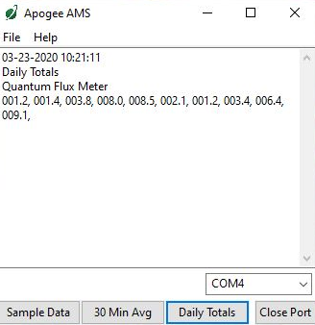

“Daily Totals” shows all the saved Daily Light Integral (DLI) totals per day.

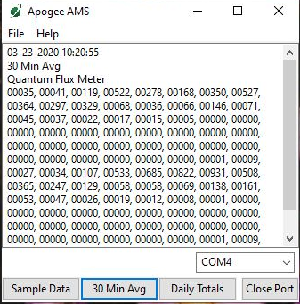

Click “30 Min Avg” to see the meter’s 99, 30-minute averages.

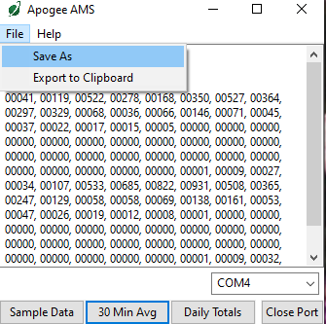

To analyze the data, click on “File” and “Save As” to save the data as a .csv file.
Or you can highlight the numbers, copy, and paste them into a blank Excel spreadsheet. Data will need to be comma delimited.

Maintenance and Recalibration
Blocking of the optical path between the target and detector can cause low readings. Occasionally, accumulated materials on the diffuser of the sensor can block the optical path in three common ways:
- Moisture or debris on the diffuser.
- Dust during periods of low rainfall.
- Salt deposit accumulation from evaporation of sea spray or sprinkler irrigation water.
Apogee Instruments quantum sensors have a domed diffuser and housing for improved self-cleaning from rainfall, but active cleaning may be necessary. Dust or organic deposits are best removed using water, or window cleaner, and a soft cloth or cotton swab. Salt deposits should be dissolved with vinegar and removed with a cloth or cotton swab. Salt deposits cannot be removed with solvents such as alcohol or acetone. Use only gentle pressure when cleaning the diffuser with a cotton swab or soft cloth to avoid scratching the outer surface. The solvent should be allowed to do the cleaning, not mechanical force. Never use abrasive material or cleaner on the diffuser.
Although Apogee sensors are very stable, nominal calibration drift is normal for all research-grade sensors. To ensure maximum accuracy, recalibration every two years is recommended. Longer time periods between recalibration may be warranted depending on tolerances. See the Apogee webpage for details regarding return of sensors for recalibration (http://www.apogeeinstruments.com/tech-support-recalibration-repairs/).
To determine if your sensor needs recalibration, the Clear Sky Calculator (www.clearskycalculator.com) website and/or smartphone app can be used to indicate the PPFD incident on a horizontal surface at any time of day at any location in the world. It is most accurate when used near solar noon in spring and summer months, where accuracy over multiple clear and unpolluted days is estimated to be ± 4 % in all climates and locations around the world. For best accuracy, the sky must be completely clear, as reflected light from clouds causes PPFD to increase above the value predicted by the clear sky calculator. Measured values of PPFD can exceed values predicted by the Clear Sky Calculator due to reflection from thin, high clouds and edges of clouds, which enhances incoming PPFD. The influence of high clouds typically shows up as spikes above clear sky values, not a constant offset greater than clear sky values.
To determine recalibration need, input site conditions into the calculator and compare PPFD measurements to calculated values for a clear sky. If sensor PPFD measurements over multiple days near solar noon are consistently different than calculated values (by more than 6 %), the sensor should be cleaned and re-leveled. If measurements are still different after a second test, email calibration@apogeeinstruments.com to discuss test results and possible return of sensor(s).

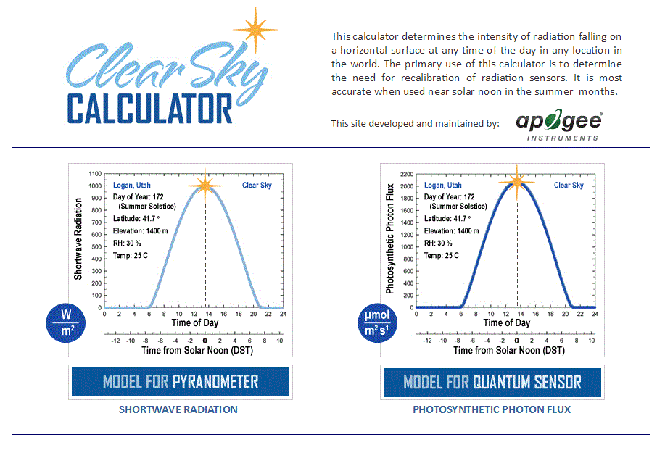
Homepage of the Clear Sky Calculator. Two calculators are available: one for quantum sensors (PPFD) and one for pyranometers (total shortwave radiation).

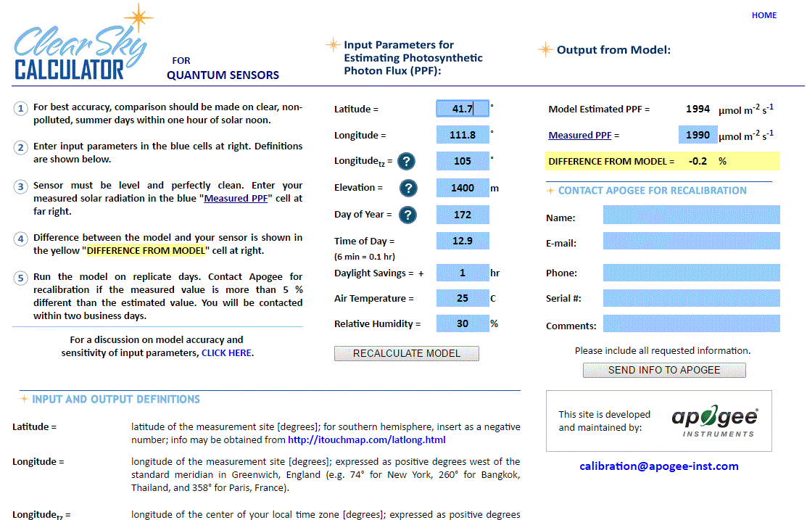

Clear Sky Calculator for quantum sensors. Site data are input in blue cells in middle of page and an estimate of PPFD is returned on right-hand side of page.

Troubleshooting and Customer Support
Verify Functionality
Pressing the power button should activate the LCD and provide a real-time PPFD reading. Direct the sensor head toward a light source and verify the PPFD reading responds. Increase and decrease the distance from the sensor to the light source to verify that the reading changes proportionally (decreasing PPFD with increasing distance and increasing PPFD with decreasing distance). Blocking all radiation from the sensor should force the PPFD reading to zero.
Battery Life
When the meter is maintained properly the coin cell battery (CR2320) should last for many months, even after continuous use. The low battery indicator will appear in the upper left-hand corner of the LCD display when the battery voltage drops below 2.8 V DC. The meter will still function correctly for some time, but once the battery is drained the pushbuttons will no longer respond and any logged measurements will be lost.
Pressing the power button to turn off the meter will actually put it in sleep mode, where there is still a slight amount of current draw. This is necessary to maintain the logged measurements in memory. Therefore, it is recommended to remove the battery when storing the meter for many months at a time, in order to preserve battery life.
Low-Battery Error after Battery Replacement
A master reset will usually correct this error, please see the master reset section for details and cautions. If a master reset does not remove the low battery indicator, please double check that the voltage of your new battery is above 2.8 V, this is the threshold for the indicator to turn on.
Master Reset
If a meter ever becomes non-responsive or experiences anomalies, such as a low battery indicator even after replacing the old battery, a master reset can be performed that may correct the problem. Note that a master reset will erase all logged measurements from memory.
Step 1: press the power button so that the LCD display is activated.
Step 2: Slide the battery out of the holder, which will cause the LCD display to fade out.
Step 3: After a few seconds, slide the battery back into the holder.
The LCD display will flash all segments and then show a revision number (e.g., “R1.0”). This indicates the master reset was performed and the display should return to normal.

Error Codes and Fixes
Error codes will appear in place of the real-time reading on the LCD display and will continue to flash until the problem is corrected. Contact Apogee if the following fixes do not rectify the problem.
Err 1: battery voltage out of range. Fix: replace CR2320 battery and perform master reset.
Err 2: sensor voltage out of range. Fix: perform master reset.
Err 3: not calibrated. Fix: perform master reset.
Err 4: CPU voltage below minimum. Fix: replace CR2320 battery and perform master reset.
Modifying Cable Length
Although it is possible to splice additional cable to the separate sensor of the appropriate MQx model, note that the cable wires are soldered directly into the circuit board of the meter. Care should be taken to remove the back panel of the meter in order to access the board and splice on the additional cable, otherwise two splices would need to be made between the meter and sensor head. See Apogee webpage for further details on how to extend sensor cable length: (http://www.apogeeinstruments.com/how-to-make-a-weatherproof-cable-splice/).
Unit Conversion Charts
Apogee MQX series quantum sensors are calibrated to measure PPFD in units of µmol m⁻² s⁻¹. Units other than photon flux density (e.g., energy flux density, illuminance) may be required for certain applications. It is possible to convert the PPFD value from a quantum sensor to other units, but it requires spectral output of the radiation source of interest. Conversion factors for common radiation sources can be found on the Unit Conversions page in the Support Center on the Apogee website (http://www.apogeeinstruments.com/unit-conversions/). A spreadsheet to convert PPFD to energy flux density or illuminance is also provided on the Unit Conversions page in the Support Center on the Apogee website (http://www.apogeeinstruments.com/content/PPFD-to-Illuminance-Calculator.xls).

Return and Warranty Policy

RETURN POLICY
Apogee Instruments will accept returns within 30 days of purchase as long as the product is in new condition (to be determined by Apogee). Returns are subject to a 10 % restocking fee.

WARRANTY POLICY
What is Covered
All products manufactured by Apogee Instruments are warranted to be free from defects in materials and craftsmanship for a period of four (4) years from the date of shipment from our factory. To be considered for warranty coverage an item must be evaluated by Apogee.
Products not manufactured by Apogee (spectroradiometers, chlorophyll content meters, EE08-SS probes) are covered for a period of one (1) year.
What is Not Covered
The customer is responsible for all costs associated with the removal, reinstallation, and shipping of suspected warranty items to our factory.
The warranty does not cover equipment that has been damaged due to the following conditions:
1. Improper installation, use, or abuse.
2. Operation of the instrument outside of its specified operating range.
3. Natural occurrences such as lightning, fire, etc.
4. Unauthorized modification.
5. Improper or unauthorized repair.
Please note that nominal accuracy drift is normal over time. Routine recalibration of sensors/meters is considered part of proper maintenance and is not covered under warranty.
Who is Covered
This warranty covers the original purchaser of the product or other party who may own it during the warranty period.
What Apogee Will Do
At no charge Apogee will:
1. Either repair or replace (at our discretion) the item under warranty.
2. Ship the item back to the customer by the carrier of our choice.
Different or expedited shipping methods will be at the customer’s expense.

How To Return An Item
1. Please do not send any products back to Apogee Instruments until you have received a Return Merchandise Authorization (RMA) number from our technical support department by submitting an online RMA form at www.apogeeinstruments.com/tech-support-recalibration-repairs/. We will use your RMA number for tracking of the service item. Call (435) 245-8012 or email techsupport@apogeeinstruments.com with questions.
2. For warranty evaluations, send all RMA sensors and meters back in the following condition: Clean the sensor’s exterior and cord. Do not modify the sensors or wires, including splicing, cutting wire leads, etc. If a connector has been attached to the cable end, please include the mating connector – otherwise the sensor connector will be removed in order to complete the repair/recalibration. Note: When sending back sensors for routine calibration that have Apogee’s standard stainless-steel connectors, you only need to send the sensor with the 30 cm section of cable and one-half of the connector. We have mating connectors at our factory that can be used for calibrating the sensor.
3. Please write the RMA number on the outside of the shipping container.
4. Return the item with freight pre-paid and fully insured to our factory address shown below. We are not responsible for any costs associated with the transportation of products across international borders.
Apogee Instruments, Inc.
721 West 1800 North Logan, UT
84321, USA
5. Upon receipt, Apogee Instruments will determine the cause of failure. If the product is found to be defective in terms of operation to the published specifications due to a failure of product materials or craftsmanship, Apogee Instruments will repair or replace the items free of charge. If it is determined that your product is not covered under warranty, you will be informed and given an estimated repair/replacement cost.

Products Beyond the Warranty Period
For issues with sensors beyond the warranty period, please contact Apogee at techsupport@apogeeinstruments.com to discuss repair or replacement options.

Other Terms
The available remedy of defects under this warranty is for the repair or replacement of the original product, and Apogee Instruments is not responsible for any direct, indirect, incidental, or consequential damages, including but not limited to loss of income, loss of revenue, loss of profit, loss of data, loss of wages, loss of time, loss of sales, accruement of debts or expenses, injury to personal property, or injury to any person or any other type of damage or loss.
This limited warranty and any disputes arising out of or in connection with this limited warranty ("Disputes") shall be governed by the laws of the State of Utah, USA, excluding conflicts of law principles and excluding the Convention for the International Sale of Goods. The courts located in the State of Utah, USA, shall have exclusive jurisdiction over any Disputes.
This limited warranty gives you specific legal rights, and you may also have other rights, which vary from state to state and jurisdiction to jurisdiction, and which shall not be affected by this limited warranty. This warranty extends only to you and cannot by transferred or assigned. If any provision of this limited warranty is unlawful, void, or unenforceable, that provision shall be deemed severable and shall not affect any remaining provisions. In case of any inconsistency between the English and other versions of this limited warranty, the English version shall prevail.
This warranty cannot be changed, assumed, or amended by any other person or agreement.
APOGEE INSTRUMENTS, INC. | 721 WEST 1800 NORTH, LOGAN, UTAH 84321, USA
TEL: (435) 792-4700 | FAX: (435) 787-8268 | WEB: APOGEEINSTRUMENTS.COM
Copyright © 2022 Apogee Instruments, Inc.

