

Owner’s Manual

Ultraviolet Meter
Models MU-100 and MU-200
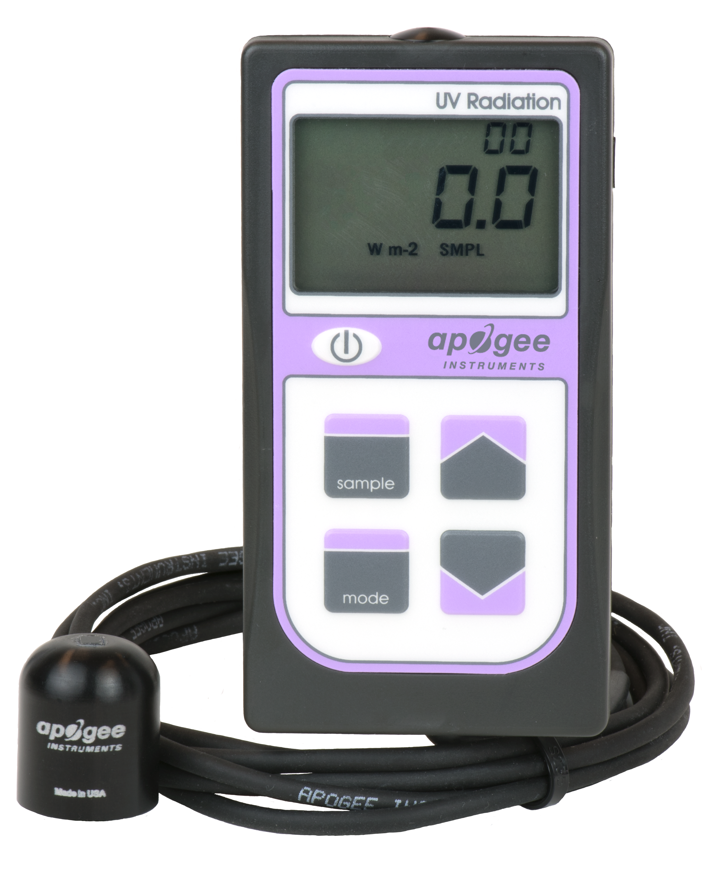
Table of Contents
Owner’s Manual 1
Certificate of Compliance 3
Introduction 4
Sensor Models 5
Specifications 6
Deployment and Installation 7
Operation and Measurement 8
Maintenance and Recalibration 11
Troubleshooting and Customer Support 13
Return and Warranty Policy 15

Certificate of Compliance

EU Declaration of Conformity
This declaration of conformity is issued under the sole responsibility of the manufacturer:
Apogee Instruments, Inc.
721 W 1800 N
Logan, Utah 84321
USA
for the following product(s):

Models: MU-100, MU-200
Type: Ultraviolet Sensor

The object of the declaration described above is in conformity with the relevant Union harmonization legislation:

2014/30/EU Electromagnetic Compatibility (EMC) Directive
2011/65/EU Restriction of Hazardous Substances (RoHS 2) Directive
2015/863/EU Amending Annex II to Directive 2011/65/EU (RoHS 3)

Standards referenced during compliance assessment:

EN 61326-1:2013 Electrical equipment for measurement, control and laboratory use – EMC requirements
EN 50581:2012 Technical documentation for the assessment of electrical and electronic products with respect to the restriction of hazardous substances

Please be advised that based on the information available to us from our raw material suppliers, the products manufactured by us do not contain, as intentional additives, any of the restricted materials including lead (see note below), mercury, cadmium, hexavalent chromium, polybrominated biphenyls (PBB), polybrominated diphenyls (PBDE), bis(2-ethylhexyl) phthalate (DEHP), butyl benzyl phthalate (BBP), dibutyl phthalate (DBP), and diisobutyl phthalate (DIBP). However, please note that articles containing greater than 0.1% lead concentration are RoHS 3 compliant using exemption 6c.

Further note that Apogee Instruments does not specifically run any analysis on our raw materials or end products for the presence of these substances, but rely on the information provided to us by our material suppliers.

Signed for and on behalf of:
Apogee Instruments, October 2019

Bruce Bugbee
President
Apogee Instruments, Inc.

Introduction
Ultraviolet (UV) radiation constitutes a portion of the electromagnetic spectrum from 100 to 400 nm, and is further subdivided into three wavelength ranges: UV-A (315 to 400 nm), UV-B (280 to 315 nm) and UV-C (100 to 280 nm). Much of the UV-B and all of the UV-C wavelengths from the sun are absorbed by the Earth’s atmosphere. There are also many artificial UV light sources available that output a select wavelength range or offer a broadband UV radiation source.
Most UV sensors designed for sunlight measurements are sensitive to UV radiation in the UV-A and UV-B ranges. Apogee Instruments MU series meters detect UV radiation from 250 to 400 nm and are calibrated in photon flux density units of micromoles per square meter per second (µmol m⁻² s⁻¹). The output can also be expressed in energy flux units of watts per square meter (W m⁻², equal to Joules per second per square meter).
Typical applications of UV meters include incoming UV radiation measurement in outdoor environments or in laboratory use with artificial light sources (e.g., germicidal lamps).
Apogee Instruments MU series UV meters consist of a handheld meter and a dedicated sensor that is integrated into the top of the meter housing (MU-100) or connected by cable to an anodized aluminum housing (MU-200). Integrated and separate sensors consist of a photodiode and filter, and are potted solid with no internal air space. MU series meters provide a real-time photon flux or energy flux (menu selectable) reading on the LCD display that determines the UV radiation incident on a planar surface (does not have to be horizontal), where the radiation emanates from all angles of a hemisphere. MU series meters include manual and automatic data logging features for making spot-check measurements or calculating integrated daily total values.

Sensor Models
Apogee MU series UV meters covered in this manual are self-contained and come complete with handheld meter and sensor.
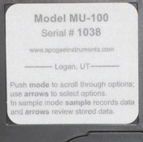
Sensor model number and serial number are located on a label on the backside of the handheld meter.

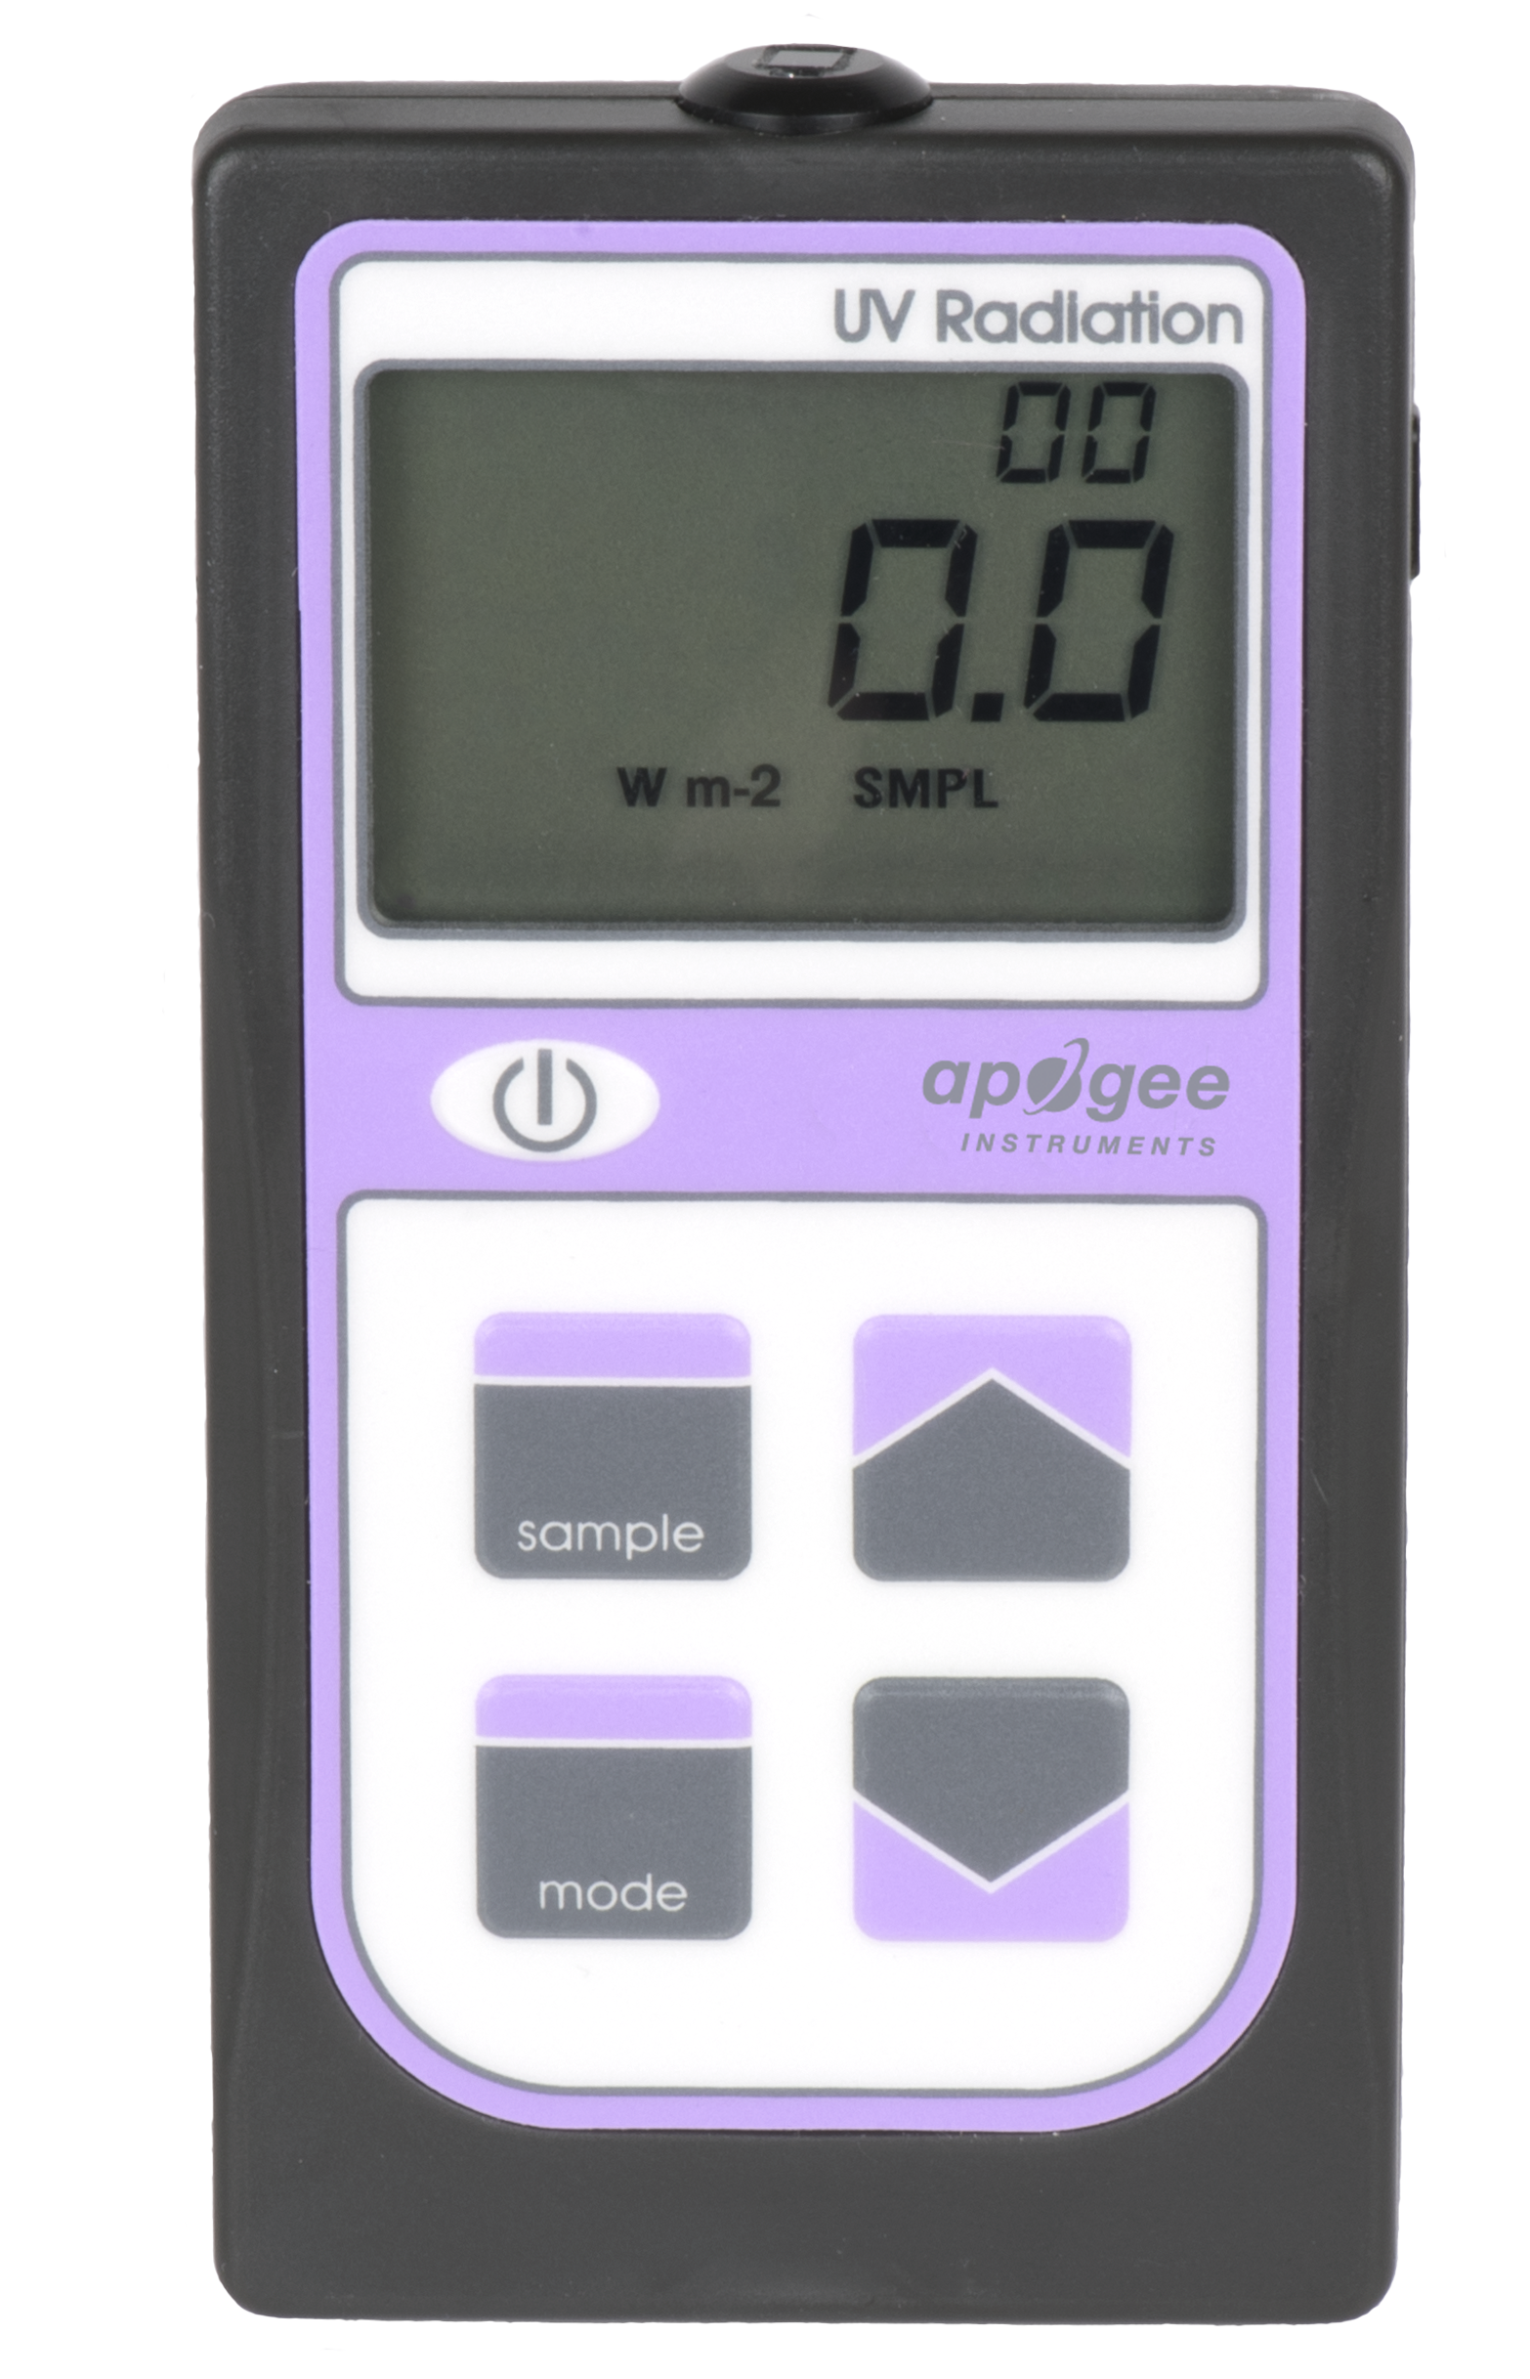
MU-100 MU-200

Specifications
 | MU-100 | MU-200
Calibration Uncertainty | ± 10 % (see Calibration Traceability below)
Measurement Repeatability | Less than 1 %
Non-stability  (Long-term Drift) | Less than 3 % per year
Non-linearity | Less than 1 % (up to 300 µmol m⁻² s⁻¹)
Response Time | Less than 1 ms
Field of View | 180º
Spectral Range | 250 nm to 400 nm (see Spectral Response below)
Directional (Cosine) Response | ± 10 % at 75º zenith angle
Maximum Range | 104.9 W per m²
Temperature Response | Approximately 0.1 % per C
Operating Environment | 0 to 50 C; less than 90 % non-condensing relative humidity up to 30 C; less than 70 % non-condensing relative humidity from 30 to 50 C
Meter Dimensions | 126 mm length; 70 mm width; 24 mm height
Sensor Dimension | 24 mm diameter; 28 mm height
Mass | 150 g | 180 g
Cable | 2 m of two conductor, shielded, twisted-pair wire; TPR jacket (high water resistance, high UV stability, flexibility in cold conditions)
Calibration Traceability
Apogee MU series UV meters are calibrated through side-by-side comparison to the mean of three Apogee model SU-100 transfer standard UV sensors under high intensity discharge metal halide lamps. The transfer standard UV sensors are calibrated through side-by-side comparison to an Apogee model PS-200 spectroradiometer under sunlight (clear sky conditions) in Logan, Utah. The PS-200 is calibrated with a LI-COR model 1800-02 Optical Radiation Calibrator using a 200 W quartz halogen lamp. The 1800-02 and quartz halogen lamp are traceable to the National Institute of Standards and Technology (NIST).
Spectral Response
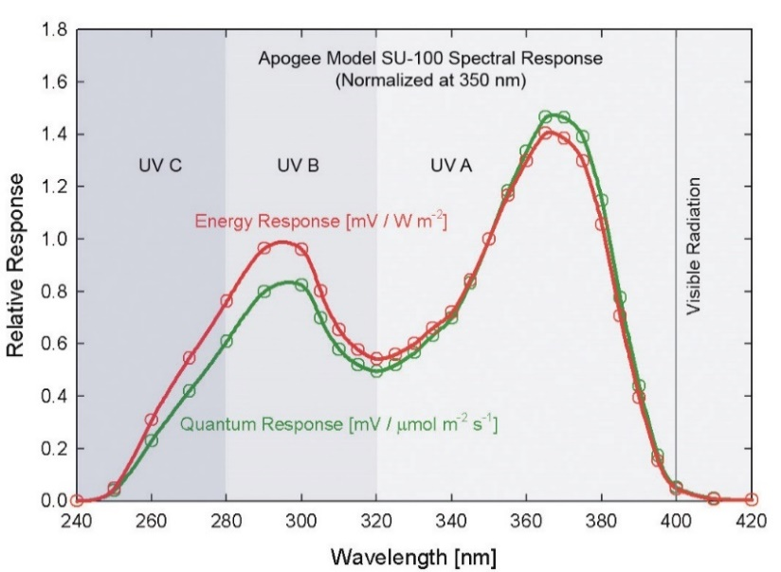
Spectral response estimate of Apogee MU series meters. Spectral response measurements were made at 10 nm increments across a wavelength range of 200 to 450 nm in a monochromator with an attached electric light source. Measured spectral data were normalized at 350 nm.

Deployment and Installation
Apogee MU series meters are designed for spot-check measurements, and calculation of integrated daily totals (total number of photons incident on a planar surface over the course of a day) through the built-in logging feature. To accurately measure UV radiation incident on a horizontal surface, the sensor must be level. For this purpose, each MU model comes with a different option for mounting the sensor to a horizontal plane.
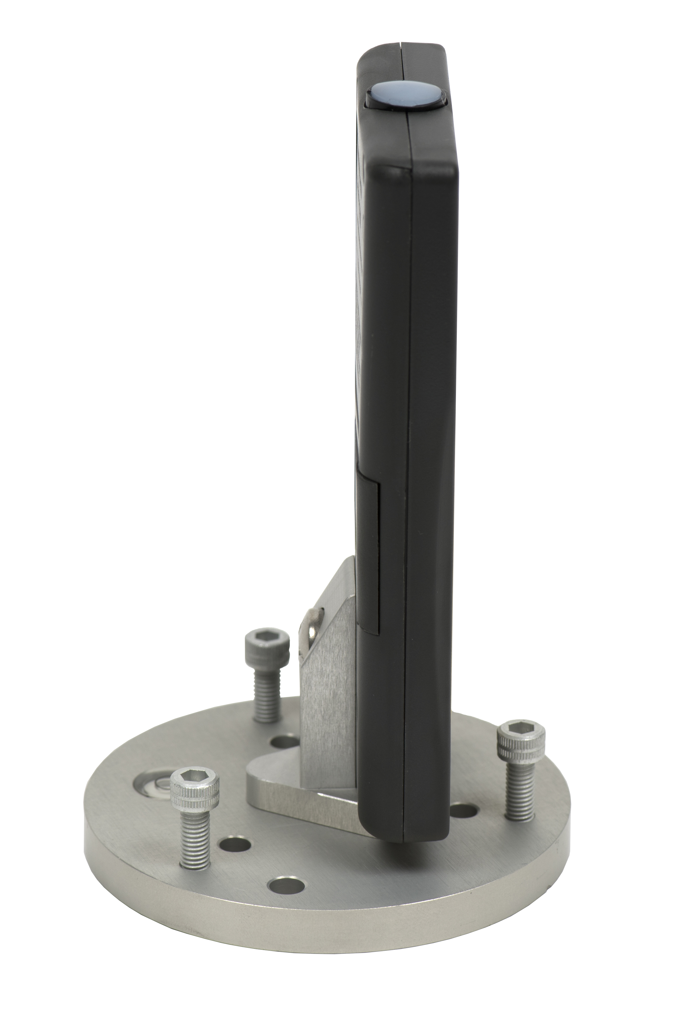
The AL-210 leveling plate is recommended for use with the MU-100.

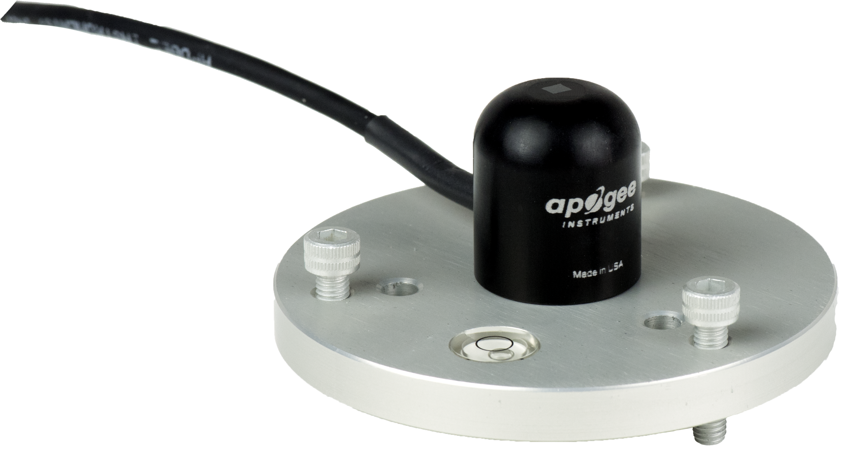
The AL-100 leveling plate is recommended for use with the MU-200. To facilitate mounting to a cross arm, the AL-120 mounting bracket is recommended.

In addition to leveling, all sensors should also be mounted such that obstructions (e.g., weather station tripod/tower or other instrumentation) do not shade the sensor.

Operation and Measurement
MU series quantum meters are designed with a user-friendly interface allowing quick and easy measurements.
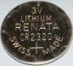 To power the meter, slide the included battery (CR2320) into the battery holder, after removing the battery door from the meter’s back panel. The positive side (designated by a “+” sign) should be facing out from the meter circuit board.
 Press the power button to activate the LCD display. After two minutes of non-activity the meter will revert to sleep mode and the display will shut off to conserve battery life.
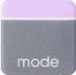 Press the mode button to access the main menu, where the appropriate unit (photon flux or energy flux) and manual or automatic logging are selected, and where the meter can be reset.
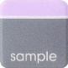 Press the sample button to log a reading while taking manual measurements.
 Press the up button to make selections in the main menu. This button is also used to view and scroll through the logged measurements on the LCD display.
 Press the down button to make selections in the main menu. This button is also used to view and scroll through the logged measurements on the LCD display.
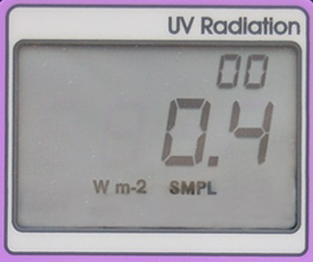
The LCD display consists of the total number of logged measurements in the upper right hand corner, the real-time UV measurement in the center, and the selected menu options along the bottom.
Units: To choose between units of energy flux (W m⁻²) or photon flux density (µmol m⁻² s⁻¹), push the mode button once and use the up/down buttons to make the appropriate selection. Once the desired mode is blinking, press the mode button three more times to exit the menu.
Logging: To choose between manual or automatic logging, push the mode button twice and use the up/down buttons to make the appropriate selection (SMPL or LOG). Once the desired mode is blinking, press the mode button two more times to exit the menu. When in SMPL mode press the sample button to record up to 99 manual measurements (a counter in the upper right hand corner of the LCD display indicates the total number of saved measurements). When in LOG mode the meter will power on/off to make a measurement every 30 seconds. Every 30 minutes the meter will average the sixty 30 second measurements and record the averaged value to memory. The meter can store up to 99 averages and will start to overwrite the oldest measurement once there are 99 measurements. Every 48 averaged measurements (making a 24 hour period), the meter will also store an integrated daily total in moles per meter squared per day (mol m⁻² d⁻¹).
Reset: To reset the meter, in either SMPL or LOG mode, push the mode button three times (RUN should be blinking), then while pressing the down button, press the mode button once. This will erase all of the saved measurements in memory, but only for the selected mode. That is, performing a reset when in SMPL mode will only erase the manual measurements and performing a reset when in LOG mode will only erase the automatic measurements.
Review/Download Data: Each of the logged measurements in either SMPL or LOG mode can be reviewed on the LCD display by pressing the up/down buttons. To exit and return to the real-time readings, press the sample button. Note that the integrated daily total values are not accessible through the LCD and can only be viewed by downloading to a computer.
Downloading the stored measurements will require the AC-100 communication cable and software (sold separately). The meter outputs data using the UART protocol and requires the AC-100 to convert from UART to USB, so standard USB cables will not work. Set up instructions and software can be downloaded from the Apogee website (http://www.apogeeinstruments.com/ac-100-communcation-cable/).
UV-B Measurements and Spectral Errors
Apogee Instruments MU series meters measure ultraviolet radiation between 250 and 400 nm in micromoles of photons per square meter per second. Although the UV radiation between 280 and 315 nm (UV-B) is critically important in photochemical and photobiological reactions, less than 3 % of the UV photons are in this range. Because only a small fraction of the photons are in the UV-B range, the MU series meters cannot be used to selectively measure UV-B radiation. The MU series is sensitive to UV-B radiation, but it is included with the UV-A radiation to provide a total measurement of UV radiation.
In addition to naturally occurring UV radiation from the sun, there are many electric light sources that emit UV radiation (e.g., cool white fluorescent, metal halide, mercury arc, and germicidal lamps). Although the relative wavelengths of UV radiation differ among sunlight and electric lights, the error estimates shown in the table below indicate that the MU series meters provide reasonable estimates of UV radiation coming from electric lamps (table provides spectral error estimates for UV radiation measurements from radiation sources other than clear sky solar radiation). For common lamps, the error is less than 10 %. The MU series meters are particularly useful for determining the UV filtering capacity of the transparent plastic and glass barriers that are commonly used below electric lamps.

Spectral Errors for UV Radiation Measurements with Apogee MU series UV meters
Radiation Source (Error Calculated Relative to Sun, Clear Sky) | Error [%]
Sun (Clear Sky) | 0.0
Sun (Cloudy Sky) | < 0.5
Reflected from Grass Canopy | < 0.5
Reflected from Deciduous Canopy | < 0.5
Reflected from Conifer Canopy | < 0.5
Reflected from Agricultural Soil | < 0.5
Reflected from Forest Soil | < 0.5
Reflected from Desert Soil | < 0.5
Reflected from Water | < 0.5
Reflected from Ice | < 0.5
Reflected from Snow | < 0.5
Cool White Fluorescent (T5) | 9.0
Metal Halide | 2.8
High Pressure Sodium | -1.7
Incandescent | -3.3
Mercury Arc | 17.8

Maintenance and Recalibration
Moisture or debris on the sensor is a common cause of low readings. The sensor has a domed-shaped housing for improved self-cleaning from rainfall, but materials can accumulate on the photo-sensitive area (e.g., dust during periods of low rainfall, salt deposits from evaporation of sea spray or sprinkler irrigation water) and partially block the optical path. Dust or organic deposits are best removed using water, or window cleaner and a soft cloth or cotton swab. Salt deposits should be dissolved with vinegar and removed with a soft cloth or cotton swab. Never use an abrasive material or cleaner on the sensor.
Although Apogee sensors are very stable, nominal accuracy drift is normal for all research-grade sensors. To ensure maximum accuracy, we generally recommend sensors are sent in for recalibration every two years, although you can often wait longer according to your particular tolerances.
The Clear Sky Calculator (www.clearskycalculator.com) determines total shortwave radiation or photosynthetic photon flux density (PPFD) incident on a horizontal surface at any time of day at any location in the world. It is most accurate when used near solar noon in spring and summer months, where accuracy over multiple clear and unpolluted days is estimated to be ± 4 % in all climates and locations around the world.
Although the Clear Sky Calculator does not specifically report an estimated value for UV radiation, it can still be used to help determine the need for UV sensor recalibration by approximating the ratio of UV to total shortwave or the ratio of UV to PPFD. However, due to continuous changes in atmospheric conditions and their effect on UV radiation, the comparison of the UV sensor to the Clear Sky Calculator should only be made in the summer months near solar noon, and under completely clear skies.
To calculate a reference value of UV radiation in units of energy flux (W m⁻²), input site conditions into the calculator to determine the estimated total shortwave radiation. Then multiply the estimated total shortwave value by an approximated ratio value between 0.045 and 0.050 to convert the total shortwave radiation to total UV radiation.
To calculate a reference value of UV radiation in units of photon flux density (μmol m⁻² s⁻¹), input site conditions into the calculator to determine the estimated PPFD. Then multiply the estimated PPFD by an approximated ratio value between 0.070 and 0.075 to convert the PPFD to total UV radiation.
If UV sensor measurements over multiple days near solar noon are consistently different than calculated values (by more than 10 %), the sensor should be cleaned and re-leveled. If measurements are still different after a second test, email calibration@apogeeinstruments.com to discuss test results and possible return of sensor(s).
Steps to Replace a Handheld Meter Battery
- Use a phillips head screw driver to remove the screw from the battery cover.
- Remove the battery cover by slightly lifting and sliding the outer edge of the cover away from the meter.
- Use your thumb to slide the battery out of the battery holder.
  - If the battery is difficult to move, turn the meter on its side so that the opening for the batter is facing downward and tap the meter downward against an open palm to dislodge the battery enough that it can be removed as described in step 3.
- To place the battery back in, simply slide it back into the battery holder with the flat side of the battery facing up.

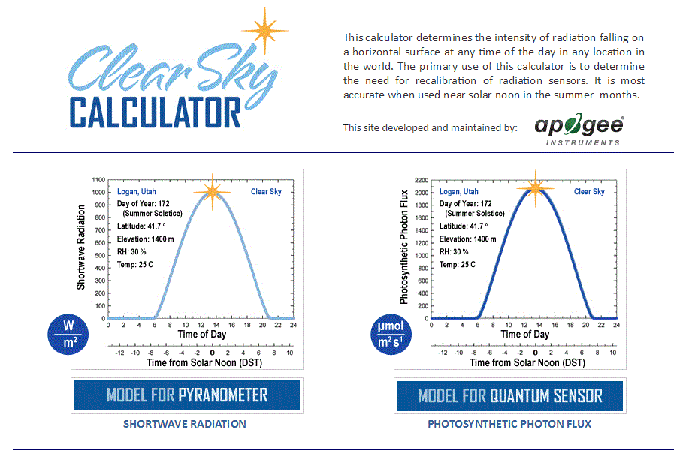
Homepage of the Clear Sky Calculator. Two calculators are available: One for pyranometers (total shortwave radiation) and one for quantum sensors (photosynthetic photon flux density).

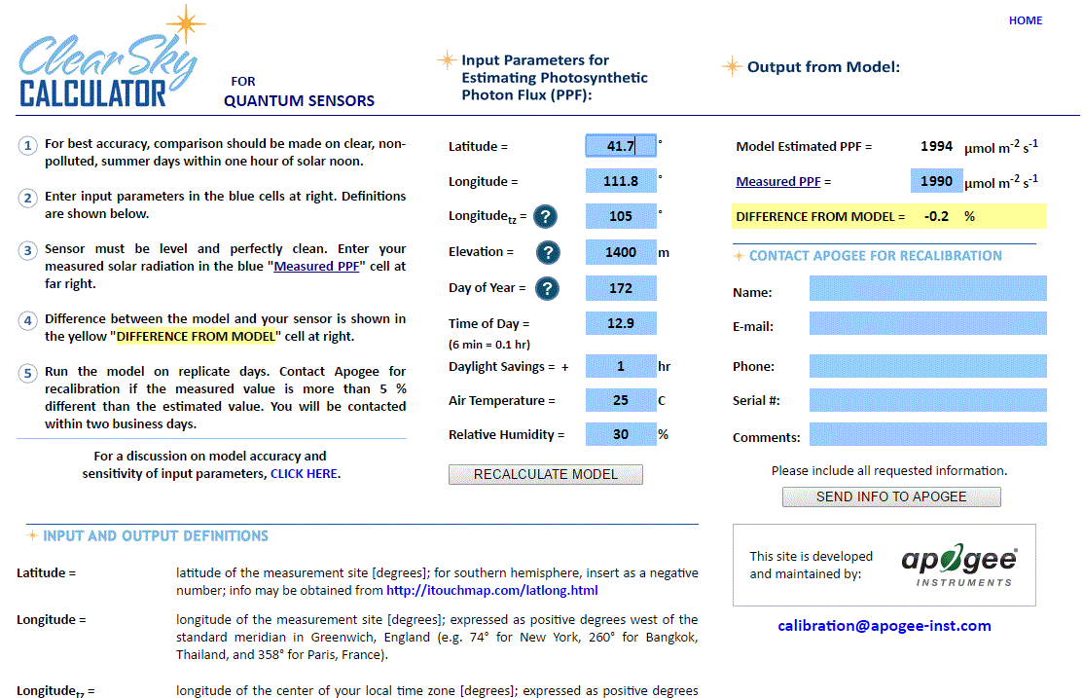
Clear Sky Calculator for pyranometers. Site data are input in blue cells in middle of page and an estimate of total shortwave radiation is returned on right-hand side of page.

Troubleshooting and Customer Support
Verify Functionality
Pressing the power button should activate the LCD and provide a real-time UV measurement. Direct the sensor head toward the sun and verify the UV reading responds. Blocking all radiation from the sensor should force the UV reading to zero.
Battery Life
When the meter is maintained properly the coin cell battery (CR2320) should last for many months, even after continuous use. The low battery indicator will appear in the upper left hand corner of the LCD display when the battery voltage drops below 2.8 V DC. The meter will still function correctly for some time, but once the battery is drained the pushbuttons will no longer respond and any logged measurements will be lost.
Pressing the power button to turn off the meter will actually put it in sleep mode, where there is still a slight amount of current draw. This is necessary to maintain the logged measurements in memory. Therefore, it is recommended to remove the battery when storing the meter for many months at a time, in order to preserve battery life.
Low-Battery Error after Battery Replacement
A master reset will usually correct this error, please see the master reset section for details and cautions. If a master reset does not remove the low battery indicator, please double check that the voltage of your new batter is above 2.8 V, this is the threshold for the indicator to turn on.
Master Reset
If a meter ever becomes non-responsive or experiences anomalies, such as a low battery indicator even after replacing the old battery, a master reset can be performed that may correct the problem. Note that a master reset will erase all logged measurements from memory.
Step 1: press the power button so that the LCD display is activated.
Step 2: Slide the battery out of the holder, which will cause the LCD display to fade out.
Step 3: After a few seconds, slide the battery back into the holder.
The LCD display will flash all segments and then show a revision number (e.g. “R1.0”). This indicates the master reset was performed and the display should return to normal.
Error Codes and Fixes
Error codes will appear in place of the real-time reading on the LCD display and will continue to flash until the problem is corrected. Contact Apogee if the following fixes do not rectify the problem.
Err 1: battery voltage out of range. Fix: replace CR2320 battery and perform master reset.
Err 2: sensor voltage out of range. Fix: perform master reset.
Err 3: not calibrated. Fix: perform master reset.
Err 4: CPU voltage below minimum. Fix: replace CR2320 battery and perform master reset.
Modifying Cable Length
Although it is possible to splice additional cable to the separate sensor of the MU-200, note that the cable wires are soldered directly into the circuit board of the meter. Care should be taken to remove the back panel of the meter in order to access the board and splice on the additional cable, otherwise two splices would need to be made between the meter and sensor head. See Apogee webpage for further details on how to extend sensor cable length: (http://www.apogeeinstruments.com/how-to-make-a-weatherproof-cable-splice/).

Return and Warranty Policy

RETURN POLICY
Apogee Instruments will accept returns within 30 days of purchase as long as the product is in new condition (to be determined by Apogee). Returns are subject to a 10 % restocking fee.

WARRANTY POLICY
What is Covered
All products manufactured by Apogee Instruments are warranted to be free from defects in materials and craftsmanship for a period of four (4) years from the date of shipment from our factory. To be considered for warranty coverage an item must be evaluated either at our factory or by an authorized distributor.
Products not manufactured by Apogee (spectroradiometers, chlorophyll content meters, EE08-SS probes) are covered for a period of one (1) year.
What is Not Covered
The customer is responsible for all costs associated with the removal, reinstallation, and shipping of suspected warranty items to our factory.
The warranty does not cover equipment that has been damaged due to the following conditions:
1. Improper installation or abuse.
2. Operation of the instrument outside of its specified operating range.
3. Natural occurrences such as lightning, fire, etc.
4. Unauthorized modification.
5. Improper or unauthorized repair.
Please note that nominal accuracy drift is normal over time. Routine recalibration of sensors/meters is considered part of proper maintenance and is not covered under warranty.
Who is Covered
This warranty covers the original purchaser of the product or other party who may own it during the warranty period.
What We Will Do
At no charge we will:
1. Either repair or replace (at our discretion) the item under warranty.
2. Ship the item back to the customer by the carrier of our choice.
Different or expedited shipping methods will be at the customer’s expense.
How To Return An Item
1. Please do not send any products back to Apogee Instruments until you have received a Return Merchandise Authorization (RMA) number from our technical support department by calling (435) 245-8012 or by submitting an online RMA form at www.apogeeinstruments.com/tech-support-recalibration-repairs/. We will use your RMA number for tracking of the service item.
2. Send all RMA sensors and meters back in the following condition: Clean the sensor’s exterior and cord. Do not modify the sensors or wires, including splicing, cutting wire leads, etc. If a connector has been attached to the cable end, please include the mating connector – otherwise the sensor connector will be removed in order to complete the repair/recalibration.
3. Please write the RMA number on the outside of the shipping container.
4. Return the item with freight pre-paid and fully insured to our factory address shown below. We are not responsible for any costs associated with the transportation of products across international borders.
5. Upon receipt, Apogee Instruments will determine the cause of failure. If the product is found to be defective in terms of operation to the published specifications due to a failure of product materials or craftsmanship, Apogee Instruments will repair or replace the items free of charge. If it is determined that your product is not covered under warranty, you will be informed and given an estimated repair/replacement cost.
Apogee Instruments, Inc.
721 West 1800 North Logan, UT
84321, USA

Products Beyond the Warranty Period
For issues with sensors beyond the warranty period, please contact Apogee at techsupport@apogeeinstruments.com to discuss repair or replacement options.

Other Terms
The available remedy of defects under this warranty is for the repair or replacement of the original product, and Apogee Instruments is not responsible for any direct, indirect, incidental, or consequential damages, including but not limited to loss of income, loss of revenue, loss of profit, loss of wages, loss of time, loss of sales, accruement of debts or expenses, injury to personal property, or injury to any person or any other type of damage or loss.
This limited warranty and any disputes arising out of or in connection with this limited warranty ("Disputes") shall be governed by the laws of the State of Utah, USA, excluding conflicts of law principles and excluding the Convention for the International Sale of Goods. The courts located in the State of Utah, USA, shall have exclusive jurisdiction over any Disputes.
This limited warranty gives you specific legal rights, and you may also have other rights, which vary from state to state and jurisdiction to jurisdiction, and which shall not be affected by this limited warranty. This warranty extends only to you and cannot by transferred or assigned. If any provision of this limited warranty is unlawful, void or unenforceable, that provision shall be deemed severable and shall not affect any remaining provisions. In case of any inconsistency between the English and other versions of this limited warranty, the English version shall prevail.
This warranty cannot be changed, assumed, or amended by any other person or agreement.
APOGEE INSTRUMENTS, INC. | 721 WEST 1800 NORTH, LOGAN, UTAH 84321, USA
TEL: (435) 792-4700 | FAX: (435) 787-8268 | WEB: APOGEEINSTRUMENTS.COM
Copyright © 2019 Apogee Instruments, Inc.

