

Owner’s Manual

Red - Far-Red sensors
Models S2-431
Rev: 31-Mar-2022
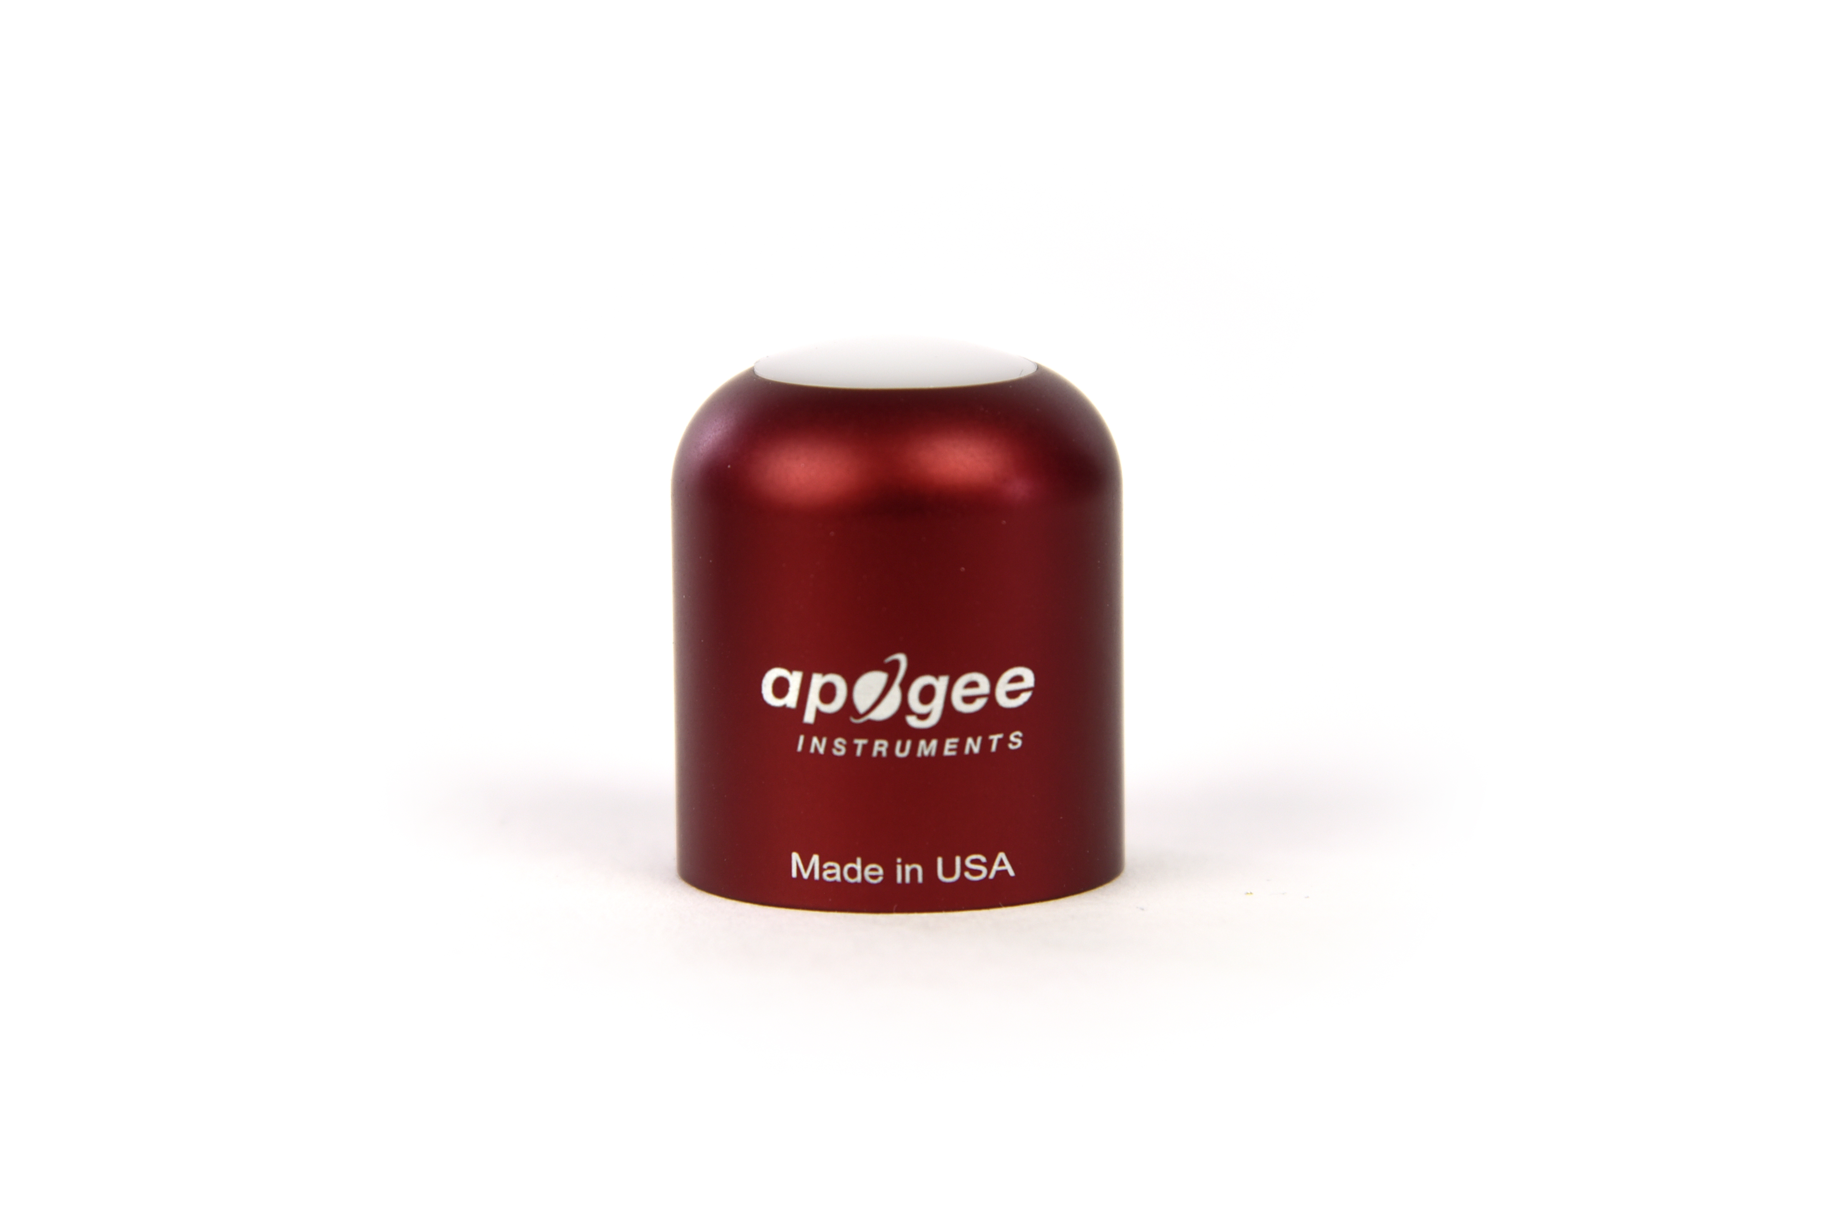
Table of Contents
Owner’s Manual 1
Certificate of Compliance 3
Introduction 4
Sensor Models 5
Specifications 6
Deployment and Installation 8
Cable Connectors 9
Operation and Measurement 10
Maintenance and Recalibration 14
Troubleshooting and Customer Support 15
Return and Warranty Policy 16

Certificate of Compliance

EU Declaration of Conformity
This declaration of conformity is issued under the sole responsibility of the manufacturer:
Apogee Instruments, Inc.
721 W 1800 N
Logan, Utah 84321
USA
for the following product(s):

Models: S2-431
Type: Red - Far-red Sensors

The object of the declaration described above is in conformity with the relevant Union harmonization legislation:

2014/30/EU Electromagnetic Compatibility (EMC) Directive
2011/65/EU Restriction of Hazardous Substances (RoHS 2) Directive
2015/863/EU Amending Annex II to Directive 2011/65/EU (RoHS 3)

Standards referenced during compliance assessment:

EN 61326-1:2013 Electrical equipment for measurement, control, and laboratory use – EMC requirements
EN 50581:2012 Technical documentation for the assessment of electrical and electronic products with respect to the restriction of hazardous substances

Please be advised that based on the information available to us from our raw material suppliers, the products manufactured by us do not contain, as intentional additives, any of the restricted materials including lead (see note below), mercury, cadmium, hexavalent chromium, polybrominated biphenyls (PBB), polybrominated diphenyls (PBDE), bis (2-ethylhexyl) phthalate (DEHP), butyl benzyl phthalate (BBP), dibutyl phthalate (DBP), and diisobutyl phthalate (DIBP). However, please note that articles containing greater than 0.1 % lead concentration are RoHS 3 compliant using exemption 6c.

Further note that Apogee Instruments does not specifically run any analysis on our raw materials or end products for the presence of these substances, but we rely on the information provided to us by our material suppliers.

Signed for and on behalf of:
Apogee Instruments, March 2022

Bruce Bugbee
President
Apogee Instruments, Inc.

Introduction
Specific wavelengths of radiation trigger distinct responses in plants. Red and far-red wavelengths are of particular interest because they influence photosynthetic and morphogenic activity. Phytochrome pigments in plants are sensitive to varying ratios of red and far-red radiation, providing information to the plant about the light environment, and therefore, optimal growth patterns. Increasing the fraction of red radiation indicates less shading and generally results in more conservative vertical growth patterns, while increasing the far-red radiation fraction indicates more shading and results in more aggressive vertical growth patterns.
Red - far-red sensors are designed to have spectral sensitivities that approximate the phytochrome absorption spectrum. Red - far-red sensors quantify properties of radiation sources, not plant responses. However, inferences of plant responses can be made from measurements of the lighting/shading environment, so it is important that red - far-red sensors have high sensitivity in the wavelength ranges where plants are most sensitive (i.e., the wavelength ranges that drive the strongest responses in plants), hence red - far-red sensor spectral responses should approximate the phytochrome absorption spectrum.
The primary application of red - far-red sensors is monitoring plant light environments, including calculation of the red to far-red ratio (red photon flux density / far-red photon flux density) and far-red fraction (far-red photon flux density / sum of red and far-red photon flux densities), in photobiology studies (e.g., researching plant morphogenic activities).
Apogee Instruments S2 series red - far-red radiometers consist of a cast acrylic diffuser, pair of photodiodes that measure specific wavelength ranges, and signal processing circuitry mounted in an anodized aluminum housing, and a cable to connect the radiometer to a measurement device. Sensors are potted solid with no internal airspace and are designed for continuous measurement in indoor and outdoor environments. S2-100 series sensors output two analog voltages, one for each photodetector, that are directly proportional to red and far-red radiation incident on a planar surface (does not have to be horizontal), where the radiation emanates from all angles of a hemisphere.

Sensor Models
This manual covers the SDI-12 model S2-431 (in bold below). Additional models are covered in their respective manuals.
Model | Signal
S2-131 | Self-powered
S2-431 | SDI-12
S2-432 | Modbus

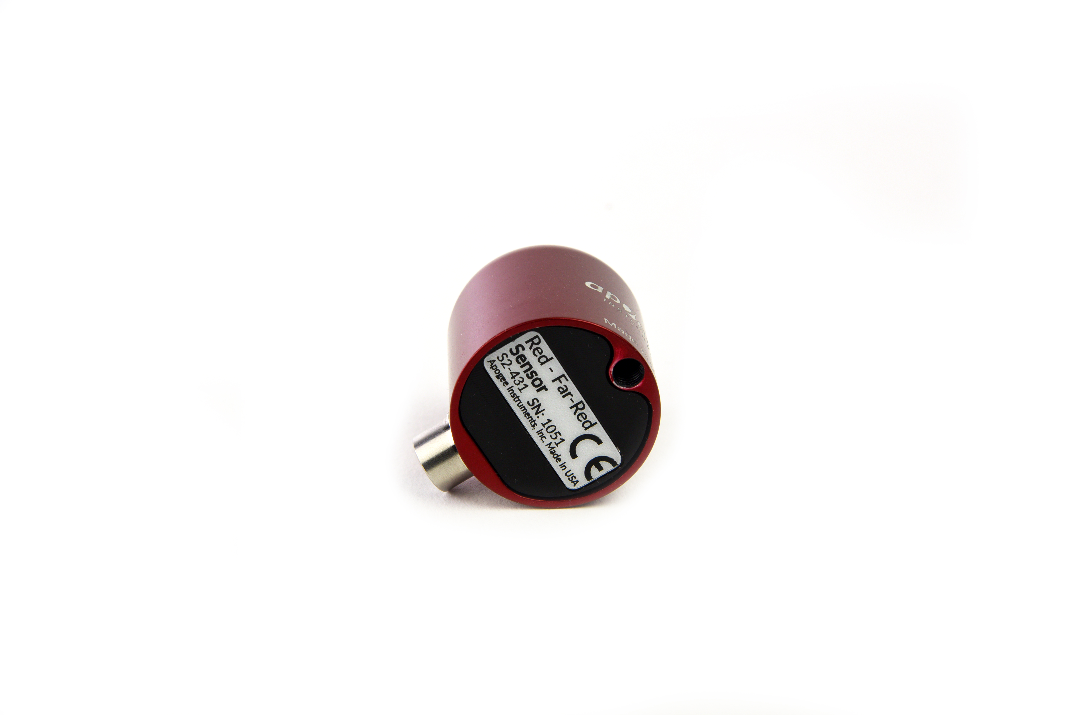
A sensor’s model number and serial number are located on the bottom of the sensor. If you need the manufacturing date of your sensor, please contact Apogee Instruments with the serial number of your sensor.

.

Specifications
 | S2-431
Power Supply | 5.5 to 24 V DC
Current Draw | 1.8 mA (quiescent), 1.9 mA (active)
Calibration Factor (reciprocal of sensitivity) | Custom for each sensor and stored in firmware
Calibration Uncertainty | ± 5 %
Output Range | SDI-12
Measurement Repeatability | Less than 1 %
Long-term Drift | Less than 2 % per year
Non-linearity | Less than 1 % (up to 400 µmol m⁻² s⁻¹)
Response Time | 0.6 s, time for detector signal to reach 95 % following a step change; fastest data transmission rate for SDI-12 circuitry is 1 s.
Field of View | 180°
Wavelength Ranges | 645 to 665 nm ± 5 nm (Red)  720 to 740 nm ± 5 nm (Far-red)
Directional (Cosine) Response | ± 2 % at 45°; ± 5 % at 75° zenith angle
Temperature Response |  | Less than 0.1 % per C
Housing | Anodized aluminum body with acrylic diffuser
IP Rating | IP68
Operating Environment | -40 to 70 C; 0 to 100 % relative humidity
Dimensions | 30.5 mm diameter, 37 mm height
Mass (with 5 m of cable) | 140 g
Cable | 5 m of shielded, twisted-pair wire; TPR jacket (high water resistance, high UV stability, flexibility in cold conditions); pigtail lead wires; stainless steel (316), M8 connector

Calibration Traceability
Apogee S2 series Red - Far-red sensors are calibrated through side-by-side comparison to the mean of three transfer standard sensors under a quartz halogen lamp. The transfer standard sensors are calibrated through side-by-side comparison to red and far-red photon flux density calculated from solar spectra collected in Logan, Utah, using an Apogee model PS-300 spectroradiometer. The PS-300 spectroradiometer is calibrated with a quartz halogen lamp traceable to the National Institute of Standards and Technology (NIST).

Cosine Response
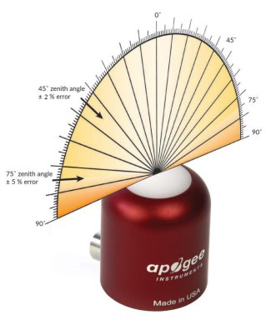
Directional, or cosine, response is defined as the measurement error at a specific angle of radiation incidence. Directional error for Apogee S2 series red - far-red sensors is approximately ± 2 % and ± 5 % at solar zenith angles of 45° and 75°, respectively.

Spectral Response
Mean spectral response measurements of six replicate red - far-red sensors (red sensor is centered near 655 nm, far-red sensor is centered near 730 nm). Spectral response measurements were made at 2 nm increments across a wavelength range of 600 to 800 nm in a monochromator with an attached electric light source. Measured spectral data from each sensor were normalized by the measured spectral response of the monochromator/electric light combination, which was measured with a spectroradiometer.

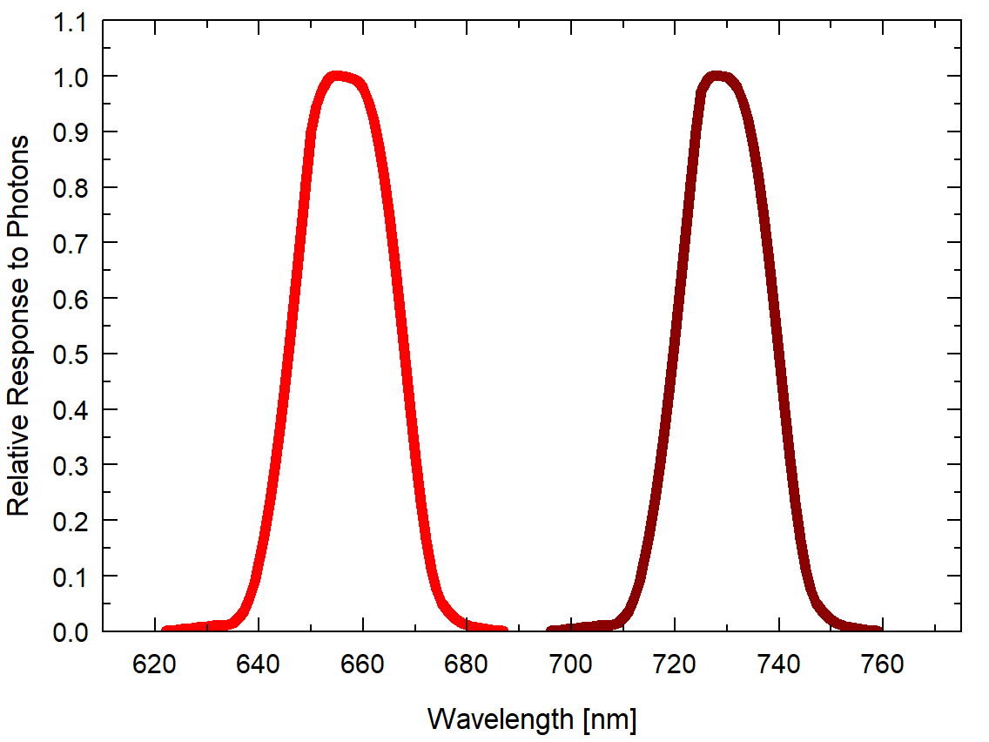

Deployment and Installation
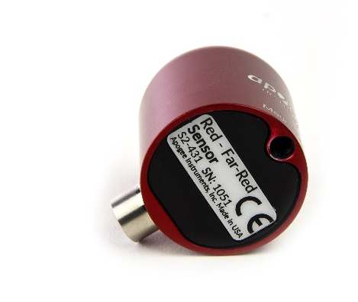
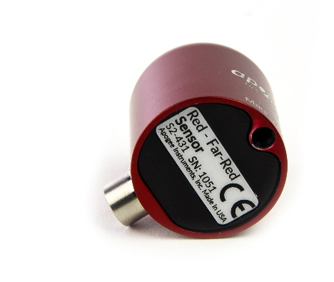
Mount the sensor to a solid surface with the nylon mounting screw provided to prevent galvanic corrosion. To accurately measure red and far-red photon flux density incident on a horizontal surface, the sensor must be level. An Apogee Instruments model AL-100 Leveling Plate is recommended to level the sensor when used on a flat surface or being mounted to surfaces such as wood. To facilitate mounting on a mast or pipe, the Apogee Instruments model AL-120 Solar Mounting Bracket with Leveling Plate is recommended.

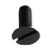
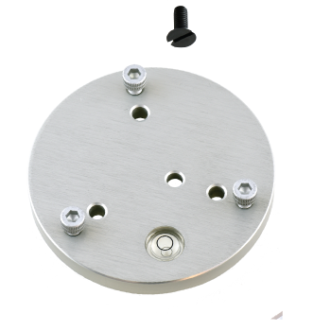
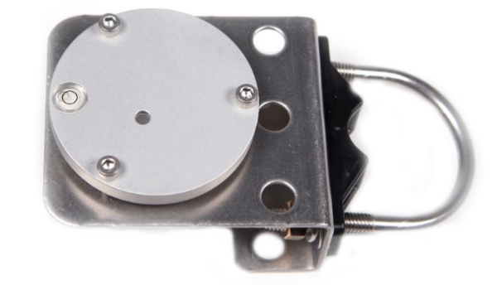
Nylon Screw: 10-32x3/8

Nylon Screw: 10-32x3/8

Model AL-120
Model AL-100

To minimize azimuth error, the sensor should be mounted with the cable pointing toward true north in the northern hemisphere or true south in the southern hemisphere. Azimuth error is typically less than 1 %, but it is easy to minimize by proper cable orientation.
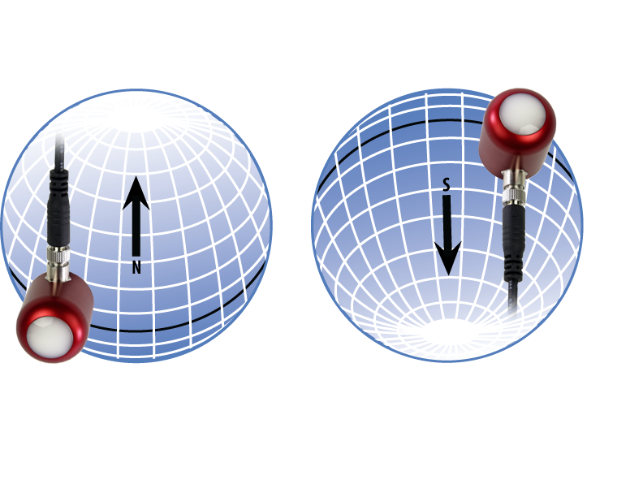
In addition to orienting the cable to point toward the nearest pole, the sensor should also be mounted such that obstructions (e.g., weather station tripod/tower or other instrumentation) do not shade the sensor. Once mounted, the green cap should be removed from the sensor. The green cap can be used as a protective covering for the sensor when it is not in use.

Cable Connectors
Apogee sensors offer cable connectors to simplify the process of removing sensors from weather stations for calibration (the entire cable does not have to be removed from the station and shipped with the sensor).  The ruggedized M8 connectors are rated IP68, made of corrosion-resistant marine-grade stainless-steel, and designed for extended use in harsh environmental conditions. | 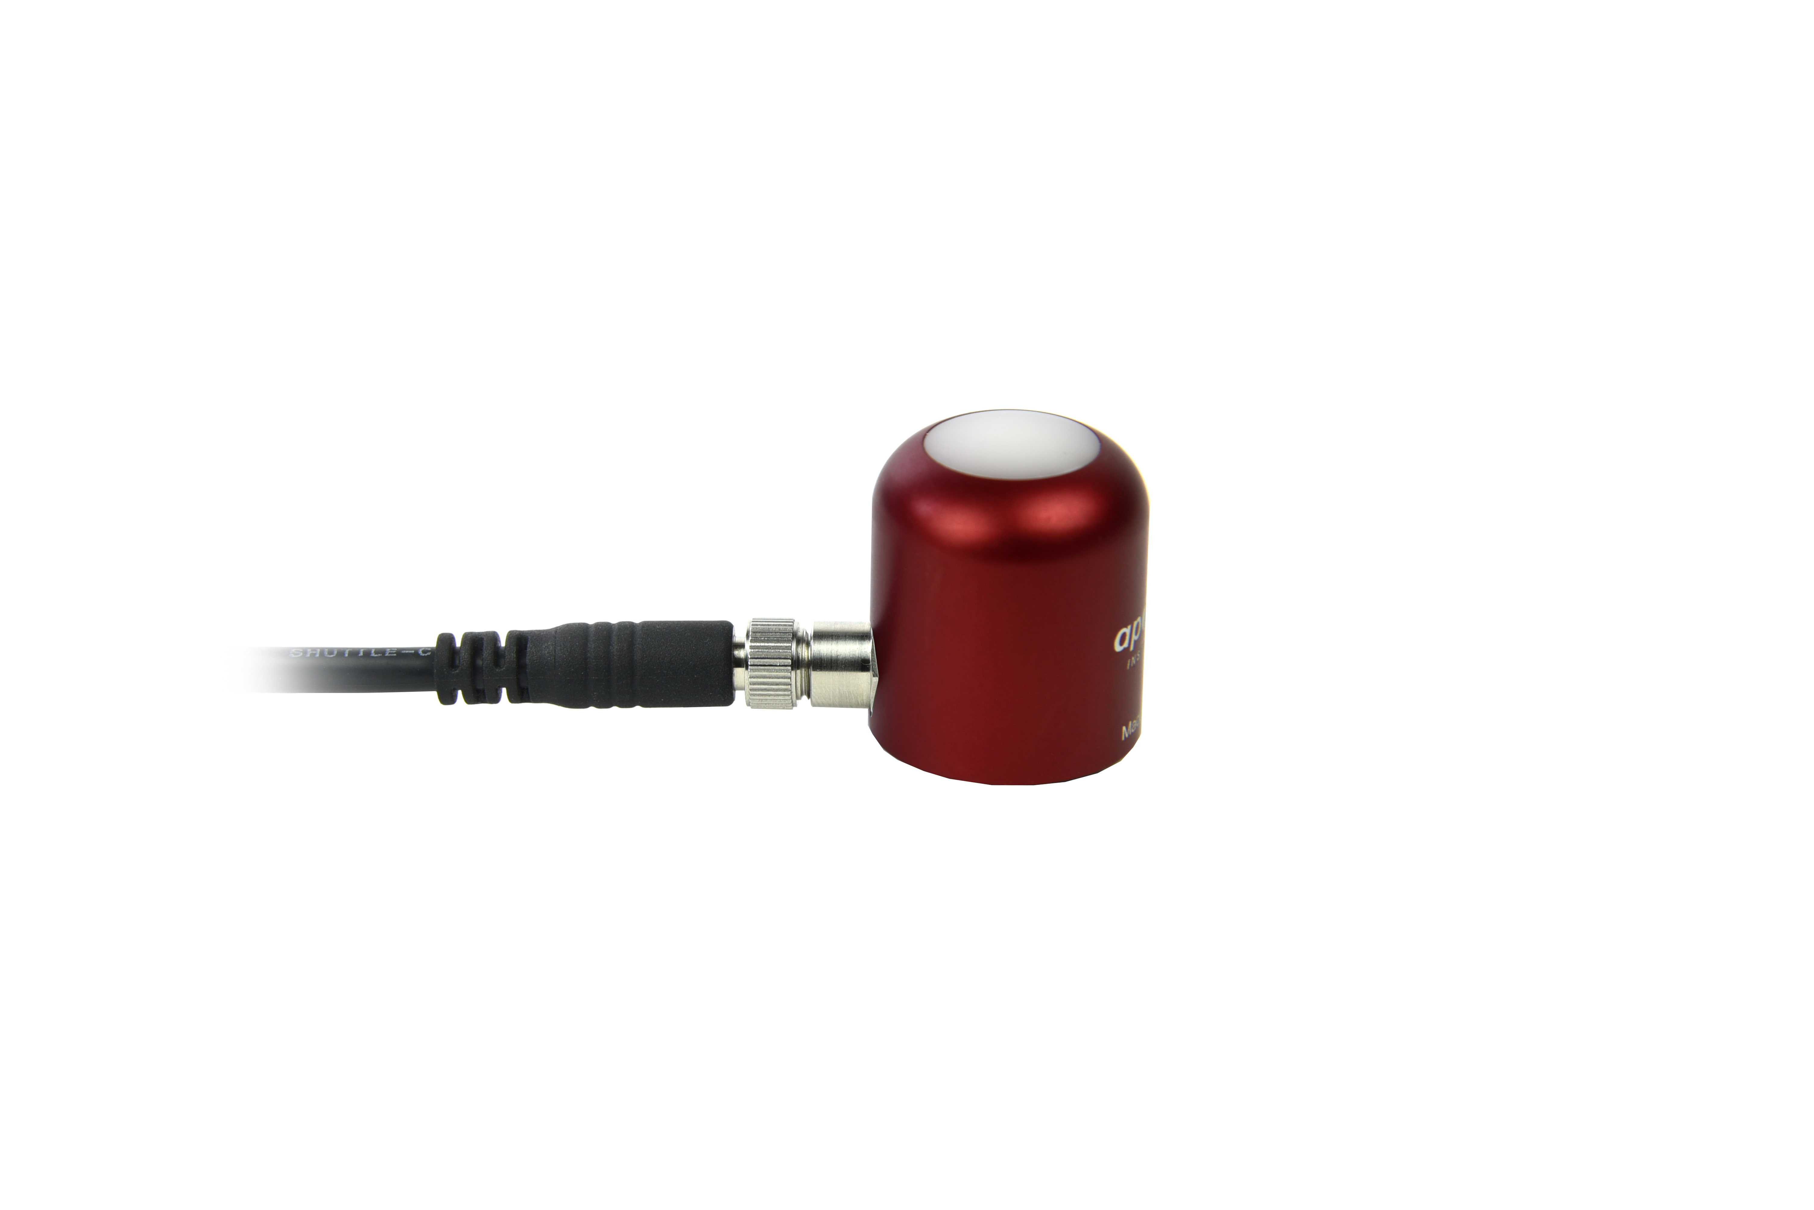  Cable connectors are attached directly to the head.
Instructions
Pins and Wiring Colors: All Apogee connectors have six pins, but not all pins are used for every sensor. There may also be unused wire colors inside the cable. To simplify datalogger connection, we remove the unused pigtail lead colors at the datalogger end of the cable.  If a replacement cable is required, please contact Apogee directly to ensure ordering the proper pigtail configuration.  Alignment: When reconnecting a sensor, arrows on the connector jacket and an aligning notch ensure proper orientation.  Disconnection for extended periods: When disconnecting the sensor for an extended period of time from a station, protect the remaining half of the connector still on the station from water and dirt with electrical tape or other method. | 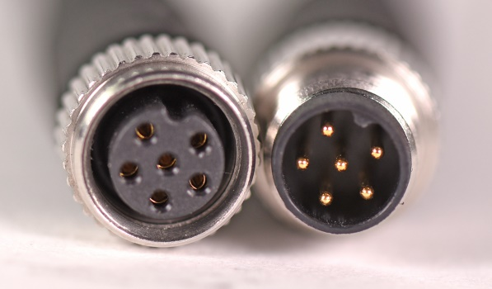  A reference notch inside the connector ensures  proper alignment before tightening.  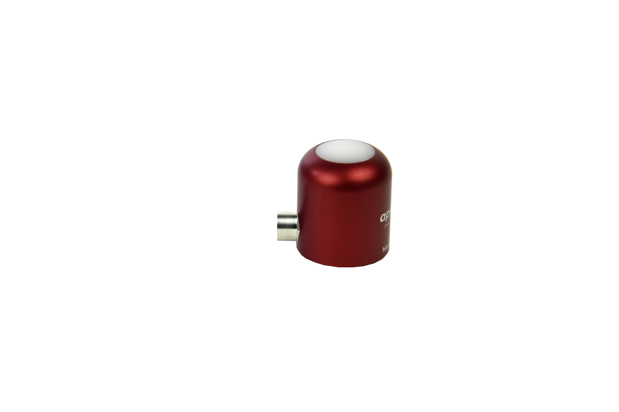  When sending sensors in for calibration, only send the sensor head.
Tightening: Connectors are designed to be firmly finger-tightened only. There is an o-ring inside the connector that can be overly compressed if a wrench is used. Pay attention to thread alignment to avoid cross-threading. When fully tightened, 1-2 threads may still be visible.  WARNING: Do not tighten the connector by twisting the black cable or sensor head, only twist the metal connector (blue arrows). | 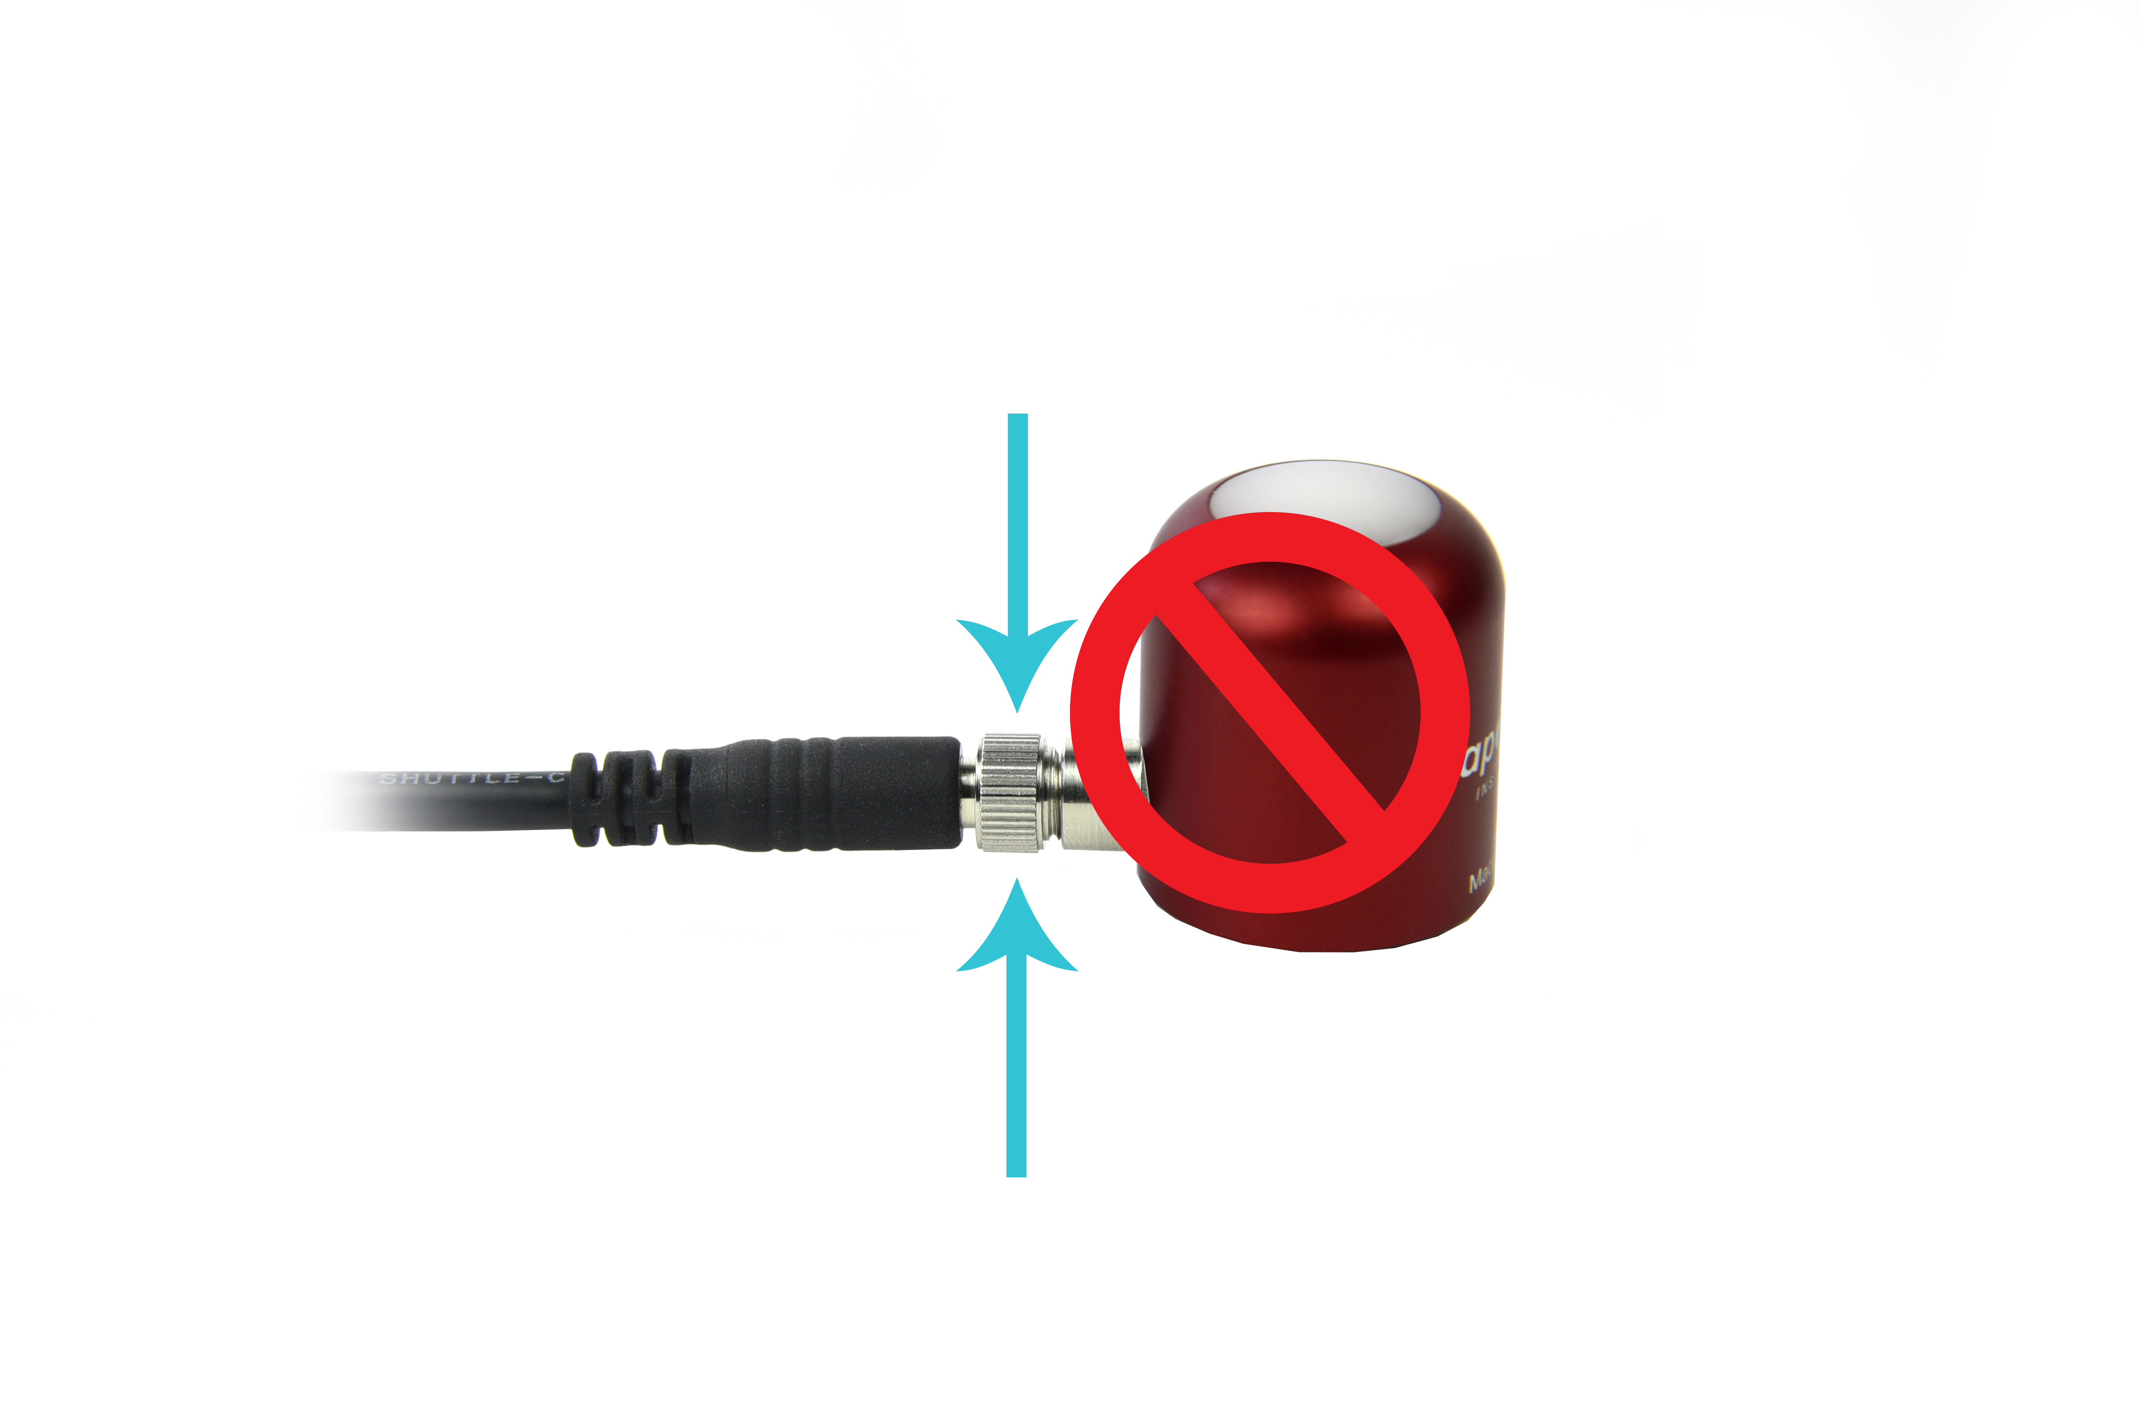  Finger-tighten firmly

Operation and Measurement

The S2-431 Red - Far-red sensor has a SDI-12 output, where red and far-red photon flux density is returned in digital format. Measurement of S2-431 Red - Far-red sensors requires a measurement device with SDI-12 functionality that includes the M or C command.

Wiring
White: Positive (signal from sensor)
Red: Input Power
Black: Ground (from sensor signal and output power)
Clear: Shield/Ground
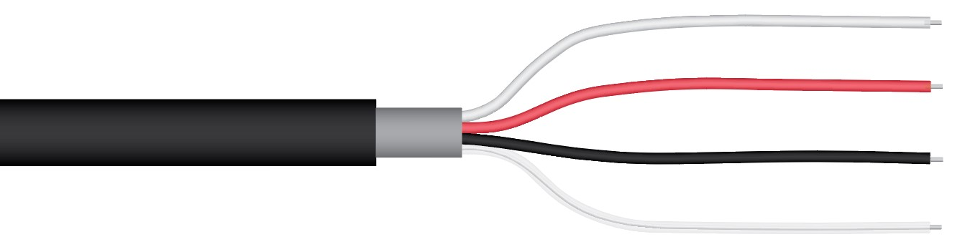

Sensor Calibration
All Apogee SDI-12 S2 sensor models have sensor-specific calibration coefficients determined during the custom calibration process. Coefficients are programmed into sensor microcontrollers at the factory.
SDI-12 Interface
The following is a brief explanation of the serial digital interface SDI-12 protocol instructions used in Apogee S2-431 Red - Far-red sensors. For questions on the implementation of this protocol, please refer to the official version of the SDI-12 protocol: http://www.sdi-12.org/specification.php (version 1.4, August 10, 2016).

Overview

During normal communication, the data recorder sends a packet of data to the sensor that consists of an address and a command. Then, the sensor sends a response. In the following descriptions, SDI-12 commands and responses are enclosed in quotes. The SDI-12 address and the command/response terminators are defined as follows:

Sensors come from the factory with the address of “0” for use in single sensor systems. Addresses “1 to 9” and “A to Z”, or “a to z”, can be used for additional sensors connected to the same SDI-12 bus.

“!” is the last character of a command instruction. In order to be compliant with SDI-12 protocol, all commands must be terminated with a “!”. SDI-12 language supports a variety of commands. Supported commands for the Apogee Instruments SQ-400 series two-band radiometers are listed in the following table (“a” is the sensor address. The following ASCII Characters are valid addresses: “0-9” or “A-Z”). Please note that SDI-12 commands are case-sensitive.
Supported Commands for Apogee Instruments S2-400 Series Red - Far-red Sensors

Instruction Name | Instruction Syntax | Description
Address Query Command | ?! | Used when the address is unknown to have the sensor identify its address, all sensors on data line respond
Change Address Command | aAb! | Changes the sensor address from a to b
Acknowledge Active Command | a! | Responds if the sensor with address a is on the line
Send Identification Command (“I” command) | aI! | Responds with sensor information
Calibration Verification (“V” command) | aV! | Retrieves calibration coefficients
Measurement Command (“M” command) | aM! | Tells the sensor to take a measurement
Measurement Command w/ Check Character (“M” command) | aMC! | Tells the sensor to take a measurement and return it with a check character
Concurrent Measurement Command (“C” command) | aC! | Used to take a measurement when more than one sensor is used on the same data line
Concurrent Measurement Command w/ Check Character (“C” command) | aCC! | Used to take a measurement when more than one sensor is used on the same data line. Data is returned with a check character.
Get Data Command (“D” command) | aD0! | Retrieves the data from a sensor
Running Average Command | aXAVG! | Returns or sets the running average for sensor measurements.

Make Measurement Command: M!

The make measurement command signals a measurement sequence to be performed. Data values generated in response to this command are stored in the sensor's buffer for subsequent collection using “D” commands. Data will be retained in sensor storage until another “M”, “C”, or “V” command is executed. M commands are shown in the following examples:

Command | Response | Response to 0D0!
aM! or aM0! | a0011<cr><If> | Returns Ratio (Red / Far-red), Far-red Percentage ((FR / total) x 100) values
aM1! | a0012<cr><If> | Returns calibrated lower wavelength output and calibrated upper wavelength output in µmol m⁻² s⁻¹
aM2! | a0012<cr><If> | Returns lower wavelength detector millivolts and upper wavelength detector millivolts
aM3! | a0013<cr><If> | Returns angle offset from vertical in degrees. (0 degrees if pointed up, 180 degrees if pointed down.)
aMC0! | a0011<cr><If> | Returns Ratio (Red / Far-red), Far-red Percentage ((FR / total) x 100) values w/CRC
aMC1! | a0012<cr><If> | Returns calibrated lower wavelength output and calibrated upper wavelength output in µmol m⁻² s⁻¹ w/ CRC
aMC2! | a0012<cr><If> | Returns lower wavelength detector millivolts and upper wavelength detector millivolts w/ CRC
aMC3! | a0013<cr><If> | Returns angle offset from vertical in degrees. (0 degrees if pointed up, 180 degrees if pointed down.) w/ CRC

“<cf>” is a carriage return and “<lf>” is line feed

where a is the sensor address (“0-9”, “A-Z”, “a-z”) and M is an upper-case ASCII character.

The data values are separated by the sign “+”, as in the following example (0 is the address):

Command | Sensor Response | Sensor Response when data is ready
0M0! | 00011<cr><lf> | 0<cr><lf>
0D0! | 0+2.0+20.0<cr><lf>
0M1! | 00012<cr><lf> | 0<cr><lf>
0D0! | 0+200.0+200.0<cr><lf>
0M2! | 00012<cr><If> | 0<cr><If>
0D0! | 0+20.0+20.0<cr><If>
0M3! | 00013<cr><If> | 0<cr><If>
0D0! | 0+35.2<cr><If>

where 200.0 is µmol m⁻² s⁻¹.

Concurrent Measurement Command: aC!

A concurrent measurement is one which occurs while other SDI-12 sensors on the bus are also making measurements. This command is similar to the “aM!” command, however, the nn field has an extra digit and the sensor does not issue a service request when it has completed the measurement. Communicating with other sensors will NOT abort a concurrent measurement. Data values generated in response to this command are stored in the sensor's buffer for subsequent collection using “D” commands. The data will be retained in the sensor until another “M”, “C”, or “V” command is executed:

Command | Response | Response to 0D0!
aC! or aC0! | a00101<cr><lf> | Returns Ratio (Red / Far-red), Far-red Percentage ((FR / total) x 100) values
aC1! | a00102<cr><lf> | Returns calibrated lower wavelength output and calibrated upper wavelength output in µmol m⁻² s⁻¹
aC2! | a00102<cr><lf> | Returns lower wavelength detector millivolts and upper wavelength detector millivolts
aC3! | a00103<cr><lf> | Returns angle offset from vertical in degrees. (0 degrees if pointed up, 180 degrees if pointed down.)
aCC! or aCC0! | a00101<cr><lf> | Returns Ratio (Red / Far-red), Far-red Percentage ((FR / total) x 100) values w/CRC
aCC1! | a00102<cr><lf> | Returns calibrated lower wavelength output and calibrated upper wavelength output in µmol m⁻² s⁻¹ w/CRC
aCC2! | a00102<cr><lf> | Returns lower wavelength detector millivolts and upper wavelength detector millivolts w/CRC
aCC3! | a00103<cr><lf> | Returns angle offset from vertical in degrees. (0 degrees if pointed up, 180 degrees if pointed down.) w/CRC

where a is the sensor address (“0-9”, “A-Z”, “a-z”, “*”, “?”) and C is an upper-case ASCII character.

For example (0 is the address):

Command | Sensor Response
0C0! | 000101<cr><lf>
0D0! | 0+2.0+20.0<cr><lf>
0C1! | 000102<cr><If>
0D0! | 0+200.0+200.0<cr><lf>
0C2! | 000102<cr><lf>
0D0! | 0+20.0+20.0<cr><If>
0C3! | 000101<cr><If>
0D0! | 0+35.2<cr><If>

where 200.0 is µmol m⁻² s⁻¹ and 20.0 is mV.
Change Sensor Address: aAb!

The change sensor address command allows the sensor address to be changed. If multiple SDI-12 devices are on the same bus, each device will require a unique SDI-12 address. For example, two SDI-12 sensors with the factory address of 0 requires changing the address on one of the sensors to a non-zero value in order for both sensors to communicate properly on the same channel:

Command | Response | Description
aAb! | b<cr><lf> | Change the address of the sensor

where a is the current (old) sensor address (“0-9”, “A-Z”), A is an upper-case ASCII character denoting the instruction for changing the address, b is the new sensor address to be programmed (“0-9”, “A-Z”), and ! is the standard character to execute the command. If the address change is successful, the datalogger will respond with the new address and a <cr><lf>.
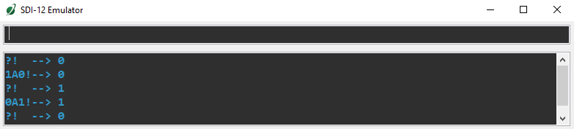

Send Identification Command: aI!

The send identification command responds with sensor vendor, model, and version data. Any measurement data in the sensor's buffer is not disturbed:

Command | Response | Description
"aI!" | a13Apogee S2-431vvvxx…xx<cr><lf> | The sensor serial number and other identifying values are returned

where a is the sensor address (“0-9”, “A-Z”, “a-z”, “*”, “?”), 431 is the sensor model number, vvv is a three character field specifying the sensor version number, and xx...xx is serial number.
Running Average Command

The running average command can be used to set or query the number of measurements that are averaged together before returning a value from a M! or MC! command. For example, if a user sends the command “0XAVG10!” to sensor with address 0, that sensor will average 10 measurements before sending the averaged value to the logger. To turn off averaging, the user should send the command “aXAVG1” to the sensor. To query the sensor to see how many measurements are being averaged, send the command “aXAVG!” and the sensor will return the number of measurements being averaged (see table below). The default for sensors is to have averaging turned off.

Command Name | Characters Sent | Response | Description
Query running Average | aXAVG! | an | a = sensor address, n = number of measurements used in average calculation. Note: n may be multiple digits.
Set running Average | aXAVGn! | a | a = sensor address, n = number of measurements to be used in average calculation. Note: n may be any value from 1 to 100.

Maintenance and Recalibration
Dust or organic deposits are best removed using water or window cleaner and a soft cloth or cotton swab. Salt deposits should be dissolved with vinegar and removed with a soft cloth or cotton swab.
Blocking of the optical path between the target and detector can cause low readings. Occasionally, accumulated materials on the diffuser of the upward-looking radiometer and in the apertures of the downward-looking radiometer can block the optical path in three common ways:
- Moisture or debris on the diffuser (upward-looking) or in the apertures (downward-looking).
- Dust during periods of low rainfall.
- Salt deposit accumulation from evaporation of sea spray or sprinkler irrigation water.
Apogee Instruments Red - Far-red have a domed diffuser and housing for improved self-cleaning from rainfall but active cleaning may be necessary. Dust or organic deposits are best removed using water, or window cleaner, and a soft cloth or cotton swab. Salt deposits should be dissolved with vinegar and removed with a cloth or cotton swab. Salt deposits cannot be removed with solvents such as alcohol or acetone. Use only gentle pressure when cleaning the diffuser with a cotton swab or soft cloth, to avoid scratching the outer surface. The solvent should be allowed to do the cleaning, not mechanical force. Never use an abrasive material or cleaner on the diffuser.
It is recommended that two-band radiometers be recalibrated every two years. See the Apogee webpage for details regarding return of sensors for recalibration (http://www.apogeeinstruments.com/tech-support-recalibration-repairs/).

Troubleshooting and Customer Support
Independent Verification of Functionality
If the sensor does not communicate with the datalogger, use an ammeter to check the current drain. It should be near 1.8 mA when the sensor is not communicating and spike to approximately 1.9 mA when the sensor is communicating. Any current drain greater than approximately 6 mA indicates a problem with power supply to the sensors, wiring of the sensor, or sensor electronics.
Compatible Measurement Devices (Dataloggers/Controllers/Meters)
Any datalogger or meter with SDI-12 functionality that includes the M or C command.
An example datalogger program for Campbell Scientific dataloggers can be found on the Apogee webpage at http://www.apogeeinstruments.com/downloads/#datalogger.
Modifying Cable Length
SDI-12 protocol limits cable length to 60 meters. For multiple sensors connected to the same data line, the maximum is 600 meters of total cable (e.g., ten sensors with 60 meters of cable per sensor). See Apogee webpage for details on how to extend sensor cable length (http://www.apogeeinstruments.com/how-to-make-a-weatherproof-cable-splice/).

Return and Warranty Policy

RETURN POLICY
Apogee Instruments will accept returns within 30 days of purchase as long as the product is in new condition (to be determined by Apogee). Returns are subject to a 10 % restocking fee.

WARRANTY POLICY
What is Covered
All products manufactured by Apogee Instruments are warranted to be free from defects in materials and craftsmanship for a period of four (4) years from the date of shipment from our factory. To be considered for warranty coverage an item must be evaluated by Apogee.
Products not manufactured by Apogee (spectroradiometers, chlorophyll content meters, EE08-SS probes) are covered for a period of one (1) year.
What is Not Covered
The customer is responsible for all costs associated with the removal, reinstallation, and shipping of suspected warranty items to our factory.
The warranty does not cover equipment that has been damaged due to the following conditions:
1. Improper installation, use, or abuse.
2. Operation of the instrument outside of its specified operating range.
3. Natural occurrences such as lightning, fire, etc.
4. Unauthorized modification.
5. Improper or unauthorized repair.
Please note that nominal accuracy drift is normal over time. Routine recalibration of sensors/meters is considered part of proper maintenance and is not covered under warranty.
Who is Covered
This warranty covers the original purchaser of the product or other party who may own it during the warranty period.
What Apogee Will Do
At no charge Apogee will:
1. Either repair or replace (at our discretion) the item under warranty.
2. Ship the item back to the customer by the carrier of our choice.
Different or expedited shipping methods will be at the customer’s expense.

How To Return An Item
1. Please do not send any products back to Apogee Instruments until you have received a Return Merchandise Authorization (RMA) number from our technical support department by submitting an online RMA form at www.apogeeinstruments.com/tech-support-recalibration-repairs/. We will use your RMA number for tracking of the service item. Call (435) 245-8012 or email techsupport@apogeeinstruments.com with questions.
2. For warranty evaluations, send all RMA sensors and meters back in the following condition: Clean the sensor’s exterior and cord. Do not modify the sensors or wires, including splicing, cutting wire leads, etc. If a connector has been attached to the cable end, please include the mating connector – otherwise the sensor connector will be removed in order to complete the repair/recalibration. Note: When sending back sensors for routine calibration that have Apogee’s standard stainless-steel connectors, you only need to send the sensor with the 30 cm section of cable and one-half of the connector. We have mating connectors at our factory that can be used for calibrating the sensor.
3. Please write the RMA number on the outside of the shipping container.
4. Return the item with freight pre-paid and fully insured to our factory address shown below. We are not responsible for any costs associated with the transportation of products across international borders.
Apogee Instruments, Inc.
721 West 1800 North Logan, UT
84321, USA
5. Upon receipt, Apogee Instruments will determine the cause of failure. If the product is found to be defective in terms of operation to the published specifications due to a failure of product materials or craftsmanship, Apogee Instruments will repair or replace the items free of charge. If it is determined that your product is not covered under warranty, you will be informed and given an estimated repair/replacement cost.

Products Beyond the Warranty Period
For issues with sensors beyond the warranty period, please contact Apogee at techsupport@apogeeinstruments.com to discuss repair or replacement options.

Other Terms
The available remedy of defects under this warranty is for the repair or replacement of the original product, and Apogee Instruments is not responsible for any direct, indirect, incidental, or consequential damages, including but not limited to loss of income, loss of revenue, loss of profit, loss of data, loss of wages, loss of time, loss of sales, accruement of debts or expenses, injury to personal property, or injury to any person or any other type of damage or loss.
This limited warranty and any disputes arising out of or in connection with this limited warranty ("Disputes") shall be governed by the laws of the State of Utah, USA, excluding conflicts of law principles and excluding the Convention for the International Sale of Goods. The courts located in the State of Utah, USA, shall have exclusive jurisdiction over any Disputes.
This limited warranty gives you specific legal rights, and you may also have other rights, which vary from state to state and jurisdiction to jurisdiction, and which shall not be affected by this limited warranty. This warranty extends only to you and cannot by transferred or assigned. If any provision of this limited warranty is unlawful, void, or unenforceable, that provision shall be deemed severable and shall not affect any remaining provisions. In case of any inconsistency between the English and other versions of this limited warranty, the English version shall prevail.
This warranty cannot be changed, assumed, or amended by any other person or agreement
APOGEE INSTRUMENTS, INC. | 721 WEST 1800 NORTH, LOGAN, UTAH 84321, USA
TEL: (435) 792-4700 | FAX: (435) 787-8268 | WEB: APOGEEINSTRUMENTS.COM
Copyright © 2022 Apogee Instruments, Inc.

