

Owner’s Manual

Infrared radiometer
Models SI-4HR
Rev: 28-Oct-2020
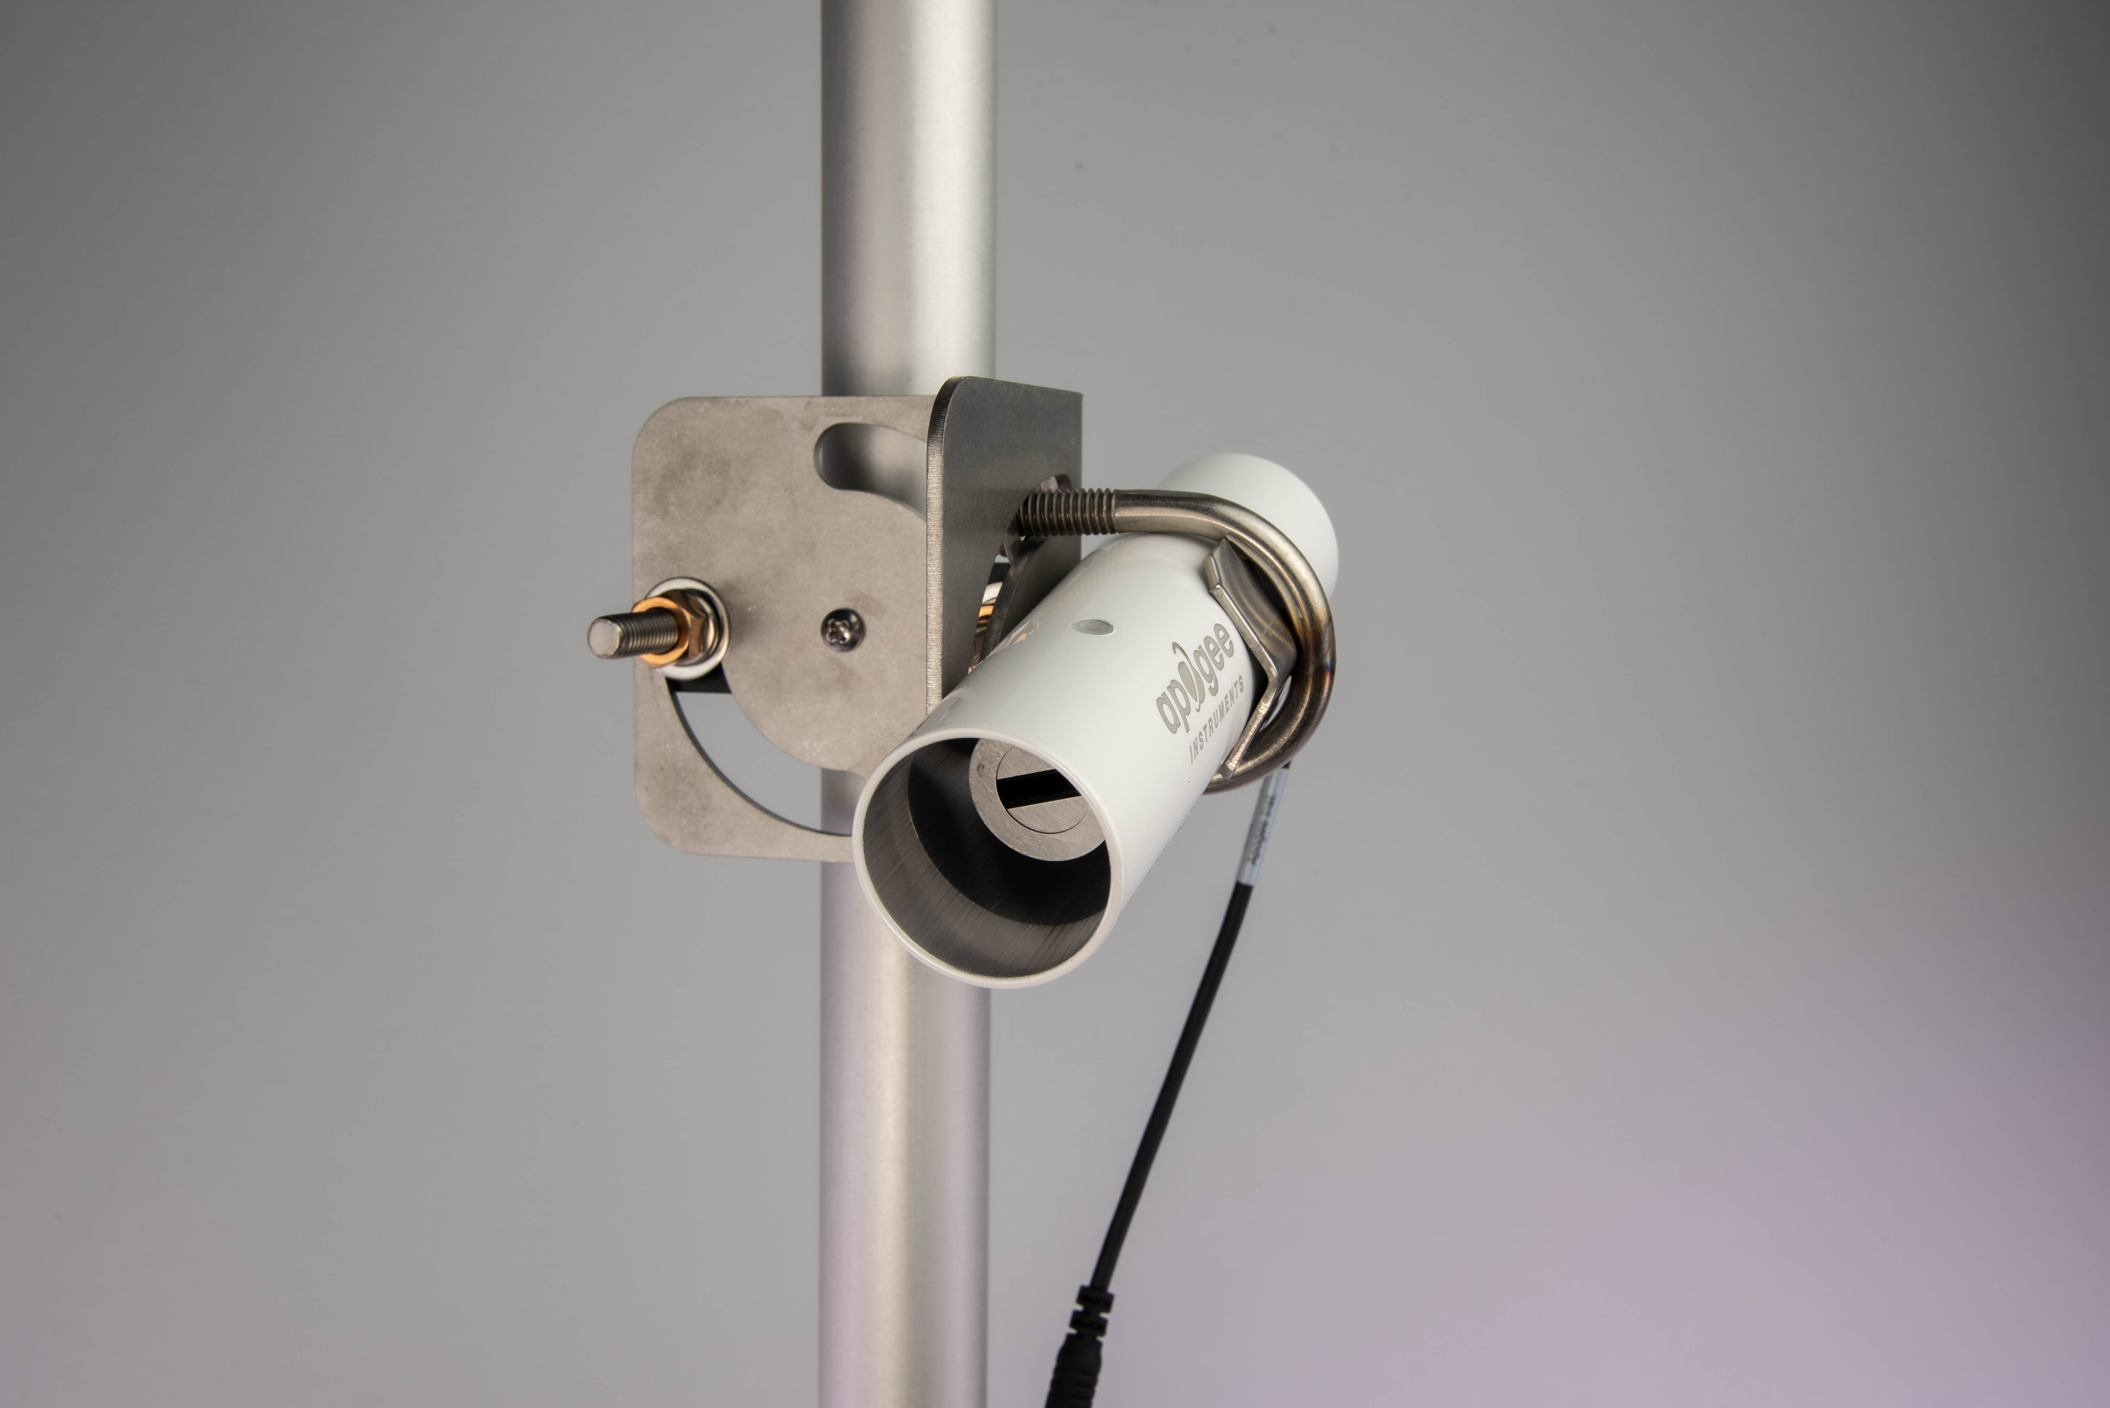
Table of Contents
Owner’s Manual 1
Declaration of Conformity 3
Introduction 4
Sensor Models 5
Specifications 6
Deployment and Installation 7
Cable Connectors 9
Operation and Measurement 10
Maintenance and Recalibration 18
Troubleshooting and Customer Support 19
Return and Warranty Policy 20

Declaration of Conformity

EU Declaration of Conformity
This declaration of conformity is issued under the sole responsibility of the manufacturer:
Apogee Instruments, Inc.
721 W 1800 N
Logan, Utah 84321
USA
for the following product(s):

Models: SI-4HR
Type: Infrared Radiometer

The object of the declaration described above is in conformity with the relevant Union harmonization legislation:

2014/30/EU Electromagnetic Compatibility (EMC) Directive
2011/65/EU Restriction of Hazardous Substances (RoHS 2) Directive
2015/863/EU Amending Annex II to Directive 2011/65/EU (RoHS 3)

Standards referenced during compliance assessment:

EN 61326-1:2013 Electrical equipment for measurement, control and laboratory use – EMC requirements
EN 50581:2012 Technical documentation for the assessment of electrical and electronic products with respect to the restriction of hazardous substances

Please be advised that based on the information available to us from our raw material suppliers, the products manufactured by us do not contain, as intentional additives, any of the restricted materials including lead (see note below), mercury, cadmium, hexavalent chromium, polybrominated biphenyls (PBB), polybrominated diphenyls (PBDE), bis(2-ethylhexyl) phthalate (DEHP), butyl benzyl phthalate (BBP), dibutyl phthalate (DBP), and diisobutyl phthalate (DIBP). However, please note that articles containing greater than 0.1% lead concentration are RoHS 3 compliant using exemption 6c.

Further note that Apogee Instruments does not specifically run any analysis on our raw materials or end products for the presence of these substances, but rely on the information provided to us by our material suppliers.

Signed for and on behalf of:
Apogee Instruments, October 2020

Bruce Bugbee
President
Apogee Instruments, Inc.

Introduction
All objects with a temperature above absolute zero emit electromagnetic radiation. The wavelengths and intensity of radiation emitted are related to the temperature of the object. Terrestrial surfaces (e.g., soil, plant canopies, water, snow) emit radiation in the mid infrared portion of the electromagnetic spectrum (approximately 4-50 µm).
Infrared radiometers are sensors that measure infrared radiation, which is used to determine surface temperature without touching the surface (when using sensors that must be in contact with the surface, it can be difficult to maintain thermal equilibrium without altering surface temperature). Infrared radiometers are often called infrared thermometers because temperature is the desired quantity, even though the sensors detect radiation.
Typical applications of infrared radiometers include plant canopy temperature measurement for use in plant water status estimation, road surface temperature measurement for determination of icing conditions, and terrestrial surface (soil, vegetation, water, snow) temperature measurement in energy balance studies.
Apogee Instruments SI series infrared radiometers consist of a thermopile detector, germanium filter, precision thermistor (for detector reference temperature measurement), and signal processing circuitry mounted in an anodized aluminum housing, and a cable to connect the sensor to a measurement device. All radiometers also come with a radiation shield designed to minimize absorbed solar radiation, but still allowing natural ventilation. The radiation shield insulates the radiometer from rapid temperature changes and keeps the temperature of the radiometer closer to the target temperature. Sensors are potted solid with no internal air space and are designed for continuous temperature measurement of terrestrial surfaces in indoor and outdoor environments. SI-400 series sensors output a digital signal using SDI-12 protocol version 1.3.
The SI-4HR-SS infrared radiometer is developed for road weather networks specifically, with a 10° vertical field of view, allowing for remote detection of a narrow and distant target roadway. The rectangular-shaped aperture maximizes the horizontal field of view allowing for a larger integrated measurement without including undesired target areas such as sky or surrounding terrain.

Sensor Models
Model | Output
SI-400 Series | SDI-12
SI-100 Series | Voltage

Sensor model number and serial number are located on a label near the pigtail leads on the sensor cable. If the manufacturing date of a specific sensor is required, please contact Apogee Instruments with the serial number of the sensor.

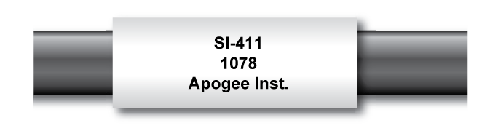

The FOV is shown below:

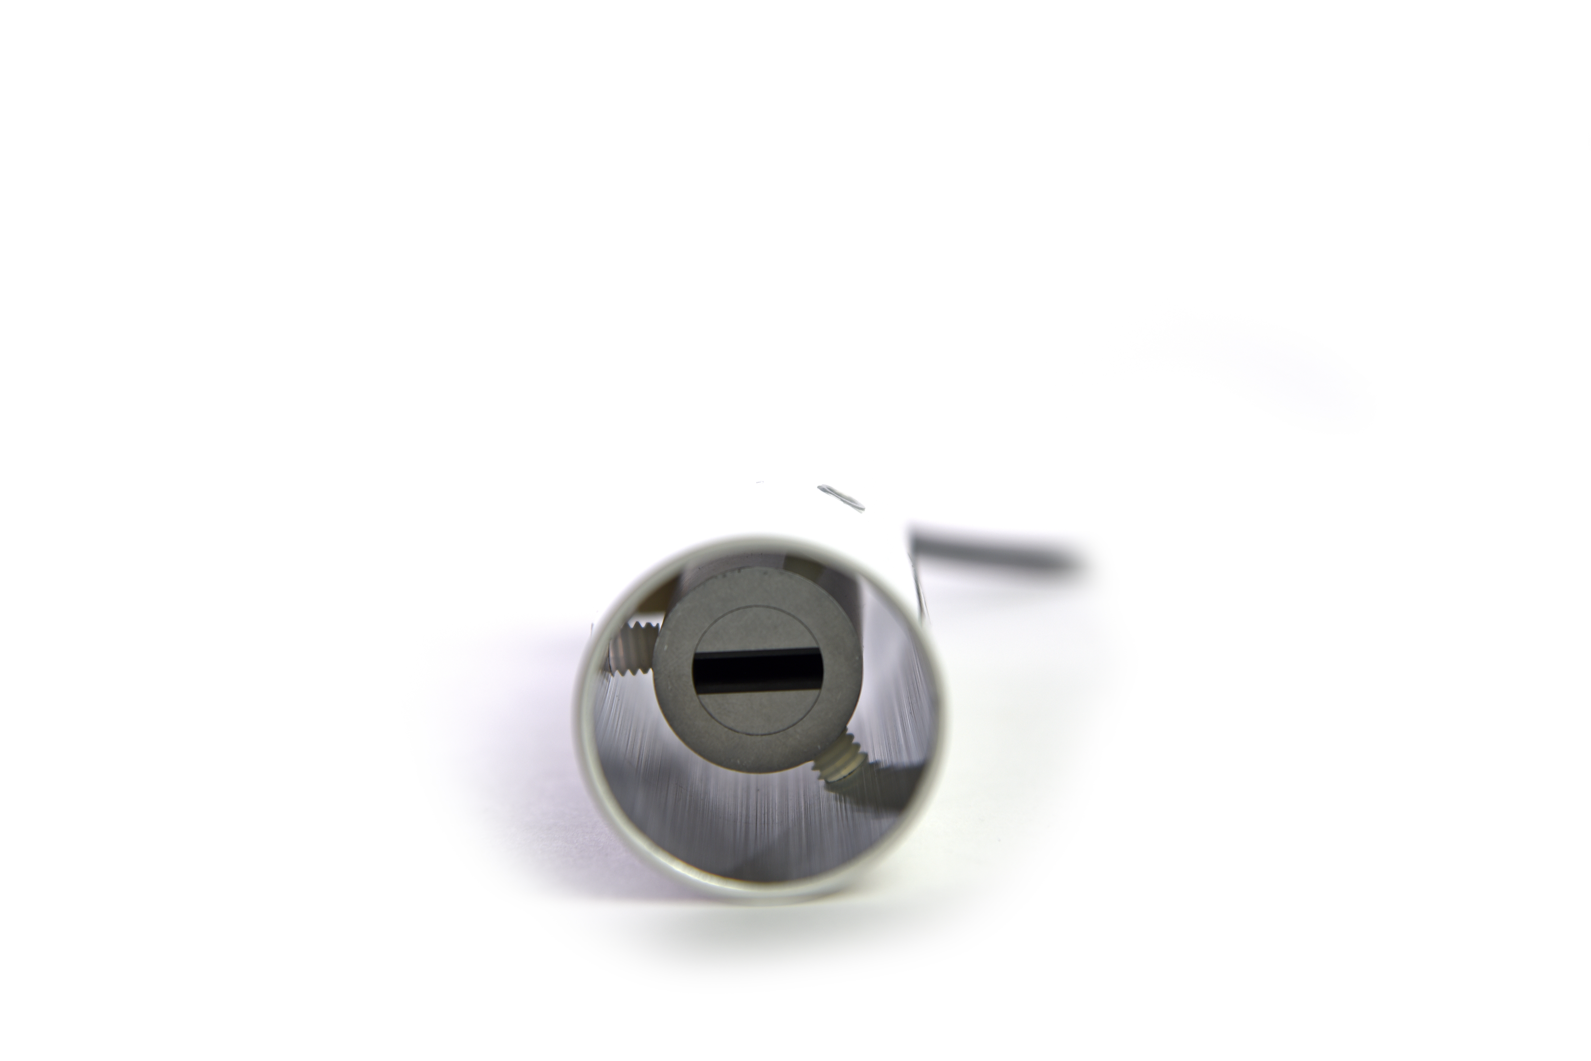

Specifications
 | SI-4HR-SS
Input Voltage Requirement | 5.5 to 24 V DC
Current Drain | 1.5 mA (quiescent), 2.0 mA (active)
Calibration Uncertainty (-30 to 65 C), when target and detector temperature are within 20 C | 0.3 C
Calibration Uncertainty (-40 to 80 C), when target and detector temperate are different by more than 20 C  (see Calibration Traceability below) | 0.5 C
Measurement Repeatability | Less than 0.05 C
Stability (Long-term Drift) | Less than 2 % change in slope per year when germanium filter is maintained in a clean condition (see Maintenance and Recalibration section below)
Response Time | 0.6 s, time for detector signal to reach 95 % following a step change; fastest data transmission rate for SDI-12 circuitry is 1 s
Field of View | 5° vertical half angle; 16° horizontal half angle
Spectral Range | 8 to 14 µm; atmospheric window (see Spectral Response below)
Operating Environment | -50 to 80 C; 0 to 100 % relative humidity (non-condensing)
Dimensions | 23 mm diameter; 76 mm length
Mass | 219 g (with 5m of lead wire)
Cable | 5 m of two conductor, shielded, twisted-pair wire; TPR jacket (high water resistance, high UV stability, flexibility in cold conditions); pigtail lead wires; stainless steel (316), M8 connector located 25 cm from sensor head
Calibration Traceability
Apogee SI series infrared radiometers are calibrated to the temperature of a custom blackbody cone held at multiple fixed temperatures over a range of radiometer (detector/sensor body) temperatures. The temperature of the blackbody cone is measured with replicate precision thermistors thermally bonded to the cone surface. The precision thermistors are calibrated for absolute temperature measurement against a platinum resistance thermometer (PRT) in a constant temperature bath. The PRT calibration is directly traceable to the NIST.
Spectral Response
Spectral response of SI series infrared radiometers. Spectral response (green line) is determined by the germanium filter and corresponds closely to the atmospheric window of 8-14 µm, minimizing interference from atmospheric absorption/emission bands (blue line) below 8 µm and above 14 µm. Typical terrestrial surfaces have temperatures that yield maximum radiation emission within the atmospheric window, as shown by the blackbody curve for a radiator at 28 C (red line).
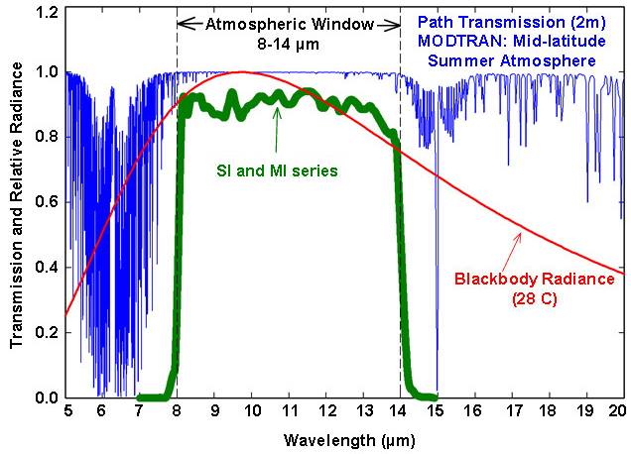

Deployment and Installation
The mounting geometry (distance from target surface, angle of orientation relative to target surface) is determined by the desired area of surface to be measured. The field of view extends unbroken from the sensor to the target surface. Sensors must be carefully mounted in order to view the desired target and avoid including unwanted surfaces/objects in the field of view, thereby averaging unwanted temperatures with the target temperature (see Field of View below). Once mounted, the green cap must be removed. The green cap can be used as a protective covering for the sensor, when it is not in use.
An Apogee Instruments model AM-220 mounting bracket is recommended for mounting the sensor to a cross arm or pole. The AM-220 allows adjustment of the angle of the sensor with respect to the target and accommodates the radiation shield designed for all SI series infrared radiometers.

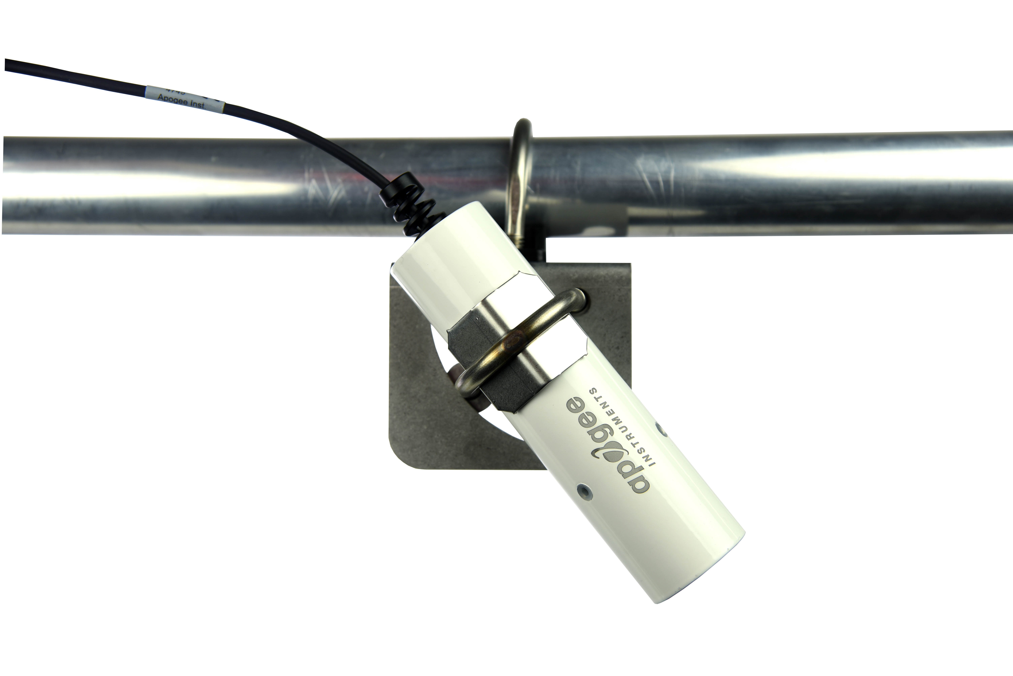

Field of View
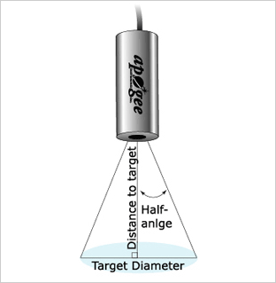
The field of view (FOV) is reported as the half-angle of the apex of the cone formed by the target surface (cone base) and the detector (cone apex), as shown below, where the target is defined as a circle from which 98 % of the radiation detected by the radiometer is emitted.

Sensor FOV, distance to target, and sensor mounting angle in relation to the target will determine target area. Different mounting geometries (distance and angle combinations) produce different target shapes and areas, as shown below.
CIRCULAR |  |  |  |  |  | HORIZONTAL
 |  |  | FOV Area (m²) |  |  |  |  | Half Angle |  | FOV Area (m²)
Type | Model | Half Angle | 0 Deg | 45 Deg | 60 Deg | Type | Model | Horizontal | Vertical | 0 Deg | 45 Deg | 60 Deg
Standard | SI-111 | 22° | 2.069 | 7.627 | 45.211 | Standard | SI-1H1 | 32° | 13° | 2.276 | 7.148 | 45.512
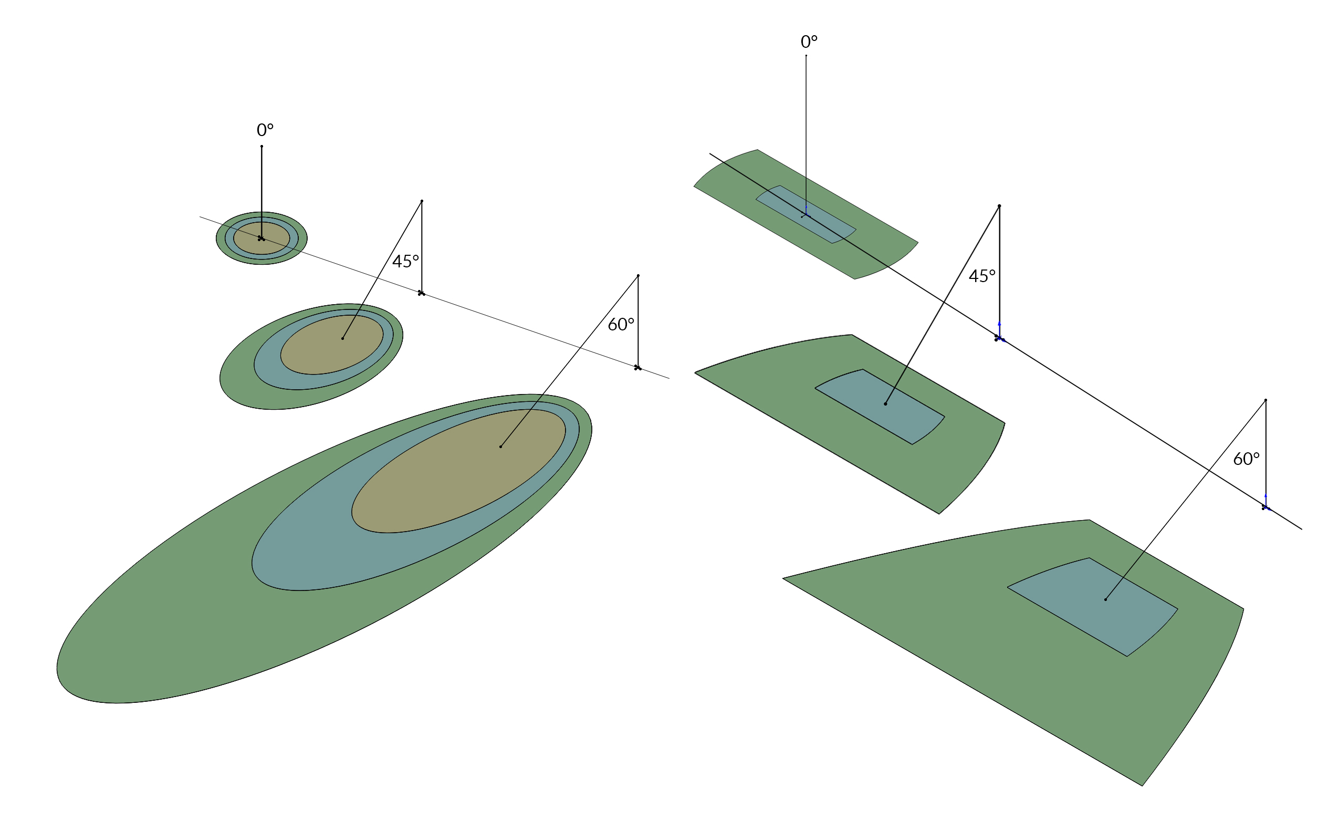Narrow | SI-121 | 18° | 1.337 | 4.461 | 18.865 | Narrow | SI-4HR | 16° | 5° | 0.403 | 1.15 | 3.341
Ultra-Narrow | SI-131 | 14° | 0.787 | 2.447 | 8.544

-

A simple FOV calculator for determining target dimensions based on infrared radiometer model, mounting height, and mounting angle, is available on the Apogee website: https://www.apogeeinstruments.com/irr-calculators.

Cable Connectors
Apogee offers in-line cable connectors on some bare-lead sensors to simplify the process of removing sensors from weather stations for calibration (the entire cable does not have to be removed from the station and shipped with the sensor).  The ruggedized M8 connectors are rated IP68, made of corrosion-resistant marine-grade stainless-steel, and designed for extended use in harsh environmental conditions. | 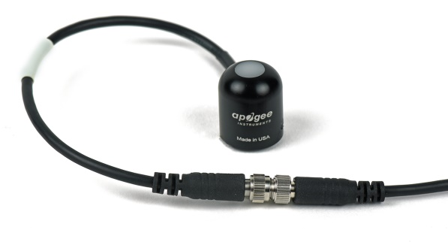  Inline cable connectors are installed 30 cm from the head  (pyranometer pictured)
Instructions
Pins and Wiring Colors: All Apogee connectors have six pins, but not all pins are used for every sensor. There may also be unused wire colors inside the cable. To simplify datalogger connection, we remove the unused pigtail lead colors at the datalogger end of the cable.  If a replacement cable is required, please contact Apogee directly to ensure ordering the proper pigtail configuration.  Alignment: When reconnecting a sensor, arrows on the connector jacket and an aligning notch ensure proper orientation.  Disconnection for extended periods: When disconnecting the sensor for an extended period of time from a station, protect the remaining half of the connector still on the station from water and dirt with electrical tape or other method. | 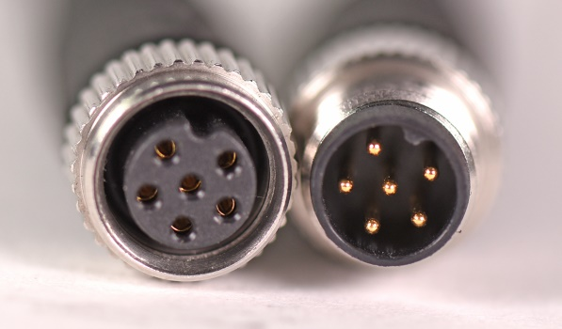  A reference notch inside the connector ensures  proper alignment before tightening.  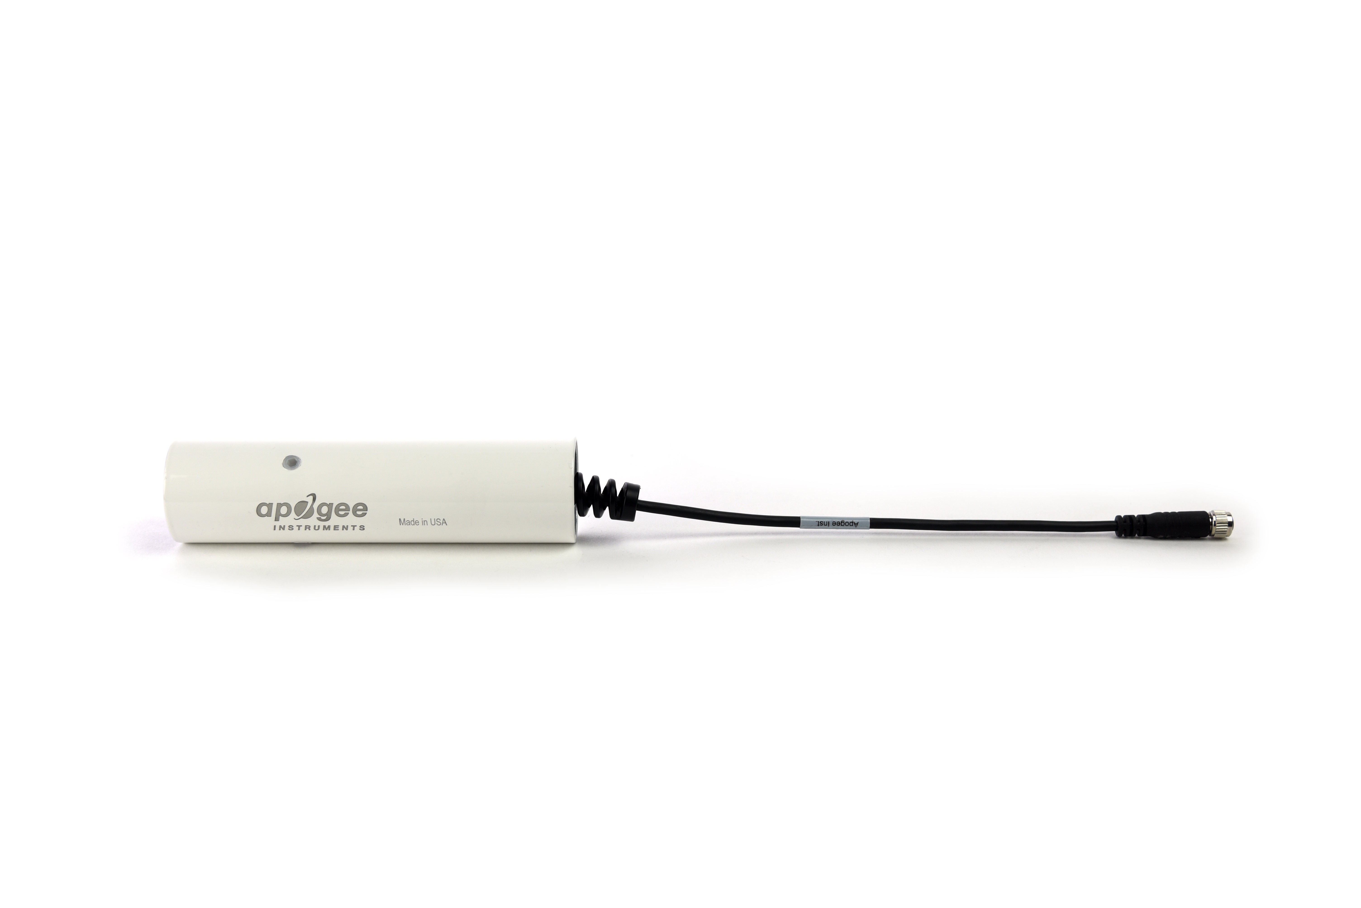  When sending sensors in for calibration, only send the short end of the cable and half the connector.
Tightening: Connectors are designed to be firmly finger-tightened only. There is an O-ring inside the connector that can be overly compressed if a wrench is used. Pay attention to thread alignment to avoid cross-threading. When fully tightened, 1-2 threads may still be visible. | 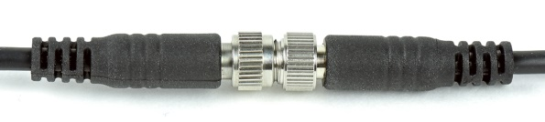  Finger-tighten firmly

Operation and Measurement
All SI-400 series radiometers have an SDI-12 output, where target and detector temperatures are returned in digital format. Measurement of SI-400 series radiometers requires a measurement device with SDI-12 functionality that includes the M or C command.
Wiring for SI-4HR-SS
White: SDI-12 Data Line
Red: Power In (4.5-24 V DC)
Black: Ground (for sensor signal and input power)
Clear: Shield/Ground
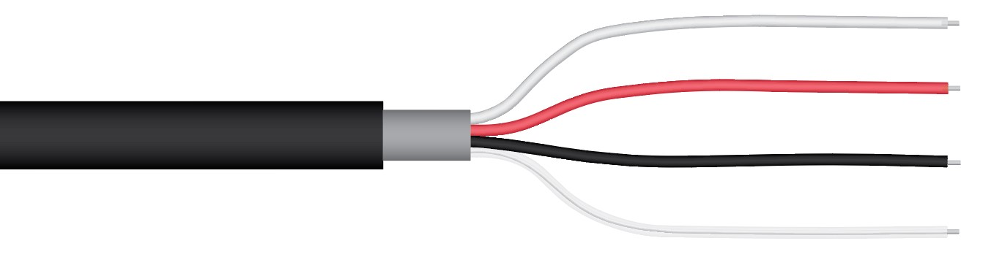

Sensor Calibration
Apogee SI series infrared radiometers are calibrated in a temperature controlled chamber that houses a custom-built blackbody cone (target) for the radiation source. During calibration, infrared radiometers (detectors) are held in a fixture at the opening of the blackbody cone, but are thermally insulated from the cone. Detector and target temperature are controlled independently. At each calibration set point, detectors are held at a constant temperature while the blackbody cone is controlled at temperatures below (12 C), above (18 C), and equal to the detector temperature. The range of detector temperatures is -15 C to 45 C (set points at 10 C increments). Data are collected at each detector temperature set point, after detectors and target reach constant temperatures.
All Apogee SDI-12 infrared radiometer models (SI-400 series) have sensor-specific calibration coefficients determined during the custom calibration process. Coefficients are programmed into the microcontroller at the factory. Calibration data for each sensor are provided on a calibration certificate (example shown on following page).

Calibration overview data are listed in box in upper left-hand corner, temperature errors are shown in graph, and calibration date is listed below descriptions of calibration procedure and traceability.
SDI-12 Interface
The following is a brief explanation of the serial digital interface SDI-12 protocol instructions used in Apogee SI-400 series infrared radiometers. For questions on the implementation of this protocol, please refer to the official version of the SDI-12 protocol: http://www.sdi-12.org/specification.php (version 1.4, August 10, 2016).

Overview

During normal communication, the data recorder sends a packet of data to the sensor that consists of an address and a command. Then, the sensor sends a response. In the following descriptions, SDI-12 commands and responses are enclosed in quotes. The SDI-12 address and the command/response terminators are defined as follows:

Sensors come from the factory with the address of “0” for use in single sensor systems. Addresses “1 to 9” and “A to Z”, or “a to z”, can be used for additional sensors connected to the same SDI-12 bus.

“!” is the last character of a command instruction. In order to be compliant with SDI-12 protocol, all commands must be terminated with a “!”. SDI-12 language supports a variety of commands. Supported commands for the Apogee Instruments SI-400 series infrared radiometers are listed in the following table (“a” is the sensor address. The following ASCII Characters are valid addresses: “0-9” or “A-Z”).

Supported Commands for Apogee Instruments SI-400 Series Infrared Radiometers

Instruction Name | Instruction Syntax | Description
Send Identification Command | aI! | Send Identification Information
Measurement Command | aM! | Tells the Sensor to take a Measurement
Measurement Command w/ Check Character | aMC! | Tells the Sensor to take a Measurement and return it with a Check Character
Change Address Command | aAb! | Changes the Address of the Sensor from a to b
Concurrent Measurement Command | aC! | Used to take a measurement when more than one sensor is used on the same data line
Concurrent Measurement Command w/ Check Character | aCC! | Used to take a measurement when more than one sensor is used on the same data line. Data is returned with a check character.
Address Query Command | ?! | Used when the address is unknown to have the sensor identify its address
Get Data Command | aD0! | Retrieves the data from a sensor
Running Average Command | aXAVG! | Returns or sets the running average for sensor measurements.

Make Measurement Command: M!

The make measurement command signals a measurement sequence to be performed. Data values generated in response to this command are stored in the sensor's buffer for subsequent collection using “D” commands. Data will be retained in sensor storage until another “M”, “C”, or “V” command is executed. M commands are shown in the following examples:

Command | Response | Response to 0D0!
aM! or aM0! | a0011<cr><lf> | Target temperature
aM1! | a0012<cr><lf> | Target temperature and sensor body temperature
aM2! | a0012<cr><If> | Target millivolts and sensor body temperature
aM3! | a0012<cr><If> | Returns angle offset from vertical in degrees. (0 degrees if pointed up, 180 degrees if pointed down.)
aMC! or aMC0! | a0011<cr><lf> | Target temperature w/ CRC
aMC1! | a0012<cr><lf> | Target temperature and sensor body temperature w/ CRC
aMC2! | a0012<cr><If> | Target millivolts and sensor body temperature w/CRC
aMC3! | a0012<cr><If> | Returns angle offset from vertical in degrees w/CRC. (0 degrees if pointed up, 180 degrees if pointed down.)
where a is the sensor address (“0-9”, “A-Z”, “a-z”) and M is an upper-case ASCII character.

The target temperature and sensor body temperature are separated by the sign “+” or “-“, as in the following example (0 is the address):

Command | Sensor Response | Sensor Response when data is ready
0M! | 00011<cr><lf> | 0<cr><lf>
0D0! | 0+23.4563<cr><lf>
0M1! | 00012<cr><lf> | 0<cr><lf>
0D0! | 0+23.4563+35.1236<cr><lf>
0M2! | 00012<cr><If> | 0<cr><If>
0D0! | 0+1.0+35.1236<cr><If>
0M3! | 00012<cr><If> | 0<cr><If>
0D0! | 0+90.2<cr><lf>

where 23.4563 is target temperature, 1.0 is target millivolts, and 35.1236 is detector (sensor body) temperature.

Concurrent Measurement Command: aC!

A concurrent measurement is one which occurs while other SDI-12 sensors on the bus are also making measurements. This command is similar to the “aM!” command, however, the nn field has an extra digit and the sensor does not issue a service request when it has completed the measurement. Communicating with other sensors will NOT abort a concurrent measurement. Data values generated in response to this command are stored in the sensor's buffer for subsequent collection using “D” commands. The data will be retained in the sensor until another “M”, “C”, or “V” command is executed:

Command | Response | Response to 0D0!
aC! | a00101<cr><lf> | Target temperature
aC1! | a00102<cr><lf> | Target temperature and sensor body temperature
aC2! | a00102<cr><If> | Target millivolts and sensor body temperature
aC3! | a00102<cr><If> | Returns angle offset from vertical in degrees. (0 degrees if pointed up, 180 degrees if pointed down.)
aCC! | a00101<cr><lf> | Target temperature w/ CRC
aCC1! | a00102<cr><lf> | Target temperature and sensor body temperature w/ CRC
aCC2! | a00102<cr><If> | Target millivolts and sensor body temperature w/CRC
aCC3! | a00102<cr><If> | Returns angle offset from vertical in degrees w/CRC. (0 degrees if pointed up, 180 degrees if pointed down.)

where a is the sensor address (“0-9”, “A-Z”, “a-z”, “*”, “?”) and C is an upper-case ASCII character.

For example (0 is the address):

Command | Sensor Response
0C! | 000101<cr><lf>
0D0! | 0+23.4563<cr><lf>
0C1! | 000102<cr><lf>
0D0! | 0+23.4563+35.1236<cr><lf>
0C2! | 000102<cr><If>
0D0! | 0+1.0+35.1236<cr><If>
0C3! | 000102<cr><If>
0D0! | 0+90.2<cr><lf>

where 23.4563 is target temperature, 1.0 is target millivolts, and 35.1236 is detector (sensor body) temperature.

Change Sensor Address: aAb!

The change sensor address command allows the sensor address to be changed. If multiple SDI-12 devices are on the same bus, each device will require a unique SDI-12 address. For example, two SDI-12 sensors with the factory address of 0 requires changing the address on one of the sensors to a non-zero value in order for both sensors to communicate properly on the same channel:

Command | Response | Description
aAb! | b<cr><lf> | Change the address of the sensor

where a is the current (old) sensor address (“0-9”, “A-Z”), A is an upper-case ASCII character denoting the instruction for changing the address, b is the new sensor address to be programmed (“0-9”, “A-Z”), and ! is the standard character to execute the command. If the address change is successful, the datalogger will respond with the new address and a <cr><lf>.

Send Identification Command: aI!

The send identification command responds with sensor vendor, model, and version data. Any
measurement data in the sensor's buffer is not disturbed:

Command | Response | Description
"aI!" | a13Apogee SI-4mmvvvxx…xx<cr><lf> | The sensor serial number and other identifying values are returned

where a is the sensor address (“0-9”, “A-Z”, “a-z”, “*”, “?”), mm is a the sensor model number (11, 21, 31, or H1), vvv is a three character field specifying the sensor version number, and xx...xx is serial number.

Running Average Command

The running average command can be used to set or query the number of measurements that are averaged together before returning a value from a M! or MC! command. For example, if a user sends the command “0XAVG10!” to sensor with address 0, that sensor will average 10 measurements before sending the averaged value to the logger. To turn off averaging, the user should send the command “aXAVG1” to the sensor. To query the sensor to see how many measurements are being averaged, send the command “aXAVG!” and the sensor will return the number of measurements being averaged (see table below). The default for sensors is to have averaging turned off.

Command Name | Characters Sent | Response | Description
Query running Average | aXAVG! | an | a = sensor address, n = number of measurements used in average calculation. Note: n may be multiple digits.
Set running Average | aXAVGn! | a | a = sensor address, n = number of measurements to be used in average calculation. Note: n may be any value from 1 to 100.

Metadata Commands
Identify Measurement Commands
The Identify Measurement Commands can be used to view the command response without making a measurement. The command response indicates the time it takes to make the measurement and the number of data values that it returns. It works with the Verification Command (aV!), Measurement Commands (aM!, aM1! … aM9!, aMC!, aMC1! … aMC9!), and Concurrent Measurement Commands (aC!, aC1! … aC9! , aCC!, aCC1! … aCC9!).
The format of the Identify Measurement Command is the address, the capital letter I, the measurement command, and the command terminator (“!”), as follows:
<address>I<command>!
The format of the response is the same as if the sensor is making a measurement. For the Verification Command and Measurement Commands, the response is atttn<CR><LF>. For the C Command, it is atttnn<CR><LF>. For the High Volume Commands, it is atttnnn<CR><LF>. The address is indicated by a, the time in seconds to make the measurement is indicated by ttt, and the number of measurements is indicated by n, nn, and nnn. The response is terminated with a Carriage Return (<CR>) and Line Feed (<LF>).
Identify Measurement Command example:
3IMC2! | The Identify Measurement Command for sensor address 3, M2 command, requesting a CRC.
30032<CR><LF> | The response from sensor address three indicating that the measurement will take three seconds and two data values will be returned.
Identify Measurement Parameter Commands
The Measurement Parameter Commands can be used to retrieve information about each data value that a command returns. The first value returned is a Standard Hydrometeorological Exchange Format (SHEF) code. SHEF codes are published by the National Oceanic and Atmospheric Administration (NOAA). The SHEF code manual can be found at http://www.nws.noaa.gov/oh/hrl/shef/indexshef.htm. The second value is the units of the parameter. Additional fields with more information are optional.
The Measurement Parameter Commands work with the Verification Command (aV!), Measurement Commands (aM!, aM1! … aM9!, aMC!, aMC1! … aMC9!), and Concurrent Measurement Commands (aC!, aC1! … aC9! , aCC!, aCC1! … aCC9!).
The format of the Identify Measurement Parameter Command is the address, the capital letter I, the measurement command, the underscore character (“_”), a three-digit decimal number, and the command terminator (“!”). The three-digit decimal indicates which number of measurement that the command returns, starting with “001” and continuing to “002” and so on, up to the number of measurements that the command returns.
<address>I<command>_<three-digit decimal>!
The format of the response is comma delimited and terminated with a semicolon. The first value is the address. The second value is the SHEF code. The third value is the units. Other optional values may appear, such as a description of the data value. The response is terminated with a Carriage Return (<CR>) and Line Feed (<LF>).
a,<SHEF Code>,<units>;<CR><LF>
Identify Measurement Parameter Command example:
1IC_001! | The Identify Measurement Parameter Command for sensor address 1, C command, data value 1.
1,RW,Watts/meter squared,incoming solar radiation;<CR><LF> | The response from sensor address 1, SHEF code RW, units of Watts/meter squared, and additional information of incoming solar radiation.
Target Temperature Measurement
SI-400 series infrared radiometers have an SDI-12 output. The following equations and the custom calibration coefficients described in this section are programmed into the microcontroller. Target temperature is output directly in digital format.
The detector output from SI series radiometers follows the fundamental physics of the Stefan-Boltzmann Law, where radiation transfer is proportional to the fourth power of absolute temperature. A modified form of the Stefan-Boltzmann equation is used to calibrate sensors, and subsequently, calculate target temperature:
(1)
where T_{T} is target temperature [K], T_{D} is detector temperature [K], S_{D} is the millivolt signal from the detector, m is slope, and b is intercept. The mV signal from the detector is linearly proportional to the energy balance between the target and detector, analogous to energy emission being linearly proportional to the fourth power of temperature in the Stefan-Boltzmann Law.
During the calibration process, m and b are determined at each detector temperature set point (10 C increments across a -15 C to 45 C range) by plotting measurements of T_{T}⁴ – T_{D}⁴ versus mV. The derived m and b coefficients are then plotted as function of T_{D} and second order polynomials are fitted to the results to produce equations that determine m and b at any T_{D}:
(2)
(3)
Where C2, C1, and C0 are the custom calibration coefficients listed on the calibration certificate (shown above) that comes with each SI-100 series radiometer (there are two sets of polynomial coefficients, one set for m and one set for b). Note that T_{D} is converted from Kelvin to Celsius (temperature in C equals temperature in K minus 273.15) before m and b are plotted versus T_{D}.
To make measurements of target temperatures, Eq. (1) is rearranged to solve for T_{T} [C], measured values of S_{D} and T_{D} are input, and predicted values of m and b are input:
(4)

Emissivity Correction
Appropriate correction for surface emissivity is required for accurate surface temperature measurements. The simple (and commonly made) emissivity correction, dividing measured temperature by surface emissivity, is incorrect because it does not account for reflected infrared radiation.
The radiation detected by an infrared radiometer includes two components: 1. radiation directly emitted by the target surface, and 2. reflected radiation from the background. The second component is often neglected. The magnitude of the two components in the total radiation detected by the radiometer is estimated using the emissivity (ε) and reflectivity (1 - ε) of the target surface:
(1)
where E_{Sensor} is radiance [W m⁻² sr⁻¹] detected by the radiometer, E_{Target} is radiance [W m⁻² sr⁻¹] emitted by the target surface, E_{Background} is radiance [W m⁻² sr⁻¹] emitted by the background (when the target surface is outdoors the background is generally the sky), and ε is the ratio of non-blackbody radiation emission (actual radiation emission) to blackbody radiation emission at the same temperature (theoretical maximum for radiation emission). Unless the target surface is a blackbody (ε = 1; emits and absorbs the theoretical maximum amount of energy based on temperature), E_{sensor} will include a fraction (1 – ε) of reflected radiation from the background.
Since temperature, rather than energy, is the desired quantity, Eq. (1) can be written in terms of temperature using the Stefan-Boltzmann Law, E = σT⁴ (relates energy being emitted by an object to the fourth power of its absolute temperature):
(2)
where T_{Sensor} [K] is temperature measured by the infrared radiometer (brightness temperature), T_{Target} [K] is actual temperature of the target surface, T_{Background} [K] is brightness temperature of the background (usually the sky), and σ is the Stefan-Boltzmann constant (5.67 x 10⁻⁸ W m⁻² K⁻⁴). The power of 4 on the temperatures in Eq. (2) is valid for the entire blackbody spectrum.
Rearrangement of Eq. (2) to solve for T_{Target} yields the equation used to calculate the actual target surface temperature (i.e., measured brightness temperature corrected for emissivity effects):
. (3)
Equations (1)-(3) assume an infinite waveband for radiation emission and constant ε at all wavelengths. These assumptions are not valid because infrared radiometers do not have infinite wavebands, as most correspond to the atmospheric window of 8-14 µm, and ε varies with wavelength. Despite the violated assumptions, the errors for emissivity correction with Eq. (3) in environmental applications are typically negligible because a large proportion of the radiation emitted by terrestrial objects is in the 8-14 µm waveband (the power of 4 in Eqs. (2) and (3) is a reasonable approximation), ε for most terrestrial objects does not vary significantly in the 8-14 µm waveband, and the background radiation is a small fraction (1 – ε) of the measured radiation because most terrestrial surfaces have high emissivity (often between 0.9 and 1.0). To apply Eq. (3), the brightness temperature of the background (T_{Background}) must be measured or estimated with reasonable accuracy. If a radiometer is used to measure background temperature, the waveband it measures should be the same as the radiometer used to measure surface brightness temperature. Although the ε of a fully closed plant canopy can be 0.98-0.99, the lower ε of soils and other surfaces can result in substantial errors if ε effects are not accounted for.

Maintenance and Recalibration
Blocking of the optical path between the target and detector, often due to moisture or debris on the filter, is a common cause of inaccurate measurements. The filter in SI series radiometers is inset in an aperture, but can become partially blocked in four ways:
- Dew or frost formation on the filter.
- Salt deposit accumulation on the filter, due to evaporating irrigation water or sea spray. This leaves a thin white film on the filter surface. Salt deposits can be removed with a dilute acid (e.g., vinegar). Salt deposits cannot be removed with solvents such as alcohol or acetone.
- Dust and dirt deposition in the aperture and on the filter (usually a larger problem in windy environments). Dust and dirt are best removed with deionized water, rubbing alcohol, or in extreme cases, acetone.
- Spiders/insects and/or nests in the aperture leading to the filter. If spiders/insects are a problem, repellent should be applied around the aperture entrance (not on the filter).
Clean inner threads of the aperture and the filter with a cotton swab dipped in the appropriate solvent. Never use an abrasive material on the filter. Use only gentle pressure when cleaning the filter with a cotton swab, to avoid scratching the outer surface. The solvent should be allowed to do the cleaning, not mechanical force.
It is recommended that infrared radiometers be recalibrated every two years. See the Apogee webpage for details regarding return of sensors for recalibration (http://www.apogeeinstruments.com/tech-support-recalibration-repairs/).

Troubleshooting and Customer Support
Independent Verification of Functionality
The simplest way to check sensor functionality is the aM2! command. This command returns detector temperature and detector voltage output. Detector temperature should read very near room temperature. When the aperature of the sensor is covered with aluminum foil, the voltage output should read very near 0 mV.
If the sensor does not communicate with the datalogger, use an ammeter to check the current drain. It should be near 1.5 mA when the sensor is not communicating and spike to approximately 2.0 mA when the sensor is communicating. Any current drain greater than approximately 6 mA indicates a problem with power supply to the sensors, wiring of the sensor, or sensor electronics.
Compatible Measurement Devices (Dataloggers/Controllers/Meters)
Any datalogger or meter with SDI-12 functionality that includes the M or C command.
An example datalogger program for Campbell Scientific dataloggers can be found on the Apogee webpage at http://www.apogeeinstruments.com/content/Infrared-Radiometer-Digital.CR1.
Modifying Cable Length
SDI-12 protocol limits cable length to 60 meters. For multiple sensors connected to the same data line, the maximum is 600 meters of total cable (e.g., ten sensors with 60 meters of cable per sensor). See Apogee webpage for details on how to extend sensor cable length (http://www.apogeeinstruments.com/how-to-make-a-weatherproof-cable-splice/).
Signal Interference
In instances where SI-400 series radiometers are being used in close proximity to communications (near an antenna or antenna wiring), it may be necessary to alternate the data recording and data transmitting functions (i.e., measurements should not be made when data are being transmitted wirelessly). If EMI is suspected, place a tinfoil cap over the front of the sensor and monitor the signal voltage from the detector. The signal voltage should remain stable at (or very near) zero.

Return and Warranty Policy

RETURN POLICY
Apogee Instruments will accept returns within 30 days of purchase as long as the product is in new condition (to be determined by Apogee). Returns are subject to a 10 % restocking fee.

WARRANTY POLICY
What is Covered
All products manufactured by Apogee Instruments are warranted to be free from defects in materials and craftsmanship for a period of four (4) years from the date of shipment from our factory. To be considered for warranty coverage an item must be evaluated by Apogee.
Products not manufactured by Apogee (spectroradiometers, chlorophyll content meters, EE08-SS probes) are covered for a period of one (1) year.
What is Not Covered
The customer is responsible for all costs associated with the removal, reinstallation, and shipping of suspected warranty items to our factory.
The warranty does not cover equipment that has been damaged due to the following conditions:
1. Improper installation or abuse.
2. Operation of the instrument outside of its specified operating range.
3. Natural occurrences such as lightning, fire, etc.
4. Unauthorized modification.
5. Improper or unauthorized repair.
Please note that nominal accuracy drift is normal over time. Routine recalibration of sensors/meters is considered part of proper maintenance and is not covered under warranty.
Who is Covered
This warranty covers the original purchaser of the product or other party who may own it during the warranty period.
What Apogee Will Do
At no charge Apogee will:
1. Either repair or replace (at our discretion) the item under warranty.
2. Ship the item back to the customer by the carrier of our choice.
Different or expedited shipping methods will be at the customer’s expense.
How To Return An Item
1. Please do not send any products back to Apogee Instruments until you have received a Return Merchandise Authorization (RMA) number from our technical support department by submitting an online RMA form at www.apogeeinstruments.com/tech-support-recalibration-repairs/. We will use your RMA number for tracking of the service item. Call (435) 245-8012 or email techsupport@apogeeinstruments.com with questions.
2. For warranty evaluations, send all RMA sensors and meters back in the following condition: Clean the sensor’s exterior and cord. Do not modify the sensors or wires, including splicing, cutting wire leads, etc. If a connector has been attached to the cable end, please include the mating connector – otherwise the sensor connector will be removed in order to complete the repair/recalibration. Note: When sending back sensors for routine calibration that have Apogee’s standard stainless-steel connectors, you only need to send the sensor with the 30 cm section of cable and one-half of the connector. We have mating connectors at our factory that can be used for calibrating the sensor.
3. Please write the RMA number on the outside of the shipping container.
4. Return the item with freight pre-paid and fully insured to our factory address shown below. We are not responsible for any costs associated with the transportation of products across international borders.
Apogee Instruments, Inc.
721 West 1800 North Logan, UT
84321, USA
5. Upon receipt, Apogee Instruments will determine the cause of failure. If the product is found to be defective in terms of operation to the published specifications due to a failure of product materials or craftsmanship, Apogee Instruments will repair or replace the items free of charge. If it is determined that your product is not covered under warranty, you will be informed and given an estimated repair/replacement cost.

Products Beyond the Warranty Period
For issues with sensors beyond the warranty period, please contact Apogee at techsupport@apogeeinstruments.com to discuss repair or replacement options.

Other Terms
The available remedy of defects under this warranty is for the repair or replacement of the original product, and Apogee Instruments is not responsible for any direct, indirect, incidental, or consequential damages, including but not limited to loss of income, loss of revenue, loss of profit, loss of data, loss of wages, loss of time, loss of sales, accruement of debts or expenses, injury to personal property, or injury to any person or any other type of damage or loss.
This limited warranty and any disputes arising out of or in connection with this limited warranty ("Disputes") shall be governed by the laws of the State of Utah, USA, excluding conflicts of law principles and excluding the Convention for the International Sale of Goods. The courts located in the State of Utah, USA, shall have exclusive jurisdiction over any Disputes.
This limited warranty gives you specific legal rights, and you may also have other rights, which vary from state to state and jurisdiction to jurisdiction, and which shall not be affected by this limited warranty. This warranty extends only to you and cannot by transferred or assigned. If any provision of this limited warranty is unlawful, void or unenforceable, that provision shall be deemed severable and shall not affect any remaining provisions. In case of any inconsistency between the English and other versions of this limited warranty, the English version shall prevail.
This warranty cannot be changed, assumed, or amended by any other person or agreement
APOGEE INSTRUMENTS, INC. | 721 WEST 1800 NORTH, LOGAN, UTAH 84321, USA
TEL: (435) 792-4700 | FAX: (435) 787-8268 | WEB: APOGEEINSTRUMENTS.COM
Copyright © 2020 Apogee Instruments, Inc.

