

Owner’s Manual

PYRGEOMETER
Models SL-510 and SL-610
Rev: 28-Oct-2020
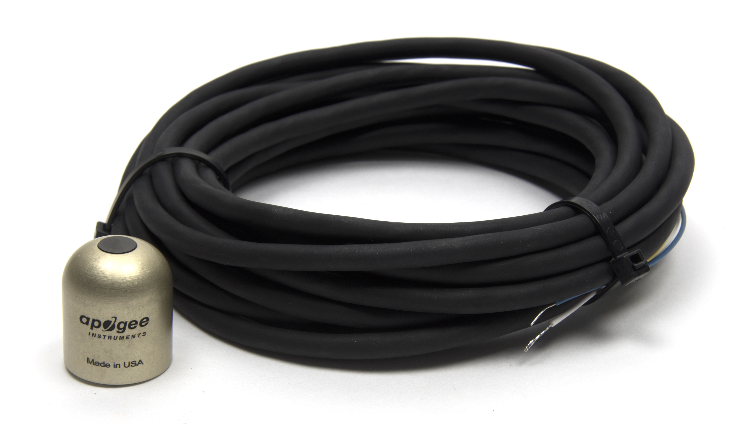

Table of Contents
Owner’s Manual 1
Certificate of Compliance 3
Introduction 4
Sensor Models 5
Specifications 6
Deployment and Installation 8
Cable Connectors 9
Operation and Measurement 10
Maintenance and Recalibration 15
Troubleshooting and Customer Support 16
Return and Warranty Policy 17

Certificate of Compliance

EU Declaration of Conformity
This declaration of conformity is issued under the sole responsibility of the manufacturer:
Apogee Instruments, Inc.
721 W 1800 N
Logan, Utah 84321
USA
for the following product(s):

Models: SL-510, SL-610
Type: Pyrgeometer

The object of the declaration described above is in conformity with the relevant Union harmonization legislation:

2014/30/EU Electromagnetic Compatibility (EMC) Directive
2011/65/EU Restriction of Hazardous Substances (RoHS 2) Directive
2015/863/EU Amending Annex II to Directive 2011/65/EU (RoHS 3)

Standards referenced during compliance assessment:

EN 61326-1:2013 Electrical equipment for measurement, control and laboratory use – EMC requirements
EN 50581:2012 Technical documentation for the assessment of electrical and electronic products with respect to the restriction of hazardous substances

Please be advised that based on the information available to us from our raw material suppliers, the products manufactured by us do not contain, as intentional additives, any of the restricted materials including lead (see note below), mercury, cadmium, hexavalent chromium, polybrominated biphenyls (PBB), polybrominated diphenyls (PBDE), bis(2-ethylhexyl) phthalate (DEHP), butyl benzyl phthalate (BBP), dibutyl phthalate (DBP), and diisobutyl phthalate (DIBP). However, please note that articles containing greater than 0.1% lead concentration are RoHS 3 compliant using exemption 6c.

Further note that Apogee Instruments does not specifically run any analysis on our raw materials or end products for the presence of these substances, but rely on the information provided to us by our material suppliers.

Signed for and on behalf of:
Apogee Instruments, July 2021

Bruce Bugbee
President
Apogee Instruments, Inc.

Introduction
All objects with a temperature above absolute zero emit electromagnetic radiation. The wavelengths and intensity of radiation emitted are related to the temperature of the object. The atmosphere and terrestrial surfaces (e.g., soil, plant canopies, water, snow) emit radiation in the mid infrared portion of the electromagnetic spectrum (approximately 4-50 µm).
Pyrgeometers are sensors that measure the net longwave radiation difference between the detector surface and surface the detector is directed towards (typically, atmosphere or ground surface). Longwave radiation emitted by the surface of interest can be calculated with the additional measurement of detector temperature, typically accomplished via an internal thermistor or PRT.
Typical applications of pyrgeometers include measurement of incoming longwave radiation from the sky and outgoing longwave radiation from terrestrial surfaces in atmospheric and energy balance studies. Incoming longwave radiation measurements from pyrgeometers are an important input to frost prediction models. Pyrgeometers are also integrated into net radiometers for measurement of net radiation at the land surface.
Apogee Instruments SL-510 and SL-610 pyrgeometers consist of a thermopile detector, silicon filter with a diamond-like carbon coating (for weatherproofing), precision thermistor (for detector temperature measurement), heater, and signal processing circuitry mounted in an anodized aluminum housing, and a cable to connect the sensor to a measurement device. Sensors are potted solid with no internal air space and are designed for continuous measurement of longwave radiation from the sky and terrestrial surfaces in outdoor environments. SL-510 and SL-610 pyrgeometers output an analog voltage that is directly proportional to the longwave radiation balance of the target (surface the detector is directed towards) and detector; the detector is sensitive to radiation incident on a planar surface (does not have to be horizontal), where the radiation emanates from all angles of a hemisphere. Longwave radiation incident on the detector is calculated from the radiation balance measurement and detector temperature measurement.

Sensor Models
Apogee SL-510 and SL-610 pyrgeometers covered in this manual are analog versions that provide a voltage output. Apogee offers the SL-510 for atmospheric measurements (upward-looking sensor, measures incoming longwave radiation) and SL-610 for terrestrial surface measurements (downward-looking sensor, measures outgoing longwave radiation).
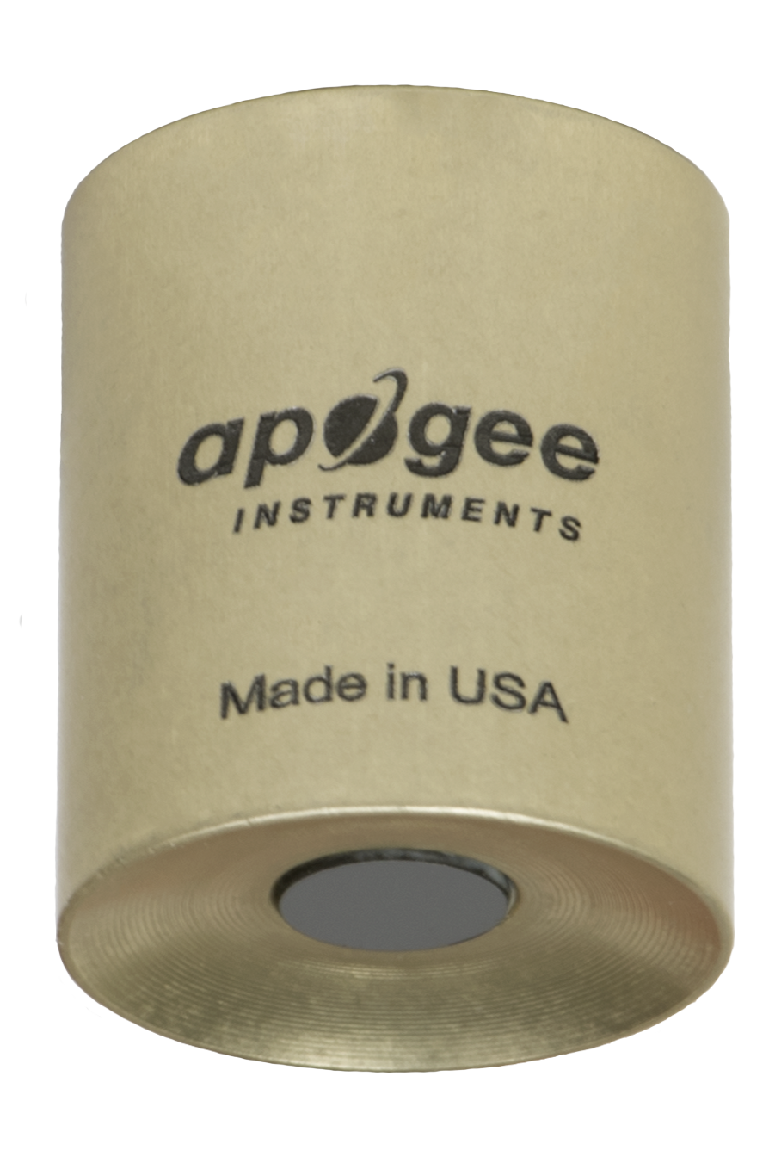
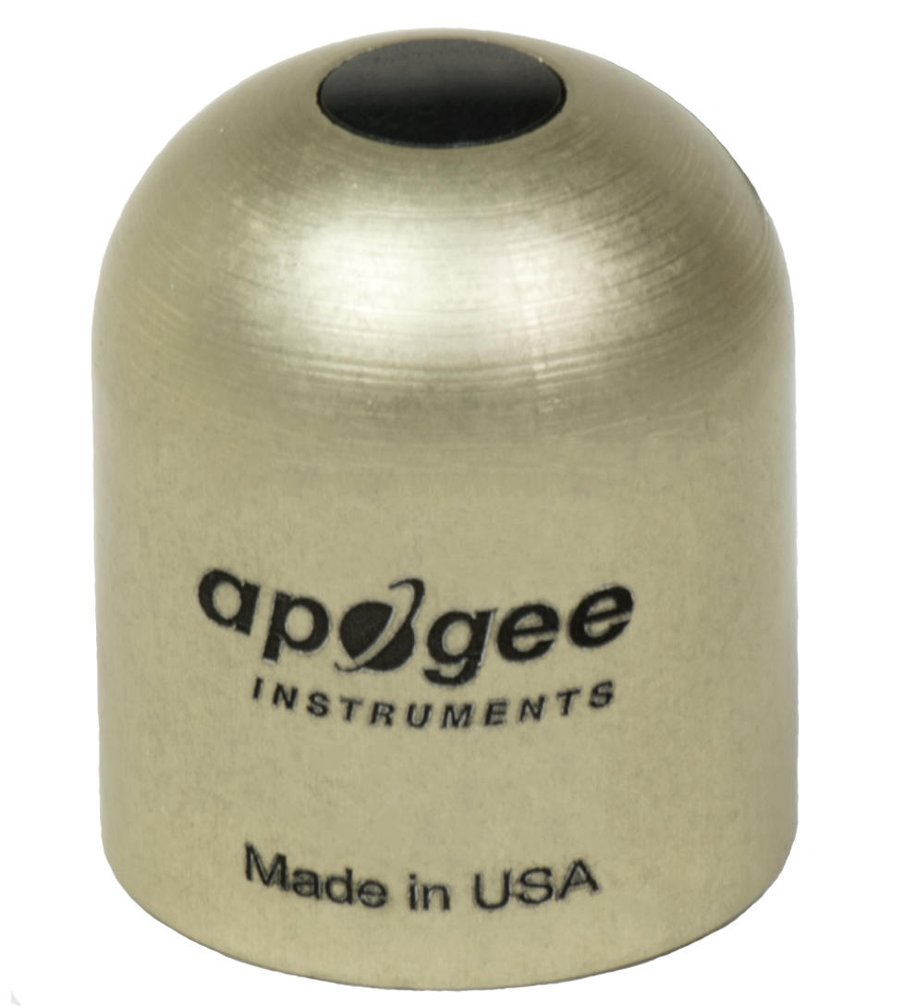
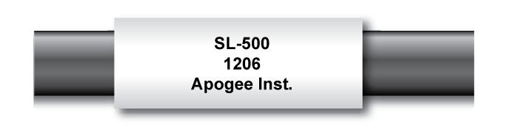
Sensor model number and serial number are located on a label near the pigtail leads on the sensor cable. If you need the manufacturing date of your sensor, please contact Apogee Instruments with the serial number of your sensor.

SL-610
Downward-looking sensor
SL-510
Upward-looking sensor

Specifications
 | SL-510-SS |  | SL-610-SS
Sensitivity | 0.12 mV per W m⁻² (variable from sensor to sensor, typical value listed)
Calibration Factor  (Reciprocal of Sensitivity) | 8.5 W m⁻² per mV (variable from sensor to sensor, typical value listed)
Calibration Uncertainty | ± 5 % (see Calibration Traceability below)
Measurement Range | -200 to 200 W m⁻² (net longwave irradiance)
Output from Thermopile | -23.5 to 23.5 mV
Output from Thermistor | 0 to 2500 mV (typical, other voltages can be used)
Temperature Sensor | 30 kΩ thermistor, ± 1 C tolerance at 25 C
Input Voltage Requirement for Thermistor | 2500 mV excitation (typical, other voltages can be used)
Measurement Repeatability | Less than 1 %
Long-term Drift | Less than 2 % change in sensitivity per year
Non-linearity | Less than 1 %
Response Time | Less than 0.5 s
Field of View | 180° | 150°
Spectral Range | 5 to 30 µm
Temperature Response | Less than 5 % from -15 to 45 C
Window Heating Offset | Less than 10 W m⁻²
Zero Offset B | Less than 5 W m⁻²
Tilt Error | Less than 0.5 %
Uncertainty in Daily Total | ± 5 %
Heater | 780 Ω, 15.4 mA current draw and 185 mW power requirement at 12 V DC
Dimensions | 27.5 mm height, 23.5 mm diameter
Mass | 90 g |  | 100 g
Cable | 5 m of six conductor, shielded, twisted-pair wire; TPR jacket (high water resistance, high UV stability, flexibility in cold conditions); pigtail lead wires; stainless steel (316), M8 connector located 25 cm from sensor head
Warranty | 4 years against defects in materials and workmanship
Calibration Traceability
Apogee SL-510 and SL-610 pyrgeometers are calibrated against the mean of two Apogee model SL-510 or SL-610 transfer standard pyrgeometers inside a custom blackbody cone held at multiple fixed temperatures over a range of radiometer (detector and sensor body) temperatures. The temperature of the blackbody cone is measured with replicate precision thermistors thermally bonded to the cone surface. The transfer standard pyrgeometers are calibrated against the mean of least two reference upward-looking pyrgeometers under all sky conditions in Logan, Utah. Each of the two reference pyrgeometers are recalibrated on an alternating year schedule (one instrument per year) at the National Renewable Energy Laboratory (NREL) in Golden, Colorado. NREL reference standards are calibrated to the World Infrared Standard Group (WISG) in Davos, Switzerland.
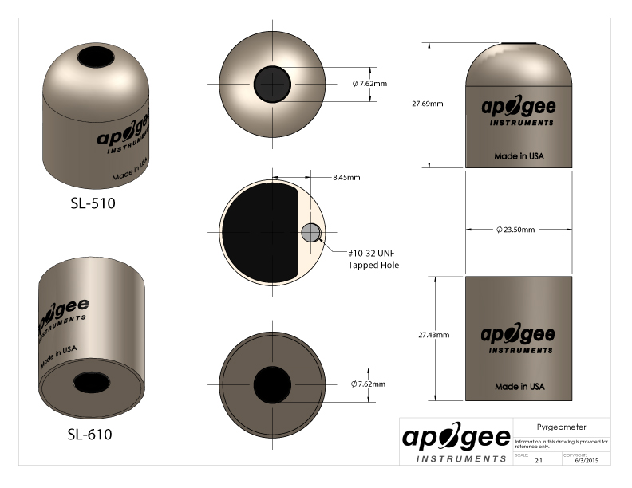

Deployment and Installation
Mount the sensor to a solid surface with the nylon mounting screw provided, included thermally-insulated base needs to be mounted between the sensor and the surface it is being mounted to. To accurately measure atmospheric longwave radiation incident on a horizontal surface, the sensor should be approximately level (longwave radiation from atmosphere is diffuse, so perfect level of the sensor is not required). An Apogee Instruments model AL-100 leveling plate is recommended for this purpose. To facilitate mounting on a cross arm, an Apogee Instruments model AM-110 mounting bracket is recommended.
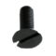
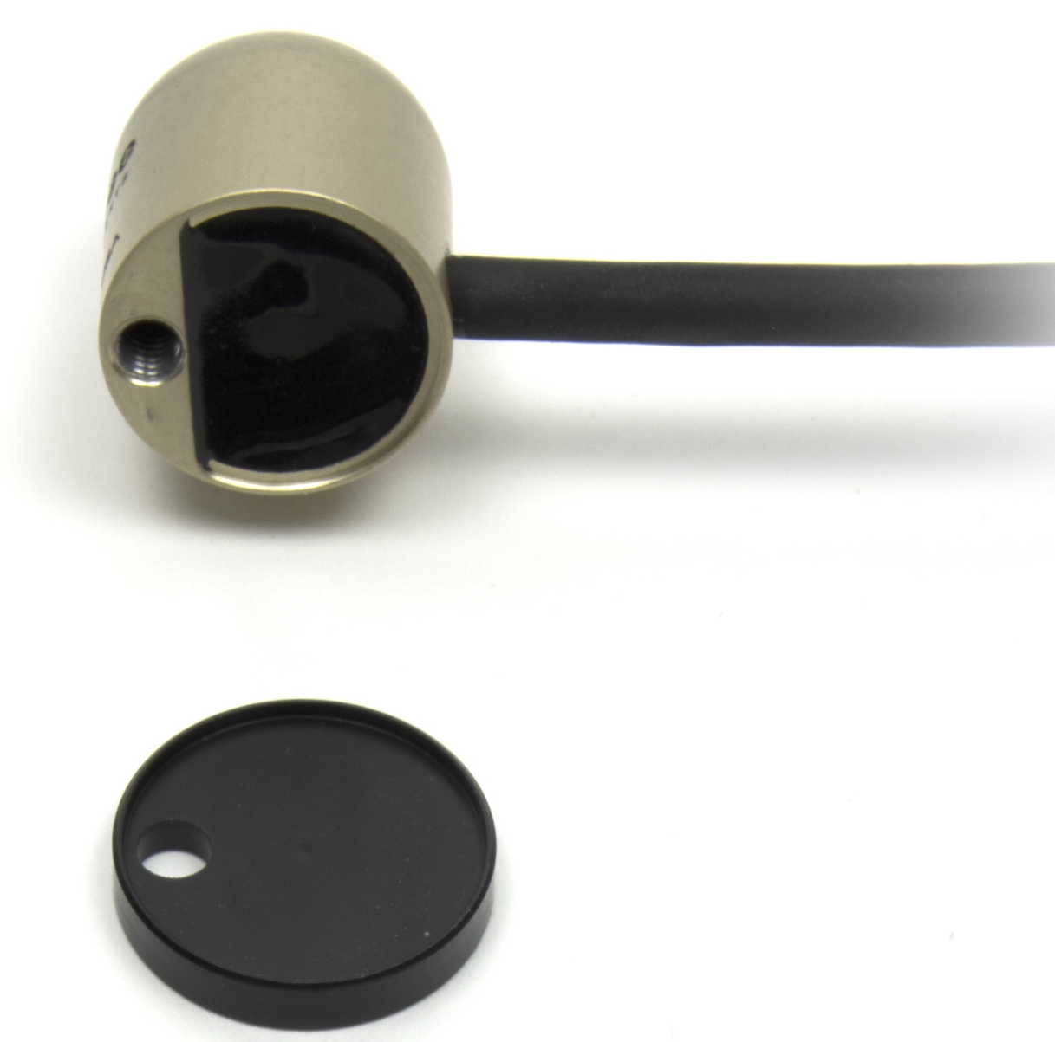
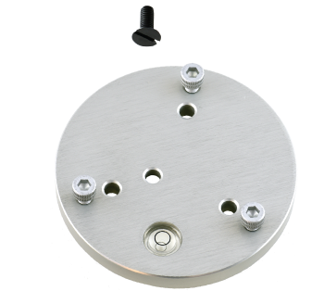
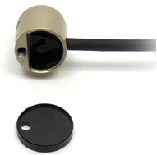
Nylon Screw: 10-32x3/8
Thermally-insulated Base
Nylon Screw: 10-32x3/8
Thermally-insulated Base
Model AL-120
Model AL-100
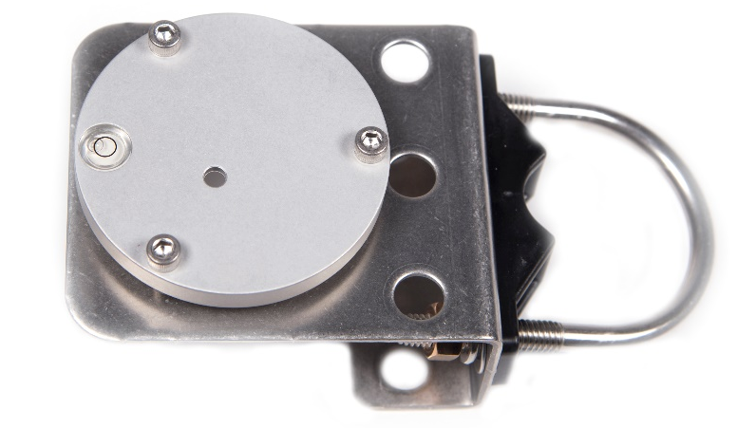

Sensors must be carefully mounted in order to view the desired target surface (sky or ground) and avoid including unwanted surfaces/objects in the field of view, thereby averaging unwanted radiation with the target radiation. The sensor should be mounted such that obstructions (e.g., weather station tripod/tower or other instrumentation) do not obstruct the sensor field of view. Once mounted, the green cap should be removed from the sensor. The green cap can be used as a protective covering for the sensor when it is not in use.

Cable Connectors
Apogee started offering in-line cable connectors on some bare-lead sensors in March 2018 to simplify the process of removing sensors from weather stations for calibration (the entire cable does not have to be removed from the station and shipped with the sensor).  The ruggedized M8 connectors are rated IP68, made of corrosion-resistant marine-grade stainless-steel, and designed for extended use in harsh environmental conditions. | 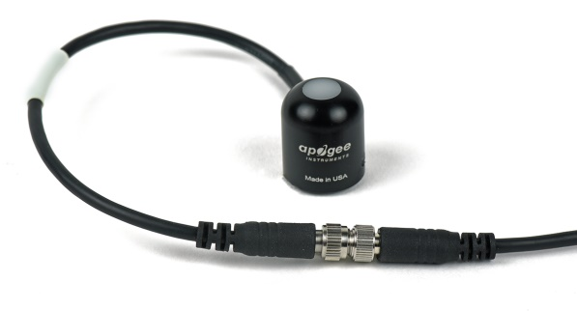  Inline cable connectors are installed 30 cm from the head  (pyranometer pictured)
Instructions
Pins and Wiring Colors: All Apogee connectors have six pins, but not all pins are used for every sensor. There may also be unused wire colors inside the cable. To simplify datalogger connection, we remove the unused pigtail lead colors at the datalogger end of the cable.  If a replacement cable is ever needed, please contact Apogee directly to ensure ordering the proper pigtail configuration.  Alignment: When reconnecting the sensor, arrows on the connector jacket and an aligning notch ensure proper orientation.  Disconnection for extended periods: When disconnecting the sensor for an extended period of time from a station, protect the remaining half of the connector still on the station from water and dirt with electrical tape or other method. | 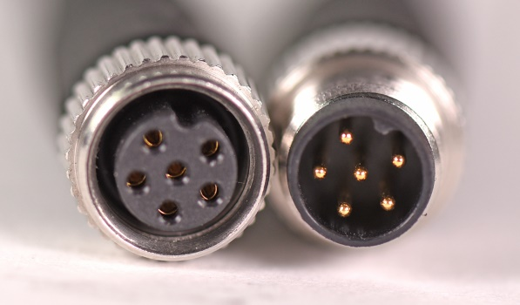  A reference notch inside the connector ensures  proper alignment before tightening.  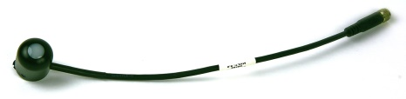  When sending sensors in for calibration, only send the short end of the cable and half the connector.
Tightening: Connectors are designed to be firmly finger-tightened only. There is an O-ring inside the connector that can be overly compressed if a wrench is used. Pay attention to thread alignment to avoid cross-threading. When fully tightened, 1-2 threads may still be visible. | 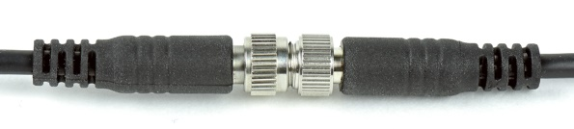  Finger-tighten firmly

Operation and Measurement
Apogee SL-510 and SL-610 pyrgeometers output two signals: a voltage from the thermopile radiation detector (proportional to the radiation balance between target and detector) and a voltage from the thermistor (proportional to the magnitude of the excitation voltage and resistance of thermistor). The voltage output from the thermopile is an electrically-isolated bipolar (polarity is dependent on temperature difference between sensor and target) signal, typically between -20 and 20 millivolts, and requires a high resolution differential measurement. The voltage output from the thermistor can be measured with a single-ended measurement. In order to maximize measurement resolution and signal-to-noise ratio, the input range of the measurement device should closely match the output range of the pyrgeometer. DO NOT connect the thermopile (white and black wires) to a power source. The detector is self-powered and applying voltage will damage it. Input voltage is required to measure resistance of the thermistor and to power the heater. Only the red and yellow wires should be connected to a power source.

VERY IMPORTANT: Apogee changed all wiring colors of our bare-lead sensors in March 2018 in conjunction with the release of inline cable connectors on some sensors. To ensure proper connection to your data device, please note your serial number or if your sensor has a stainless-steel connector 30 cm from the sensor head then use the appropriate wiring configuration below.
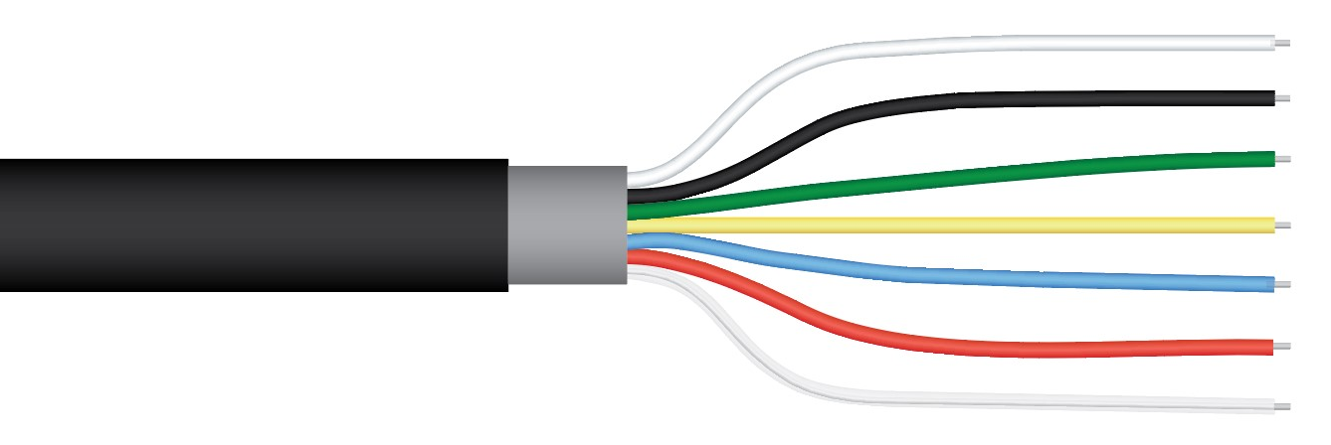
Wiring for SL-510 Serial Number 1074 and above (or with cable connector) and SL-610 Serial Number 1034 and above (or with cable connector)
White: High side of differential channel (positive thermopile lead)

Black: Low side of differential channel (negative thermopile lead)

Green: Single-ended channel (positive thermistor lead)

Yellow: 12 V DC (positive lead for heater)

Blue: Analog ground (negative thermistor and heater lead)

Red: Excitation channel (excitation for thermistor)

Clear: Shield/Ground

Wiring for SL-510 with Serial Numbers range 0-1073 and SL-610 with Serial number range 0-1033
White: 12 V DC (positive lead for heater)

Black: Low side of differential channel (negative thermopile lead)

Green: Ground (negative lead for heater)

Yellow: Single-ended channel (positive thermistor lead)

Blue: Excitation channel (excitation for thermistor)

Red: High side of differential channel (positive thermopile lead)

Clear: Analog ground (negative thermistor lead)

Sensor Calibration
Apogee SL-510 and SL-610 pyrgeometers are calibrated in a temperature controlled chamber that houses a custom-built blackbody cone (target) for the radiation source. During calibration, pyrgeometers (detectors) are held in a fixture at the opening of the blackbody cone, but are thermally insulated from the cone. Detector and target temperature are controlled independently. At each calibration set point, detectors are held at a constant temperature while the blackbody cone is controlled at temperatures below (approximately 20 C for first set point and approximately 6 C for second set point, but dependent on detector temperature) and above (approximately 6 C, but dependent on detector temperature) detector temperature. The range of detector temperatures is -25 C to 50 C (set points at 15 C increments). Data are collected at each detector temperature set point, after detectors and target reach constant temperatures.
All SL-510 and SL-610 pyrgeometers have sensor-specific calibration coefficients determined during the custom calibration process. Unique coefficients for each sensor are provided on a coefficient certificate (example shown below).
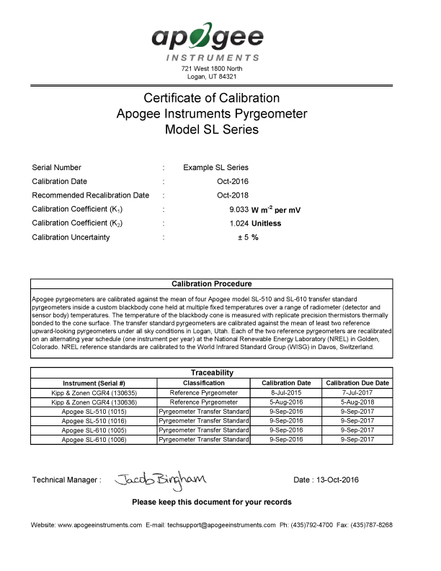

Calibration overview data and specific calibration coefficients are listed in the upper section of the calibration sheet, followed by the calibration procedure. Calibration traceability information and calibration dates are in the lower section of the sheet.

Temperature Measurement with Internal Thermistor
Measurement devices (e.g., datalogger, controller) do not measure resistance directly, but determine resistance from a half-bridge measurement, where an excitation voltage is input across the bridge resistor and an output voltage is measured across the thermistor.

Thermistor wiring for SL-510 Serial Number 1074 and above (or with cable connector) and SL-610 Serial Number 1034 and above (or with cable connector)

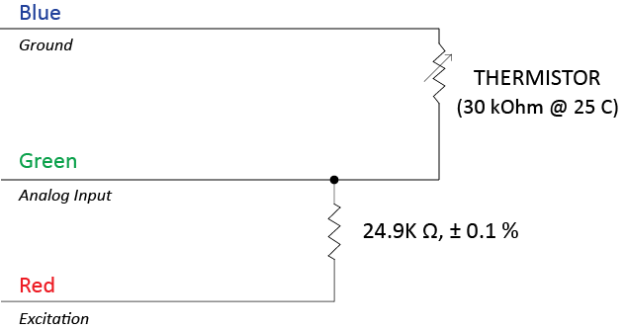

Thermistor wiring for SL-510 with Serial Numbers range 0-1073 and SL-610 with Serial number range 0-1033
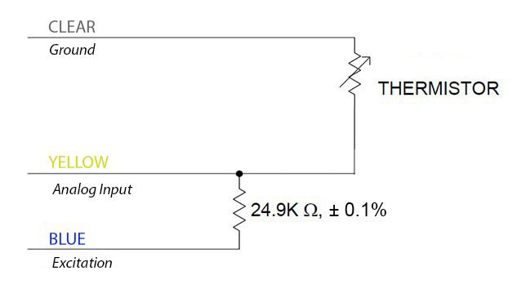
(30 kOhm @ 25 C)
An excitation voltage of 2.5 V DC is recommended to minimize self-heating and current drain, while still maintaining adequate measurement sensitivity (mV output from thermistor per C). However, other excitation voltages can be used. Decreasing the excitation voltage will decrease self-heating and current drain, but will also decrease thermistor measurement sensitivity. Increasing the excitation voltage will increase thermistor measurement sensitivity, but will also increase self-heating and current drain.
The internal thermistor provides a temperature reference for calculation of target temperature. Resistance of the thermistor changes with temperature. The thermistor resistance (R_{T}, in Ω) is measured with a half-bridge measurement, requiring an excitation voltage input (V_{EX}) and a measurement of output voltage (V_{OUT}):
(1a) OR (1b)
where 24900 is the resistance of the bridge resistor in Ω. In the generic equation 1b, V_{R} is the direct output from the half bridge measurement, where V_{R} is equal to the ratio of V_{OUT} to V_{EX} (i.e. V_{OUT} = V_{R} * V_{EX}).
From thermistor resistance (R_{T}), temperature (T_{K}, in Kelvin) is calculated with the Steinhart-Hart equation and thermistor specific coefficients (30 kOhm @ 25 C):
(2)
For temperatures less than zero Celsius: A = 9.32960 x 10⁻⁴, B = 2.21424 x 10⁻⁴, and C = 1.26329 x 10⁻⁷
For temperatures greater than zero Celsius: A = 9.32794 x 10⁻⁴, B = 2.21451 x 10⁻⁴, and C = 1.26233 x 10⁻⁷

Longwave Radiation Measurement
The detector output from SL-510 and SL-610 pyrgeometers follows the fundamental physics of the Stefan-Boltzmann Law, where radiation transfer is proportional to the fourth power of absolute temperature. The mV signal from the detector is linearly proportional to the longwave radiation balance between the target and detector, analogous to longwave radiation emission being linearly proportional to the fourth power of temperature in the Stefan-Boltzmann Law. A modified form of the Stefan-Boltzmann equation is used to calibrate sensors, and subsequently, calculate longwave irradiance from target:
LW_{i} | Incoming Longwave, in W m⁻²
k₁ | Calibration coefficient 1 (see cal. sheet)
k₁ | Calibration coefficient 2 (see cal. sheet)
S_{D} | Signal from detector, mV (Apprx. -23.5 to 23.5 mV)
σ | Stefan-Boltzmann constant, 5.6704 x 10⁻⁸ W m⁻² K⁻⁴
T_{D} | Detector temperature, in K

(1)

where LW_{i} is longwave radiation emitted from target [W m⁻²], S_{D} is the millivolt signal from the detector, T_{D} is the temperature measured with a thermistor thermally bonded to the detector [K], σ is Stefan-Boltzmann constant = 5.6704 x 10⁻⁸ W m⁻² K⁻⁴, and k₁ and k₂ are custom calibration coefficients. During the calibration process, k₁ and k₂ are determined by minimizing the difference between measurements of LW_{i} from each sensor and reference LW_{i} measured with transfer standard pyrgeometers. The derived k₁ and k₂ coefficients are the custom calibration coefficients listed on the calibration certificate (shown above) that comes with each SL-510 and SL-610 pyrgeometer.
Operation of Heater
Apogee SL-510 and SL-610 pyrgeometers have an internal heater to allow for sensor heating during precipitation events or under conditions of dew and frost deposition. The heater is designed to keep the water (liquid and frozen) off the silicon filter and does not need to be powered in order to make measurements of longwave radiation. However, if the filter has water on the surface, errors can result. Continuously powering the heater under conditions that do not require heating will not damage the sensor or influence measurements.

Maintenance and Recalibration
Blocking of the optical path between the target and detector, often due to moisture or debris on the silicon filter, is a common cause of inaccurate measurements. SL-510 pyrgeometers have a domed housing for improved self-cleaning from rainfall, but the flat filter surface of SL-510 and SL-610 pyrgeometers can become partially blocked in three ways:
- Dew or frost formation on the silicon filter (can be minimized by powering heater).
- Salt deposit accumulation on the filter, due to evaporating irrigation water or sea spray. This leaves a thin white film on the filter surface. Salt deposits can be removed with a dilute acid (e.g., vinegar). Salt deposits cannot be removed with solvents such as alcohol or acetone.
- Dust and dirt deposition on the window (usually a larger problem in windy environments). Dust and dirt are best removed with deionized water, rubbing alcohol, or in extreme cases, acetone.
Clean filter with a cotton swab dipped in the appropriate solvent. Never use an abrasive material on the silicon filter. Use only gentle pressure when cleaning the filter with a cotton swab, to avoid scratching the outer surface. The solvent should be allowed to do the cleaning, not mechanical force.
It is recommended that pyrgeometers be recalibrated every two years. See the Apogee webpage for details regarding return of sensors for recalibration (http://www.apogeeinstruments.com/tech-support-recalibration-repairs/).

Troubleshooting and Customer Support
Independent Verification of Functionality
The radiation detector in Apogee SL-510 and SL-610 pyrgeometers is a self-powered device that outputs a voltage signal proportional to the radiation balance between the detector and target surface. A quick and easy check of detector functionality can be accomplished using a voltmeter with microvolt (µV) resolution. Connect the positive lead of the voltmeter to the white wire from the sensor and the negative lead (or common) to the black wire from the sensor. Direct the sensor toward a surface with a temperature significantly different than the detector. The voltage signal will be negative if the surface is colder than the detector and positive if the surface is warmer than the detector. Placing a piece of tinfoil in front of the sensor should force sensor voltage signal to zero.
The thermistor inside SL-510 and SL-610 pyrgeometers yields a resistance proportional to temperature. A quick and easy check of thermistor functionality can be accomplished with an ohmmeter. Connect the lead wires of the ohmmeter to the blue and green wires from the sensor. The resistance should read 30 kΩ at 25 C. If the sensor temperature is less than 25 C, the resistance will be higher. If the sensor temperature is greater than 25 C, the resistance will be lower. Connect the lead wires of the ohmmeter to the red and green wires from the sensor. The resistance should read 24.9 kΩ, and should not vary. Connect the lead wires of the ohmmeter to the red and blue wires from the sensor. The resistance should be the sum of the resistances measured across the blue and green wires, and red and green wires (e.g., 30 kΩ plus 24.9 kΩ at 25 C).
Compatible Measurement Devices (Dataloggers/Controllers/Meters)
Apogee SL-510 and SL-610 pyrgeometers have sensitivities in the microvolt range, approximately 0.11 mV per W m⁻² difference between target and detector. Thus, a compatible measurement device (e.g., datalogger or controller) should have resolution of at least 0.11 mV to produce longwave radiation resolution of 1 W m⁻².
Measurement of detector temperature from the internal thermistor requires an input excitation voltage, where 2500 mV is recommended. A compatible measurement device should have the capability to supply the necessary voltage.
An example datalogger program for Campbell Scientific dataloggers can be found on the Apogee webpage at http://www.apogeeinstruments.com/content/Thermopile-Pyrgeometer-Unamplified.CR1.
Modifying Cable Length
When the sensor is connected to a measurement device with high input impedance, sensor output signals are not changed by shortening the cable or splicing on additional cable in the field. Tests have shown that if the input impedance of the measurement device is 10 MΩ or higher, there is negligible effect on the radiometer calibration, even after adding up to 50 m of cable. Apogee SL-510 and SL-610 pyrgeometers use shielded, twisted pair cable, which minimizes electromagnetic interference. This is particularly important for long lead lengths in electromagnetically noisy environments. See Apogee webpage for details on how to extend sensor cable length (http://www.apogeeinstruments.com/how-to-make-a-weatherproof-cable-splice/).
Signal Interference
Due to the small voltage signals from the detector, care should be taken to provide appropriate grounding for the sensor and cable shield wire, in order to minimize the influence of electromagnetic interference (EMI). In instances where SL-510 and SL-610 series pyrgeometers are being used in close proximity to communications (near an antenna or antenna wiring), it may be necessary to alternate the data recording and data transmitting functions (i.e., measurements should not be made when data are being transmitted wirelessly). If EMI is suspected, place a tinfoil cap over the front of the sensor and monitor the signal voltage from the detector. The signal voltage should remain stable at (or very near) zero.

Return and Warranty Policy

RETURN POLICY
Apogee Instruments will accept returns within 30 days of purchase as long as the product is in new condition (to be determined by Apogee). Returns are subject to a 10 % restocking fee.

WARRANTY POLICY
What is Covered
All products manufactured by Apogee Instruments are warranted to be free from defects in materials and craftsmanship for a period of four (4) years from the date of shipment from our factory. To be considered for warranty coverage an item must be evaluated by Apogee.
Products not manufactured by Apogee (spectroradiometers, chlorophyll content meters, EE08-SS probes) are covered for a period of one (1) year.
What is Not Covered
The customer is responsible for all costs associated with the removal, reinstallation, and shipping of suspected warranty items to our factory.
The warranty does not cover equipment that has been damaged due to the following conditions:
1. Improper installation or abuse.
2. Operation of the instrument outside of its specified operating range.
3. Natural occurrences such as lightning, fire, etc.
4. Unauthorized modification.
5. Improper or unauthorized repair.
Please note that nominal accuracy drift is normal over time. Routine recalibration of sensors/meters is considered part of proper maintenance and is not covered under warranty.
Who is Covered
This warranty covers the original purchaser of the product or other party who may own it during the warranty period.
What Apogee Will Do
At no charge Apogee will:
1. Either repair or replace (at our discretion) the item under warranty.
2. Ship the item back to the customer by the carrier of our choice.
Different or expedited shipping methods will be at the customer’s expense.
How To Return An Item
1. Please do not send any products back to Apogee Instruments until you have received a Return Merchandise Authorization (RMA) number from our technical support department by submitting an online RMA form at www.apogeeinstruments.com/tech-support-recalibration-repairs/. We will use your RMA number for tracking of the service item. Call (435) 245-8012 or email techsupport@apogeeinstruments.com with questions.
2. For warranty evaluations, send all RMA sensors and meters back in the following condition: Clean the sensor’s exterior and cord. Do not modify the sensors or wires, including splicing, cutting wire leads, etc. If a connector has been attached to the cable end, please include the mating connector – otherwise the sensor connector will be removed in order to complete the repair/recalibration. Note: When sending back sensors for routine calibration that have Apogee’s standard stainless-steel connectors, you only need to send the sensor with the 30 cm section of cable and one-half of the connector. We have mating connectors at our factory that can be used for calibrating the sensor.
3. Please write the RMA number on the outside of the shipping container.
4. Return the item with freight pre-paid and fully insured to our factory address shown below. We are not responsible for any costs associated with the transportation of products across international borders.
Apogee Instruments, Inc.
721 West 1800 North Logan, UT
84321, USA
5. Upon receipt, Apogee Instruments will determine the cause of failure. If the product is found to be defective in terms of operation to the published specifications due to a failure of product materials or craftsmanship, Apogee Instruments will repair or replace the items free of charge. If it is determined that your product is not covered under warranty, you will be informed and given an estimated repair/replacement cost.

Products Beyond the Warranty Period
For issues with sensors beyond the warranty period, please contact Apogee at techsupport@apogeeinstruments.com to discuss repair or replacement options.

Other Terms
The available remedy of defects under this warranty is for the repair or replacement of the original product, and Apogee Instruments is not responsible for any direct, indirect, incidental, or consequential damages, including but not limited to loss of income, loss of revenue, loss of profit, loss of data, loss of wages, loss of time, loss of sales, accruement of debts or expenses, injury to personal property, or injury to any person or any other type of damage or loss.
This limited warranty and any disputes arising out of or in connection with this limited warranty ("Disputes") shall be governed by the laws of the State of Utah, USA, excluding conflicts of law principles and excluding the Convention for the International Sale of Goods. The courts located in the State of Utah, USA, shall have exclusive jurisdiction over any Disputes.
This limited warranty gives you specific legal rights, and you may also have other rights, which vary from state to state and jurisdiction to jurisdiction, and which shall not be affected by this limited warranty. This warranty extends only to you and cannot by transferred or assigned. If any provision of this limited warranty is unlawful, void or unenforceable, that provision shall be deemed severable and shall not affect any remaining provisions. In case of any inconsistency between the English and other versions of this limited warranty, the English version shall prevail.
This warranty cannot be changed, assumed, or amended by any other person or agreement
APOGEE INSTRUMENTS, INC. | 721 WEST 1800 NORTH, LOGAN, UTAH 84321, USA
TEL: (435) 792-4700 | FAX: (435) 787-8268 | WEB: APOGEEINSTRUMENTS.COM
Copyright © 2021 Apogee Instruments, Inc.

